**Characterising ploidy-differentiated genomic regions under immediate variation in the neotetraploid QUA population of *Mimulus guttatus***

**Name and Student ID: Matthew Gaskins (14328692)**

**Abbreviations:**

AFD: Allele Frequency Difference

CDC2: Cell Division Control Protein 2

CNV: Copy Number Variant

FST: Fixation Index

GO: Gene Ontology

GUI: Graphical User Interface

LD: Linkage Disequilibrium

PCA: Principal Component Analysis

PGM: Population Genomic Metric

QUA: Quarff, Shetland Islands

SNP: Single Nucleotide Polymorphism

WGD: Whole Genome Duplication

**Abstract:**

Whole genome duplication represents a stark transformation to the genomic landscape, disrupting a wealth of notable intracellular processes including meiosis, yet the evolutionary opportunities available upon successful transition to the polyploid state are plentiful. The onset of enhanced gene redundancy post-polyploidization expedites development of selectively advantageous characteristics, as harmful genetic variants become masked by the duplicated number of chromosomes. However, the ability of neopolyploids to tolerate immediate consequences from genome doubling is poorly characterised, largely owing to challenges handling polyploid data and underestimations of autopolyploid incidence.

Here, we employ QUA, a neotetraploid population of *Mimulus guttatus* from the Shetland Islands, as a paradigm to identifying ploidy-differentiated genomic regions mediating plant survival in the immediate aftermath of polyploidization. Predicted candidates are identified as upper-99th percentile outliers from several population genomic metrics, namely FST, AFD, DXY and Rho, evaluated using the ScanTools pipeline developed in the Yant lab. After functionally characterising candidates through GO analysis, we identify WGD in QUA invokes adaptation of similar processes to those previously observed in *Cardamine amara* and *Arabidopsis arenosa* systems, notably ion-homeostasis, nuclear division, and metal-ion transportation in stress response. However, the identity of specific genes under variation remains remarkably divergent, suggesting regulation of core cellular processes possesses significant evolutionary flexibility.

To provide a broader outlook on genomic regions under selection, we characterise copy number variant locations for each QUA cytotype using cn.mops software. Here, we identify an elevated frequency of centromeric tetraploid CNVs larger than 50-kilobases relative to diploids. These copy number variants could represent novel evolutionary opportunities for polyploids following adaptation to the duplicated state, however may also simply reflect noise from additional chromosome sampling and an unavoidably lowered threshold for CNV detection in tetraploids. Nevertheless, identifying genomic regions under variation post-WGD represents an essential line of research in the face of climate change, as the enhanced genomic plasticity of polyploids facilitates accelerated environmental flexibility. Understanding mechanisms underlying immediate polyploid survival post-WGD may therefore shape rational design of synthetic crops capable of tolerating increasingly challenging growth conditions, ultimately contributing to ameliorated agricultural consequences from climate change.

**Introduction:**

Polyploidisation events act as major drivers of evolutionary change in plants, supplying an additional source of genetic material that provides novel opportunities for lineage diversification. Damaging fitness consequences from harmful allelic variants are more easily masked by the increased number of alleles in polyploids compared to their genetic progenitors – such gene redundancy ensures polyploidy is often accompanied with onset of selectively advantageous characteristics including enhanced stress tolerance and increased relative organ growth rates[1,2]. However, doubling the number of homologs also presents salient challenges to several conserved intracellular processes, most notably meiosis in lieu of the drastic alteration in topological relationships between chromosomes during segregation. Indeed, multiple studies have identified spindle irregularities and somatic aneuploidy in tetraploid plants[3,4]. Nevertheless, novel population and ecological opportunities await a lineage that successfully adapts to the WGD-state, with direct empirical evidence of increased polyploid adaptability that favours their successful establishment, including examples from *Arabidopsis* and *Centaura*[5,6].

Enhanced polyploid plasticity therefore represents an attractive target for rational design of synthetic crops with agronomically beneficial traits. Amidst an increasing human population and ever-worsening plant growing conditions due to climate change, understanding genomic mechanisms underlying these desired adaptive traits is critical to designing more resilient crops with increased yields. Throughout the past century, interspecific hybridisation succeeded by whole genome duplication – termed allopolyploidy – represented the primary mechanistic theory explaining enhanced adaptability[6]. As constituent genomic material derives from two distinct sources, allopolyploids contain extensive genetic variability. Such widespread intragenomic divergence can quickly escalate to advantageous phenotypic changes such as increased reproductive rates; high intrinsic variation readily precipitates fixed homoeoallelic heterozygosity and fitness increase through heterosis[7]. Allopolyploids therefore represent established targets for rational design of crops with enhanced adaptive potential.

However, modern advances in flow cytometry have uncovered an unexpectedly high natural prevalence of autopolyploidy, acquisition of additional chromosomal copies through intraspecific WGD[8]. Autopolyploids were originally identified through abnormal chromosome segregation patterns caused by multivalent formation during meiosis, with no partner pairing preference between homologs. This elevated rate of multivalent formation among three or more homologs at anaphase was historically predicted to increase aneuploidy through resultant meiotic irregularities[8]. Autopolyploids also lack some of the theoretical benefits associated with hybridization, such as fixed heterozygosity, and were therefore deemed at an evolutionarily disadvantage to allopolyploids, consistent with their well-observed presence at tips of phylogenies[9]. However, it has recently been determined autopolyploids are less likely to form multivalents than bivalent pairs, reducing the theoretical probability of aneuploidy from aberrant meiosis[10]. Using increasingly inexpensive cytotyping techniques, polysomic inheritance now represents the primary diagnostic trait of autopolyploids, and accordingly the incidence of autopolyploid species identification has increased[8]. Moreover, several autopolyploids appear to have escaped recognition due to strong morphological similarities with diploid ancestors – correspondingly, following improvements in cytotyping, multiple natural autopolyploids have been identified with well-evidenced successful range colonisation[11,12].

As the importance of autopolyploidy to plant evolution was long underestimated, genomic mechanisms underlying enhanced autopolyploid adaptability remain relatively unexplored, and represent a fresh line of research into mitigating effects from climate change. Whilst increased gene redundancy may expedite long-term emergence of evolutionary novelty, successful establishment of autopolyploid lineages is likely to require immediate benefits[13]. Whether genome duplication itself directlyprovides this evolutionary advantage remains an open question, and represents one focus of our project. Increased genetic material is predicted to reduce the likelihood of populations experiencing deleterious effects from inbreeding depression[13].Moreover, sparse research indicates that, even in absence of interspecific hybridization, genome duplication can rapidly trigger phenotypic changes, for example colchicine-induced tetraploidy in *A.thaliana* produces immediate increases in leaf-size and improvements in drought tolerance[14,15]. This ability to rapidly generate phenotypic novelty could facilitate the establishment of non-native polyploid populations in unique locations. Against the wider backdrop of climate change, increasing the range of possible locations to grow crops represents an agronomically beneficial trait, therefore polyploid genomics represents an important strand of food security research.

Levy & Feltman delineate polyploid evolution into two fundamental stages; immediate ‘revolutionary’ changes directly succeeding WGD, followed by long-term ‘evolutionary’ divergence that provides persistent selective advantage[16]. We therefore aim to capture genomic variation at both phases of polyploid evolution – firstly, by establishing biological processes underlying immediate WGD tolerance through pairwise diploid-tetraploid selection scans. We then identify patterns of tetraploid aneuploidy, which could exploit increased selective substrate post-polyploidization to develop long-term evolutionary advantages that support successful habitat colonisation. Ultimately, both aims contribute to the overarching objective of our project: to identify genomic mechanisms facilitating enhanced autopolyploid adaptability that can be co-opted to our agronomic advantage through rational crop design. This report gains increased significance due to the limited extent of autopolyploid research and in light of the ever-increasing impact of climate change.

One species that represents a logical target for investigating the instigatory role of autopolyploidy in plant evolution is *Mimulus guttatus*, a predominantly outcrossing wild species native to the west coast of North America with a small 430Mb genome[17]. Although most *M.guttatus* populations are diploid (2*n*=28), the species contains three well-characterised autotetraploidization events in geographically distinct locations – Southern California, the Pacific North-West and the Shetland Islands[18,19]. As displayed in Figure 1a-c, all three duplication events appear distinct with independent genetic origin - tetraploid populations cluster away from one another in PCA, whilst neither gene flow nor admixture exists across the three locations, an expected outcome given considerable geographical distance between polyploid populations. *M.guttatus* shows extensive and remarkable biological flexibility in adapting to these three contrasting climates – such repeated, independent adaptation associated with polyploidization represents a suitable paradigm for elucidating genomic mechanisms underlying increased polyploid plasticity.

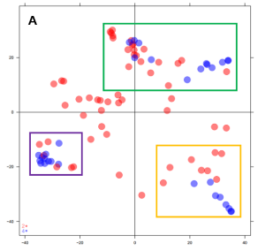

**A**

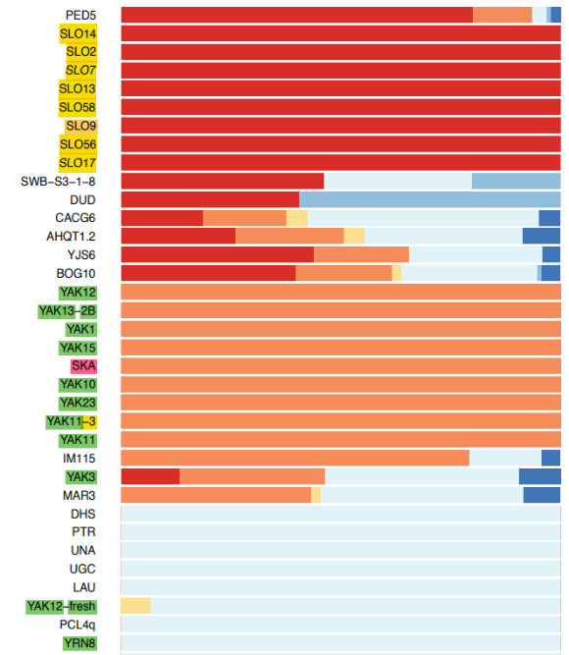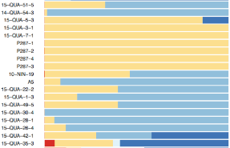

**C**

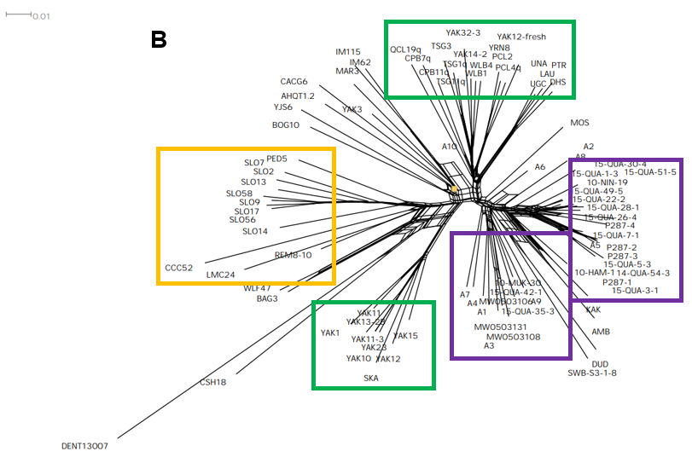

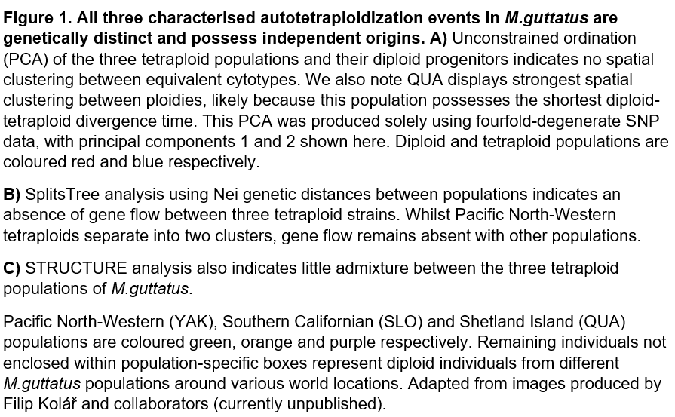

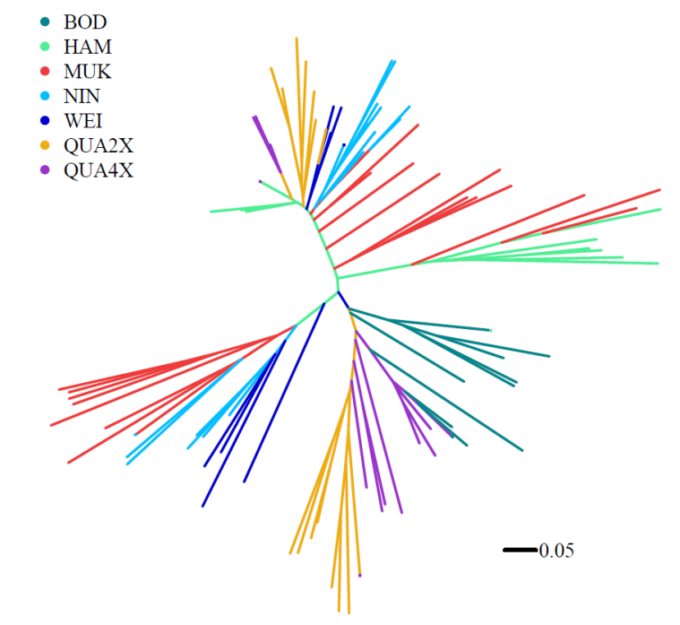Identification of autotetraploidisation in the QUA population from the Shetland Islands represents the first documented incidence of *M.guttatus* tetraploidy outside the native range[19]. Genetic analyses of this mixed-ploidy QUA strain indicate WGD arose within the last two-hundred years, representing an extremely rare opportunity to interrogate immediate variation associated with polyploidization[19]. A single neopolyploidization event with local origin in the admixed QUA strain represents the most plausible explanation for duplication, as the isolated nature of QUA renders migration of tetraploids from different populations unlikely[19]. Phylogenetic analysis shown in Figure 2 also demonstrates tetraploids from the QUA population are more genetically similar to sympatric QUA diploids than other diploids from the Shetland Islands. We possess high confidence this unique polyploidisation event represents autopolyploidy, as meiotic spreads from tetraploid QUA indicate extensive multivalent formation with no partner pairing preference between homologs. Moreover, the inferior performance of tetraploid meiosis suggests chromosomal breakage and mis-segregation events are common, further supporting use of mixed-ploidy QUA as a paradigm to understanding genomic mechanisms allowing adaptation through aneuploidy post-WGD.

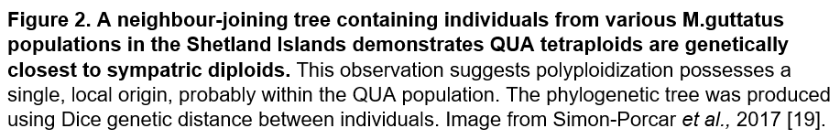

As displayed in Figure 3, neoautotetraploid QUA populations are more stress tolerant, less prone to flower, and have larger leaves and thicker stems than their diploid progenitors[19]. This accords with the theoretical direct impacts of WGD, before evolution ameliorates the consequences of genome doubling upon cell size[20]. Such immediate neopolyploid phenotypic variation permits expeditious colonisation of novel environments. Rapid ecological adaptation is particularly important in populations at the borders of traditional native ranges - consistent with *M.guttatus*, where all three characterised polyploidisation events occur at the native range boundary[21]. Furthermore, it is unsurprising that WGD arises in the northernmost Scottish population of *M.guttatus*, as the production rate of unreduced gametes increases in cold temperatures, a common route for polyploid formation[22].

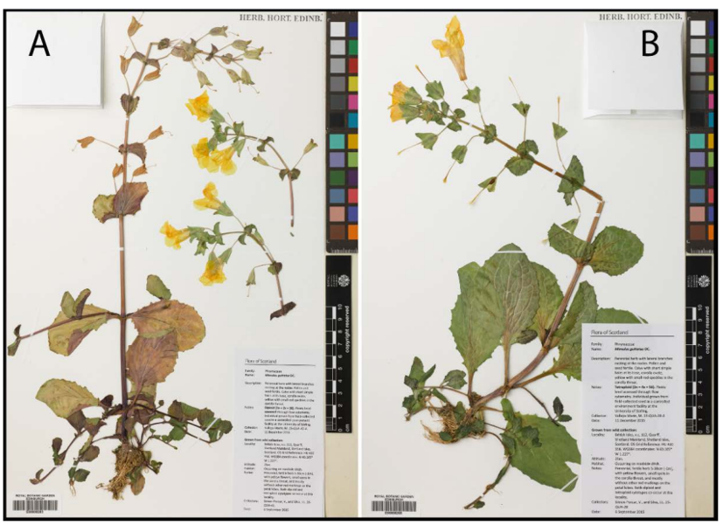

**C**

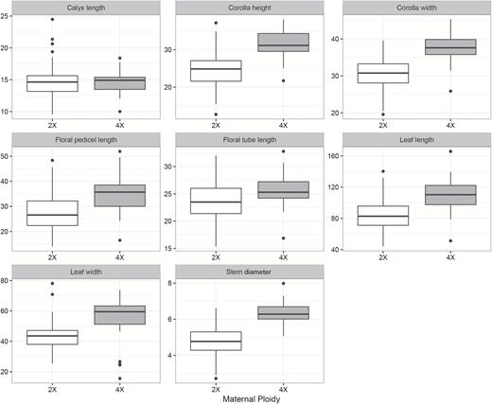

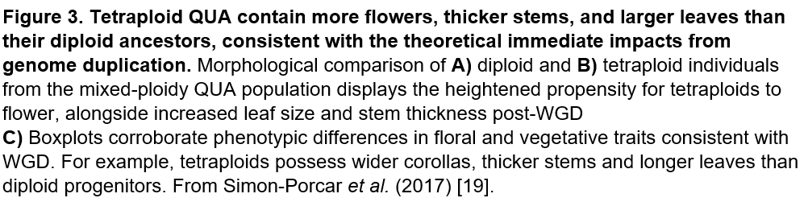

In 2017, Simon-Porcar compared genetic diversity parameters between both QUA cytotypes and other Shetland populations of *M.guttatus*, shown in Table 1[19]. Here, we observe both diploid and tetraploid QUA contain significantly more genetic variation than other Shetland strains. However, in different mixed-ploidy populations, polyploidisation is accompanied with an increase in genetic diversity, thus it is somewhat unexpected for QUA tetraploids to possess lower genotypic richness and a reduced proportion of polymorphic loci than diploid progenitors[23]. This observation may reflect significant inbreeding within partially-selfing tetraploids, or simply a decrease in relative population sizes compared to diploids. However, it is more likely that formulating accurate predictions for self-compatible polyploids is near-impossible - the authors of this 2017 paper themselves note allele dosage is difficult to quantify across alternative breeding systems within species[19]. As part of our analysis, we therefore aim to further resolve diversity relationships between diploid and tetraploid QUA using alternative genetic parameters, including Tajima’s D, nucleotide diversity and Watterson’s theta.

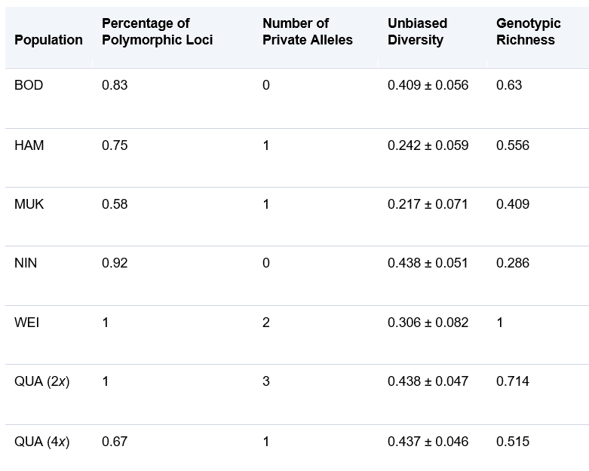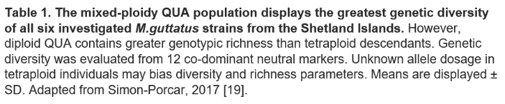

Difficulties associated with double-reduction and missing genetic-marker dosage information represent one limitation of interrogating this mixed-ploidy QUA population instead of older WGD events in *M.guttatus*. However, identifying the immediate effects of polyploidization becomes increasingly complicated as lineages age and continue accumulating evolutionary change, therefore the benefits of examining such a recent WGD event outweigh the technical disadvantages[23]. Characterising instant variation between QUA cytotypes would further explain mechanisms by which polyploidization allows populations to rapidly tolerate environmental change. This property is especially pertinent in light of climate change, justifying selection of this most recent polyploidisation event in QUA as the focus of our study.

In this report, we examine thirteen geographically proximate QUA individuals, six diploid and seven autotetraploid, alongside four synthetic tetraploids from the P287 population, where WGD has been induced by colchicine treatment. Colchicine inhibits tubulin polymerisation, thereby preventing spindle formation and subsequent chromosome segregation during cell division[24]. Correspondingly, colchiploids produce characteristic ‘bucky-ball’ meiotic spreads with unsegregated chromosomes remaining post-metaphase; two copies of each chromosome are maintained in gametes and polyploidy ensues[25]. Our four colchiploids are infertile, likely through aneuploidy linked to impaired chromosome segregation following WGD, indicating the evolutionary challenges associated with polyploidy. These colchiploids therefore act as a control to newly-established QUA tetraploids in terms of the aneuploidy landscape following genome duplication.

QUA samples were collected from four disjoint linear fragments of individuals located in roadside ditches between geographic coordinates 60°6.15N, 1°14.50W and 60°6.30N, 1°13.00W at an altitude of 25m above sea-level. However, all individuals in our study were selected from two populations representing core areas of each cytotype, geographically distinct from immediate hybrid zones. Figure 4 displays the precise location of each QUA population, whilst Table 2 provides additional sequencing information for every sample. We observe strong >9x coverage for each QUA individual, helping to mitigate difficulties sequencing the repeat-rich *M.guttatus* genome, which is correspondingly difficult to resolve[26].

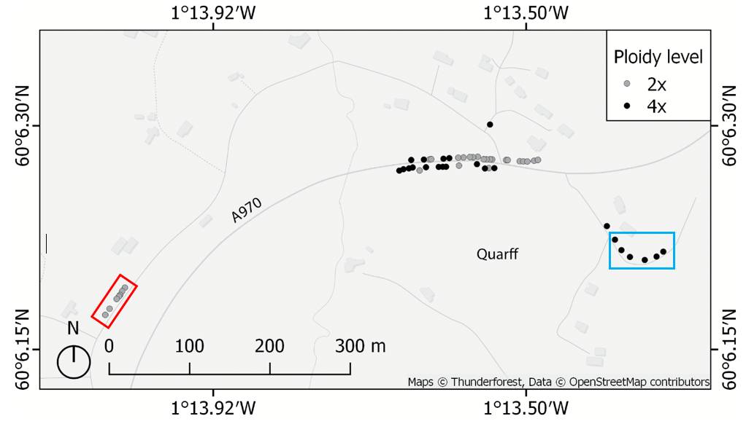

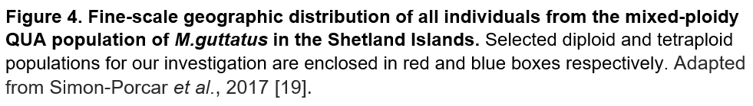



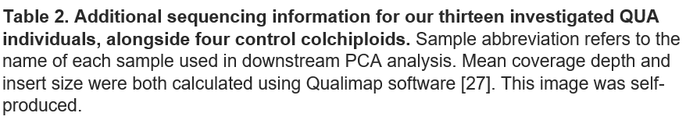

Our first objective is to identify candidate genomic regions linked to immediate variation in tetraploid QUA following polyploidization. To achieve this aim, we conduct pairwise comparison of SNP-frequency between diploid and tetraploid QUA using selection scans of several population genomic metrics, namely FST, AFD, DXY and Rho. Each metric characterises genome-wide patterns of genetic variation in a different manner, for example FST evaluates genomic differentiation at biallelic sites, whilst DXY analyses absolute divergence in monomorphic locations[28]. We therefore employ multiple metrics to identify mutual outliers, restricting the frequency of ‘false-positive’ candidate genes from genetic drift and population-specific selection to enable more accurate characterisation of adaptive biological processes. However, we also analyse each metric individually to identify global pathways altered by different genes.

As insufficient software exists capable of dealing with polyploid data, the Yant lab has recently developed the ScanTools python wrapper to evaluate selected population genomic metrics. One completely-differentiated SNP may simply reflect genetic drift, therefore PGM values are averaged across 5,000-kilobase windows in this pipeline. Elevated footprints of differentiation between diploid and tetraploid populations distinguish candidate genomic regions important to phenotypic contrast - increased allele frequency in newly adapting populations indicates selective-sweep. Functional characterisation of candidate genes through comparison with a pre-existing *M.guttatus* annotation combined with subsequent GO analysis will identify biological processes and molecular functions associated with the immediate adjustment to genome doubling.

Whilst evolutionary methods of immediate WGD tolerance remain broadly unexplored, selection scans using three alternative PGMs have identified thirty-nine candidate regions with discrete ploidy-specific differentiation in *A.arenosa* [29]. Eight of these genes are implicated in early meiosis, suggesting evolution has uncovered a polygenic solution to ameliorating difficulties associated with doubled homolog number at metaphase[29]. Recent research recapitulating this *A.arenosa* study in two flowering plant species, *C.amara* and *C.officinalis*, also demonstrates genes coordinating meiotic crossovers at metaphase experience strong divergence between cytotypes[30,31]. However, candidates possess minimal ortholog-level convergence across species, suggesting WGD adaptation represents a multifactorial approach across similar biological networks that support faithful transmission of additional chromosomes into gametes[31]. Selection scans in *C.officinalis* also discern ploidy-specific variation in kinetochore-like proteins, consistent with outliers identified in unpublished analysis of Pacific North-Western *M.guttatus* tetraploids[31]. Loci implicated in centromere structure maintenance may therefore also represent sources of adaptation post-WGD.

This research provides first insight into immediate adaptation required to tolerate WGD, and simultaneously indicates autopolyploid evolution can unfold through independent yet biologically analogous trajectories. In light of this contemporary evidence, our report places particular emphasis on interrogating genes associated with cell division. Identifying meiotic genes with cytotype-specific divergence in our mixed-ploidy QUA population will further corroborate the importance of these loci to immediate WGD adaptation, providing further insight into rational design of polyploid crops.

However, in lieu of polygenic adaptation and diffuse gene function, natural selection may act most effectively across slight variants poorly accessible to investigation[32]. Correspondingly, selection scans may fail to identify modest genetic changes that facilitate large phenotypic divergence. Moreover, despite linkage, SNP-data only represents one component of the genetic landscape – large copy number or structural variations in tetraploid QUA may also mediate WGD adaptation, therefore we analyse ploidy differentiation at this widened level to provide a broader outlook on candidate genomic regions under selection. Copy number variation may also reflect novel evolutionary opportunities awarded to polyploids following adaptation to the duplicated state, including increased gene redundancy and restricted recombination between locally beneficial alleles. For example, improved post-polyploidy efficiency of biochemical pathways synthesizing secondary metabolites that enhance abiotic stress response is well-characterised in *A.thaliana* [33]. The second aim of our study is therefore to identify large copy number variants in tetraploid QUA which may allow post-WGD neofunctionalization providing polyploids with a selective advantage that improves their ability to successfully colonise novel environments, such as this example in *A.thaliana.*

As our study aims to distinguish potential patterns of copy number loss within neotetraploids, we are required to identify structural genomic rearrangements characterised by reduced coverage depth, which may represent potential aneuploidy. CNV identification assumes read-depth is proportional to DNA copy number, therefore the extent of coverage decrease can be related to simplex, duplex, triplex and homozygous mutations, which may act as originators of enhanced tetraploid adaptability[34]. Our study employs two alternative programs to detect copy number loss through identified decreases in read-depth – cn.mops and SAMtools[35,36]. Using a mixture of Poisson model-based algorithms, cn.mops detects individual read-depth decreases against average coverage depth amongst all samples - crucially at every nucleotide position, a significant advantage over alternative CNV callers as this characteristic minimises false-discovery rate[35]. The software then uses these estimates to call CNVs, with predictions for the extent of read-depth decrease allowing precise inference of allele-specific copy number, important for determining exact aneuploidy status[35].

When coupled with the depth command, the SAMtools program also quantifies coverage at every nucleotide across all chromosomes for each individual[36]. Nucleotide windows with decreased read-depth compared to genome-wide analysis indicate presence of structural variation or an aneuploidy event – we expect significant aneuploidy in young polyploids as the fidelity of chromosomal transmission into gametes is likely to decrease following genome duplication[37]. However, read mapping is an inherently imperfect process, and sequencing quality is likely to consistently decline within repeat-rich regions of the genome[38]. We therefore only consider ploidy-specific coverage decreases in our analysis of aneuploidy.

In accordance with theory that the mechanism of cell division is altered post-WGD, we would expect identified aneuploidy to arise in chromosome termini through entanglements during meiosis-I. However, given the unusual centromeric-associated meiotic drive system in *M.guttatus*, where centromeres experience strong selective pressure to provide chromosome transmission advantages, we may also expect variation in this region, especially in light of aforementioned selection scan results from *M.guttatus* tetraploids in the Pacific North-West[39]. Ultimately, however, our two approaches to distinguishing genomic variation should together combine to identify ploidy-specific differentiation, allowing successful achievement of our primary aim from this report: to provide further insight into post-WGD aneuploidy patterns conferring an evolutionary advantage that can be exploited for rational polyploid crop design in the near-future.

**Methods:**

A prefiltered subset of 10,463,826 biallelic-SNPs from thirteen individuals of the QUA population, seven diploid and six tetraploid, was provided by Levi Yant, alongside four colchiploid samples from the P287 population of *Mimulus guttatus*. SNP data was generated from Illumina short-read sequencing in paired-runs using the four-lane NextSeq500/550 flow-cell. We employed multiple complementary approaches using 247,871 putatively neutral fourfold-degenerate SNPs extracted from this dataset to infer genetic distances between our three selected populations – diploid, neotetraploid and colchiploid. Using a custom R-script1, we employed adegenet(version2.1.1) to conduct both PCA and construct a neighbour-joining dendrogram based on estimated Nei genetic distance between populations (with 1000 bootstrap-replicates) [40]. We then applied SplitsTree(version4.17.1) to visualise gene-flow between populations [41].

Mean genome-wide diversity parameters were calculated in 10,000-kilobase windows of the full 10,463,826-biallelic SNP dataset using the ScanTools pipeline, adapted from <https://github.com/mattheatley/scantools_lite/>. Minimum read-depth and maximum missing genotype fractions were filtered at 12 and 0.5 respectively, whilst populations containing more than five individuals were randomly down-sampled to five sites for unbiased comparison between cytotypes. Mean diploid nucleotide diversity was also calculated using VCFTools(version0.1.16) [42].

We then applied ScanTools to calculate pairwise PGM values (namely AFD, DXY, FST, and Rho) between populations across non-overlapping 5-kilobase windows (Appendix 1). The upper 99th-percentile of windows containing at least 25-SNPs from empirical PGM distributions for each interpopulation comparison were then identified using a custom R-script2. Spearman’s rank correlation-coefficient between PGMs and SNP-frequency was calculated using R-package ‘dplyr’3[43]. VCFTools was also used to calculate linkage-disequilibrium values for diploid data, plotted using another custom R-script4, only comparing sites within 50-kilobases of one another. Average gene-size was calculated from the complete *M.guttatus* orientation file (Appendix 2a) [44].

Upper 99th-percentile outliers were then mapped to their corresponding *M.guttatus* ID using the intersect option from bedtools(version2.30.0)[45] and the aforementioned orientation file (containing 26,718 genes). The TAIR ID relating to this *M.guttatus* ID was identified using a second *M.guttatus* annotation (Appendix 2b) and subsequently recorded in metric-specific candidate lists for genes facilitating immediate polyploidy (Appendices 3-6).

To infer molecular functions and biological processes significantly implicated in directional selection post-WGD, we conducted GO-analysis of TAIR IDs from all candidate genes for each individual metric using PANTHER(version16) to identify enrichment in particular GO-annotations[46]. Only terms displaying 1.75x-fold enrichment were retained for analysis, provided they also contained minimum three outliers and p-values beneath 0.001 and 0.1 for biological process and molecular function categories respectively. Candidate TAIR ID lists were also input for STRING network analysis using the online GUI at <https://string-db.org/> [47]. We subsequently conducted AFD-plots for relevant selection-sweep candidates using a custom R-script5 and the orientation-file provided in Appendix 2a. Ortholog convergence was evaluated by comparing our metric outliers with 452 and 229 genes identified in *A.arenosa* and *C.amara* systems respectively (appendices 7-8); overlap significance was calculated using Fisher’s exact-test from the GeneOverlap package in a custom R-script6 [29,30,48]. Process-level convergence was also identified by evaluating overlap between enriched biological processes from our study and the 96 and 95 enriched GO terms (from a possible 44,945) in *A.arenosa* and *C.amara* respectively.

A Venn diagram of outliers identified in each of our four metrics was generated using VENNY software(version2.1.0) [49]. We subsequently refined candidate gene-lists by only retaining outliers present in at least three metrics. Subsequent GO and AFD-analysis of mutual outliers (as described above) implicated genomic regions and functional processes facilitating WGD adaptation. We then installed qualimap(version2.2.1) into a new Conda environment, employing the multi-bamqc and -r options on all binary alignment map files from each of our three populations to compare sequencing quality between ploidies[27].

Using the samtools view -h command, we then separated each of our binary alignments into chromosome-specific files for all thirteen individuals, which were subsequently input to qualimap for sequencing quality comparison across different scaffolds[36] (Appendix 9). To further evaluate sequencing biases in chromosomes 4 and 11, we conducted STAR mapping for one diploid (15-QUA-3-1) individual, the results for which are located in Appendix 10 [50].

To identify patterns of aneuploidy across tetraploid populations, we employed cn.mops in a custom R-script7 to detect copy number variants in each chromosome of all thirteen individuals, comparing read-depth from one tetraploid individual at a time against coverage from all diploid samples[35]. We also compare read-depth from each colchiploid individual against coverage from all diploids to identify CNVs in synthetic polyploids. Diploid CNVs are detected through simultaneous comparison of coverage across all diploid samples. The lower threshold for CNV window-size was originally set to 500-bases, however in absence of variants around this width, we ultimately implemented a minimum size of 1.5-kilobases. We employed the default ‘fastseg’ segmentation algorithm for CNV detection, whilst our minimum threshold for expected log2 fold-coverage decrease was set to -0.2 for tetraploids and -0.5 for diploids, to ensure all aneuploidy events reflected copy number loss. Expected mean fold-change is calculated as two to the power of mean log2 fold-change, which is then related to the nearest copy number - the relationship between mean expected log2 fold-change and copy number is displayed in Table 3.

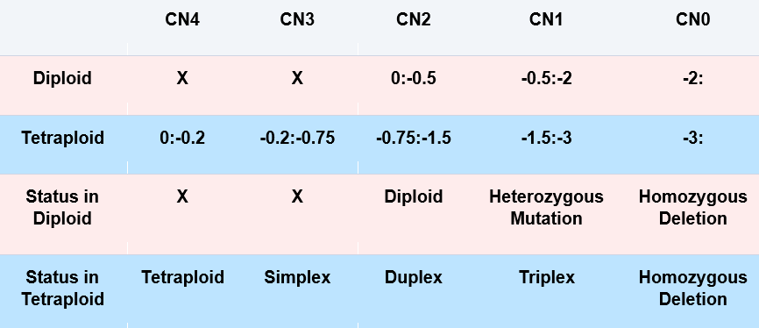

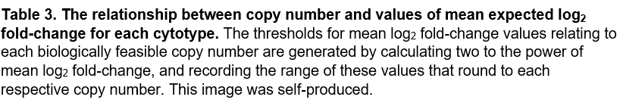

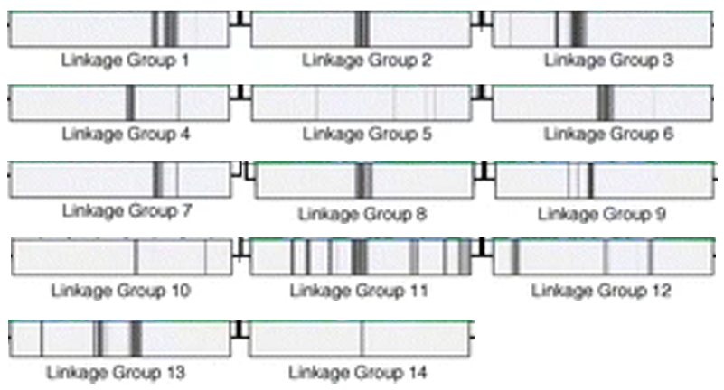For each chromosome, CNVs are extracted into ploidy-specific lists of candidate genomic regions for structural adaptation, from which our custom R-script8 produces frequency histograms and dot-plots visualising variant locations (Appendix 11). Histogram CNV count is normalized against the number of sampled chromosomes (14, 24 and 16 for diploids, neotetraploids and colchiploids respectively). Elevated tetraploid CNV frequency relative to other cytotypes is assumed to distinguish ploidy-specific variation. In our second phase of analysis, only CNVs wider than 50-kilobases are retained for histogram and dot-plot visualisation (Appendix 12). Following observation of large neotetraploid-specific putatively centromeric CNVs, we precisely locate *M.guttatus* centromeres using Figure 5, adapted from the highly-influential Fishman paper published in 2010[39,51]. We next employ the depth option from SAMtools to evaluate coverage at every nucleotide position for all chromosomes in each diploid and tetraploid individual. Mean normalized coverage is then plotted across 10,000-kilobase windows for both cytotypes using a custom R-script9, with tetraploid-specific decreases in coverage characterised as aneuploidy (Appendix 13).

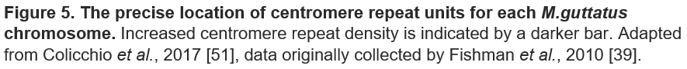

**Code:**

All scripts are found inside my GitHub repository - [https://github.com/stymwg/Dissertation](https://github.com/stymwg/DissertationCode).

1. R-script that generates PCA and NJ tree

2. R-script that extracts upper 99th percentile outliers

3. R-script that determines Spearman’s Rank Correlation Coefficient

4. R-script that plots linkage disequilibrium

5. R-script that generates absolute AFD plots

6. R-script that calculate the significance of overlap between orthologous loci

7. R script that produces cn.mops-generated lists of candidate CNVs

8. R-script that generates frequency histograms and dot-plots for identified CNVs

9. R-script that plots mean normalized coverage for diploid and tetraploid populations.

**Results and Discussion:**

To gain an initial perspective on sample demography, we conducted principal-component analysis that displayed overall grouping of our three *M.guttatus* populations into their respective cytotypes. PCAs, represented in Figures 6a-d, were produced using 247,871 putatively neutral fourfold-degenerate SNPs. Silent-substitutions have little functional impact (ignoring codon-bias) and thus do not shape adaptation - their relative variation reflects the extent of divergence between populations, allowing underlying phylogenetic relationships to be uncovered. Each individual possesses minimum 9x coverage, therefore all samples are suitable for inclusion in our analysis.

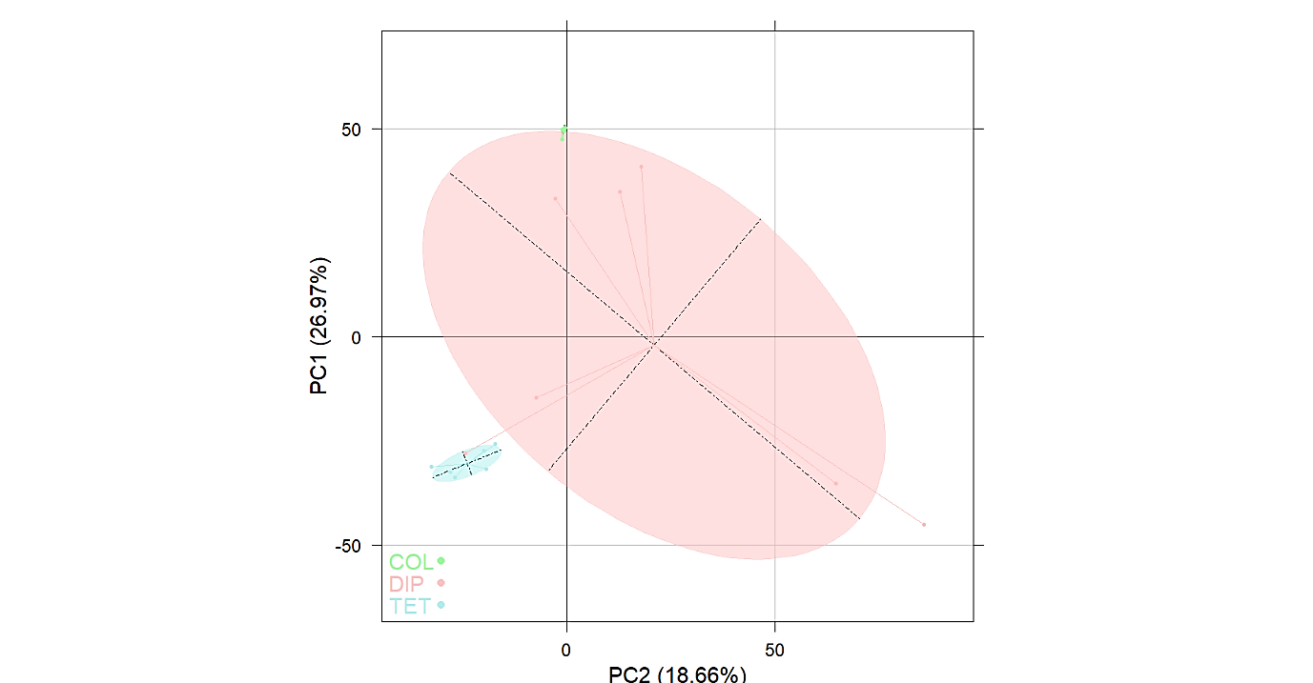

**B**

**A**

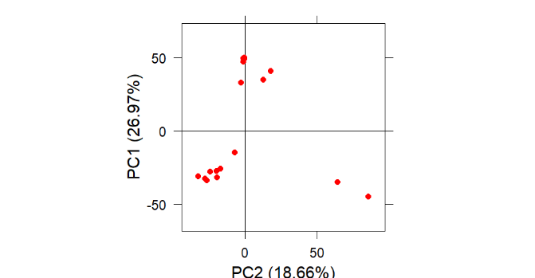

PC2 (18.66%)

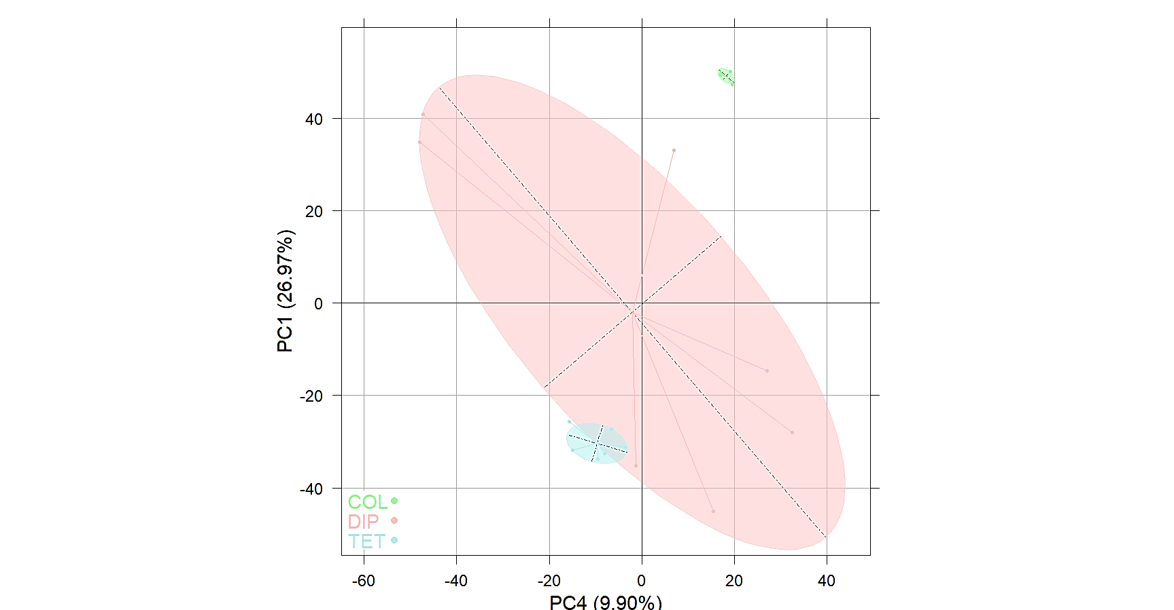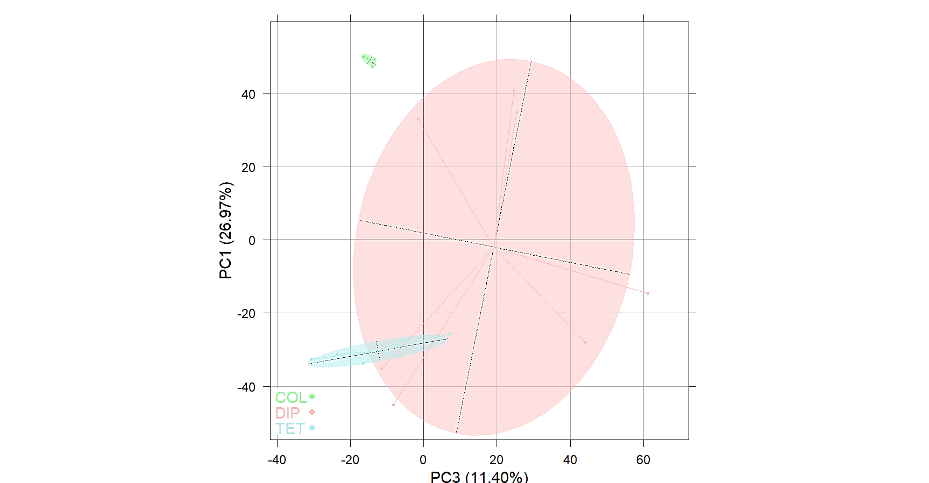

**D**

**C**

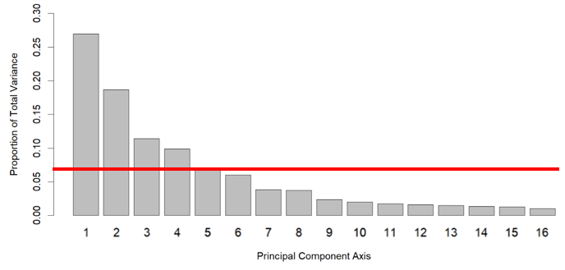

**E**

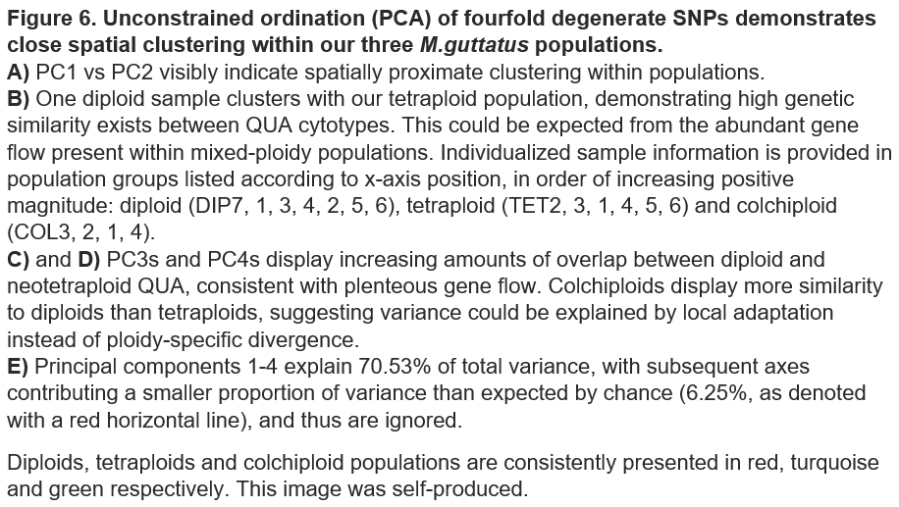

Principal-components 1 and 2, which together explain 45.6% of total-variance, split strains into three separate groups clustered dependent on population. Subsequent components display increasing overlap between diploid and tetraploids, consistent with the high genetic similarity expected in this mixed-ploidy QUA population from plentiful gene flow, together with recent genetic bottleneck in *M.guttatus*[52].

Indeed, Figure 6a displays one diploid sample clustering more closely with neotetraploids than its own cytotype, demonstrating the strong extent of genetic similarity within QUA. We highlight the potential of this DIP7 individual as an immediate predecessor of polyploidization, as this sample also shows closest similarity to neotetraploids in subsequent phylogenetic and CNV analysis. Nevertheless, broadly distinct spatial clustering between each population suggests polyploidization is accompanied with multiple independent adaptation events that cause cytotypic segregation in PCA. However, the strong disconnect between neotetraploid and colchiploid samples demonstrates any WGD adaptation is population-specific, and variance may instead reflect local adaptation from each *M.guttatus* individual.

Similar patterns of cytotypic separation were observed through phylogenetic analysis of the same fourfold-degenerate subset. The neighbour-joining tree displayed in Figure 7 confirms close intrapopulation phylogenetic relationships with strong bootstrap-support across 1,000 replicates. Indeed, all phylogenetic bifurcations occur within a range of 0.1 Nei-distance, further demonstrating minimal genetic divergence between any individual. DIP1 and DIP7 samples possess strongest phylogenetic similarity to neotetraploids, demonstrating these individuals provide closest ancestry to the immediate diploid progenitors of polyploidization. The subsequent observation that DIP7 contains the most similar aneuploidy profile to tetraploids is therefore not unexpected.

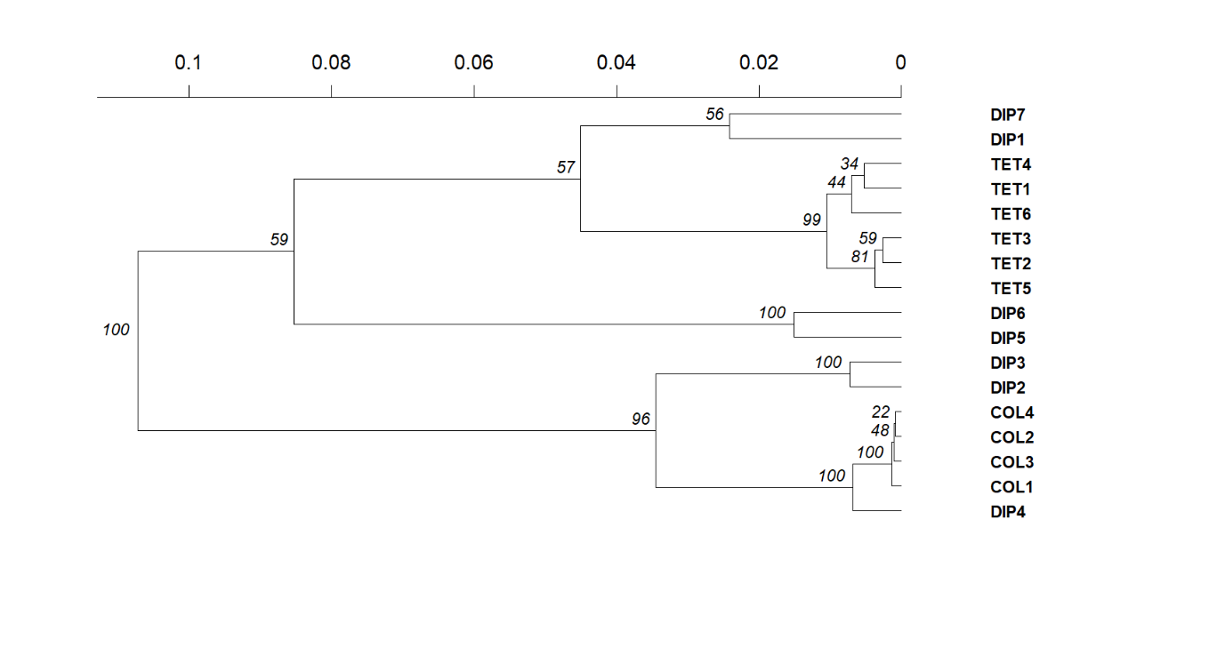

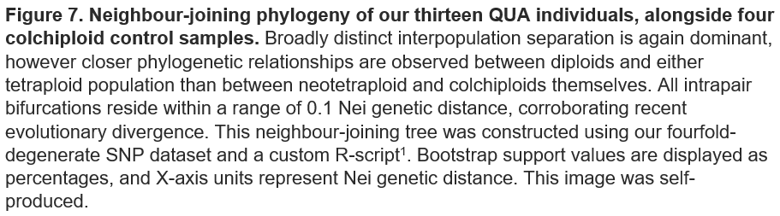

Figure 8 combines our two previous methods of analysis to identify prevalent gene flow between diploid QUA and both tetraploid populations, except DIP5 and DIP6, which cluster away from either polyploid cytotype in every approach, including SplitsTree analysis shown in Figure 9. Three diploid samples display consistent spatial association with colchiploids, indicating these natural samples have strong genetic similarity to the individuals from which colchiploidy was induced. Colchiploids possess extreme spatial clustering in all forms of analysis, coherent with their first-generation status precluding effects from natural selection, and rational considering each synthetic polyploid was artificially induced from the same population of *M.guttatus*.

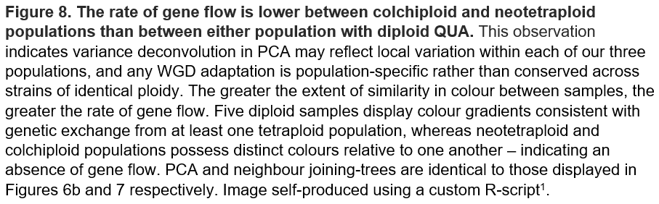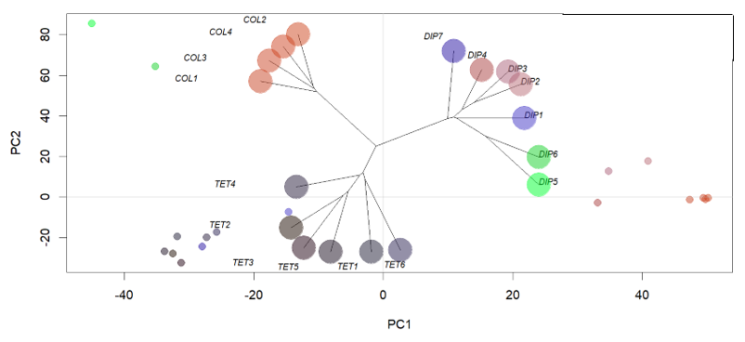

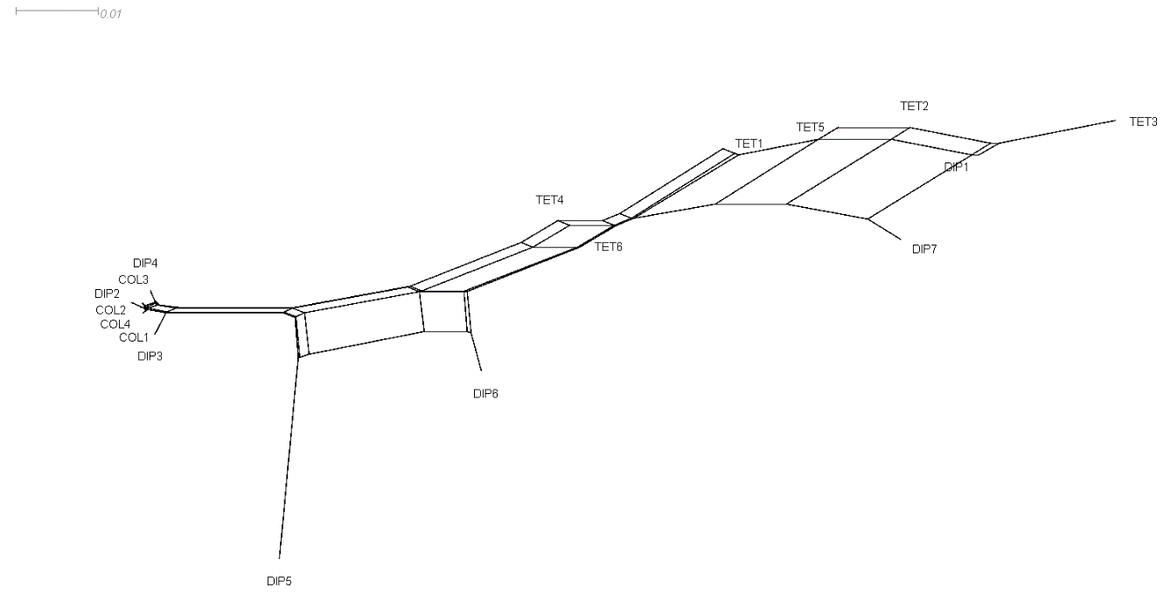

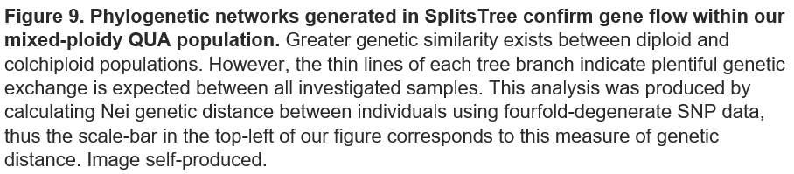

We then evaluated several genome-wide diversity and divergence metrics using ScanTools and the full 10,463,826 SNP dataset. Colchiploids are absent in this section of analysis due to their exclusion from the complete SNP repository. Before calculating parameters, ScanTools recruits GATK software to remove all polymorphisms with read-depths beneath 12 or filtered genotype fractions above 0.5 to ensure high-quality SNP calling[53]. We employ sliding windows of 10-kilobases to restrict influence from genetic drift, a minimum number of 10 SNPs per-window to prevent estimation bias, and down-sample populations to five individuals to conserve computational requirements. We here note some degree of uncertainty in calculation of within-population parameters due to issues associated with the ScanTools script. Therefore, whilst the relative magnitude of each parameter provides information suitable for intercytotypic comparison, precise metric values require recalculation once ScanTools is rewritten.

Low total genetic divergence within QUA is further supported by reduced pairwise FST and Rho between ploidies compared to equivalent values in *A.arenosa*, displayed in Table 4 [5]. Such strong interpopulation genetic similarity provides quantitative support of extensive gene flow within the mixed-ploidy QUA population, helping to explain extreme spatial clustering between DIP7 and neotetraploids. Minimal change in nucleotide-diversity across cytotypes also corroborates that polyploidization represents a very recent event, although may simply reflect low population sizes[19]. Observed genetic homogeneity in *M.guttatus* is likely explained by the partial selfing nature of this monkeyflower, whilst the population has also recently experienced genetic bottleneck[19]. However, *M.guttatus* surprisingly possesses greater genetic diversity than an *A.arenosa* comparator, although this may simply reflect issues with ScanTools[5]. As displayed in Figures 10a and 10b, tetraploid QUA exhibits decreases in both mean nucleotide diversity and Watterson’s theta relative to diploids. This provides some evidence of genetic bottleneck associated with polyploidisation, consistent with results identified by Simon-Porcar in 2017[19]. However, the neutral expectation predicts theoretical drift rate is halved in tetraploids; conversely, diploid-tetraploid ratios exceed 0.5 for these parameters, suggesting polyploidy is accompanied with increased genetic diversity as predicted in previous literature, potentially constituting changes mediating post-WGD innovation[8,23]. This conclusion is further supported by estimates of mean Tajima’s D shown in Figure 10c, which demonstrate tetraploids possess less negative values for this metric than diploid comparators, and therefore contain greater genetic richness.

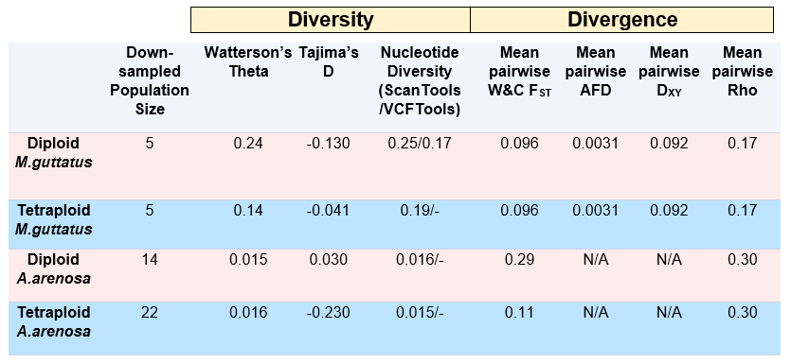

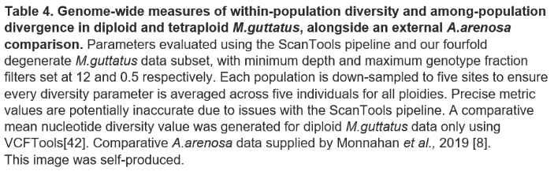

[5].

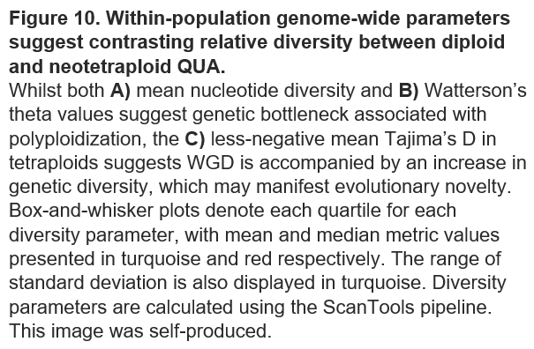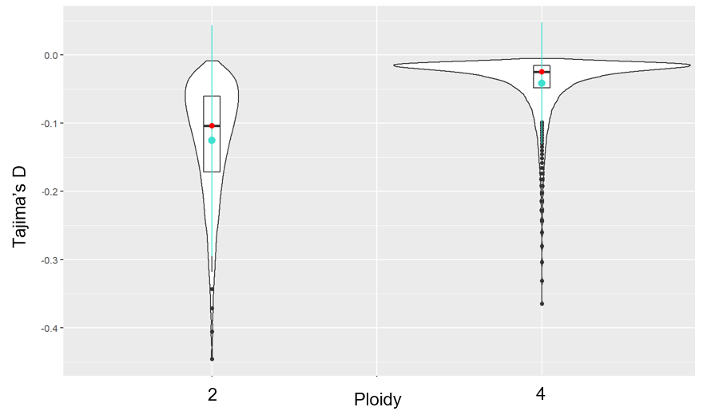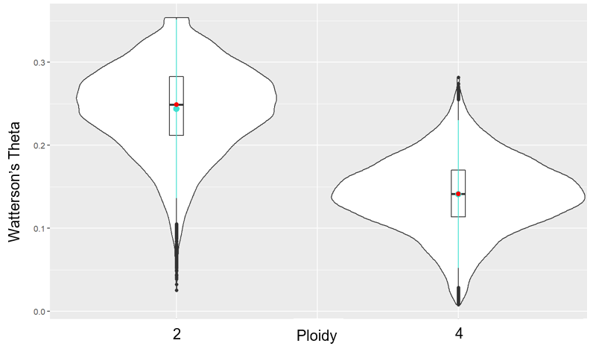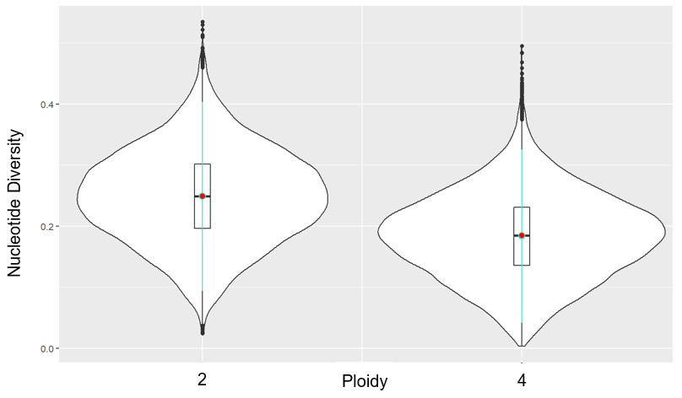

**C**

**B**

**A**

To conduct selection-scans, we employ window-based SNP comparisons between diploid and tetraploid populations using the full biallelic-SNP dataset. Identifying footprints of differentiation using window-based approaches works most effectively with strong phenotypic-contrast, as exhibited here. Moreover, the characterised recency of polyploidisation suggests signal from WGD-adaptation is less likely to be obfuscated by noise from additional functional differences arising through evolution. However, each population is down-sampled to five individuals for ScanTools, therefore each pairwise-comparison will include substantial noise - a significant limitation of this project. Nevertheless, this shortcoming can largely be mitigated by comparing identified outlier windows across multiple metrics. Colchiploids are again absent from this section of analysis due to their exclusion from the complete SNP dataset.

Combining ScanTools software with our custom R-script, we identified the upper 99th-percentile of fixed 5,000-base windows containing at least 25-SNPs from each pairwise PGM distribution. This generated inclusive lists of gene-coding loci displaying significant ploidy-specific differentiation. We used 25-SNP windows to exclude potential PGM-estimation bias caused by low-information windows. Window length was fixed to homogenise gene positions across all population-pairs, enabling interpopulation comparison between candidate outliers. 5,000-base window-sizes were selected to isolate only one gene per window - we estimate the average gene-size in *Mimulus guttatus* as 2,738-bases using the annotation file provided in Appendix 2b. These windows fail to completely account for linkage-disequilibrium, which decays by an average of 34% at this distance, as shown in Figure 11a. However, Figure 11b demonstrates consistently strong linkage across entire chromosomes, thus the benefits of isolating one gene per-window outweighed those of increasing window size to reduce LD. We again implemented minimum depth and maximum genotype-fraction thresholds of 12 and 0.5 respectively in ScanTools to exclusively retain high-confidence variant sites.

Whilst LD decay-rates are slow, Figure 11a displays a noticeable correlation between decreased adjacent SNP-linkage and increased physical distance (within 5,000-kilobases); window-based approaches therefore represent an appropriate technique for identifying genomic variation in *M.guttatus*. No current software exists to accurately evaluate linkage disequilibrium in tetraploids, therefore we evaluate QUA LD in diploids using VCFTools[42]. In 10/14 chromosomes, we only compare sites within 50,000-bases of one another to reduce computational requirements. Exhaustive analysis of chromosomes 1-4 in Figure 11b demonstrates LD is unlikely to rapidly decline beyond our 5-kilobase threshold, but may gently decay to 25% of initial linkage across megabase distances. Even across 50-kilobases, R-squared values approximate 0.5 – such intense linkage further confirms recent genetic bottleneck in *M.guttatus*, and corroborates existence of extensive gene flow within the QUA population, consistent with our demographic analysis.

Well-evidenced decreases in autopolyploid linkage compared to diploid ancestors denote an expected increase in correlation strength between LD decay-rate and genetic distance in tetraploid QUA; advantageous genes are therefore less likely to be obscured amongst noise from strong adjacent linkage than suggested by diploid data[9,54]. One caveat to this interpretation is that LD in young polyploids is typically high, as insufficient time has passed for recombination to separate neighbouring beneficial alleles[55]. Interestingly, whilst reduced polyploid linkage provides immediate selective assistance, as advantageous alleles possess greater opportunity to recombine onto haplotypes with fewer harmful mutations, disconnecting adjacent beneficial alleles is evolutionarily unfavourable in the long-term[9].

**A**

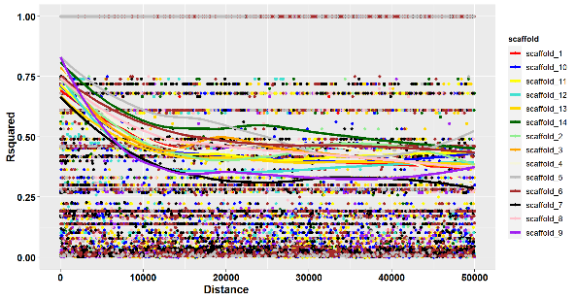

**Distance (base-pairs)**

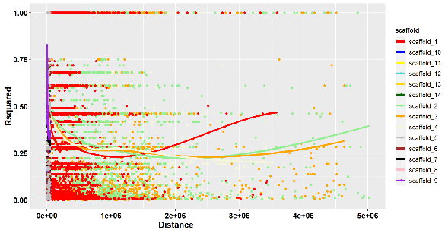

**Distance (base-pairs)**

**B**

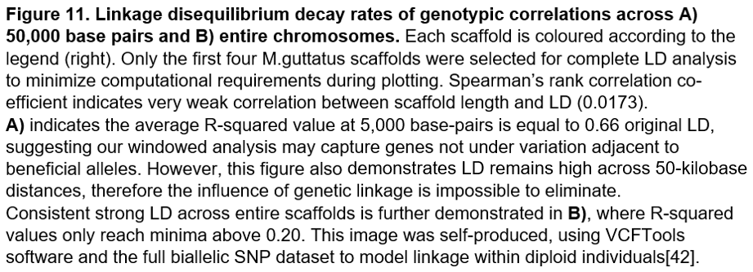

Figures 12a-d confirm weak correlation between PGMs and SNP-frequency per-window (Spearman’s rank correlation-coefficient ranges from 0.0178 (AFD) to 0.187 (DXY) across our four metrics). The relationship between absolute-AFD and SNP frequency per-window is at least three-fold weaker than all other metrics, indicating this system of measurement contains lowest frequency bias. This observation suggests our approach is most effective across lower magnitudes of variation, as AFD fluctuates less dramatically than our other three metrics. Retrospective studies should stipulate a greater number of SNPs per-window, particularly when comparing more genetically divergent populations, to reduce probability of identifying ‘false-positives’ from metrics biased by SNP incidence.

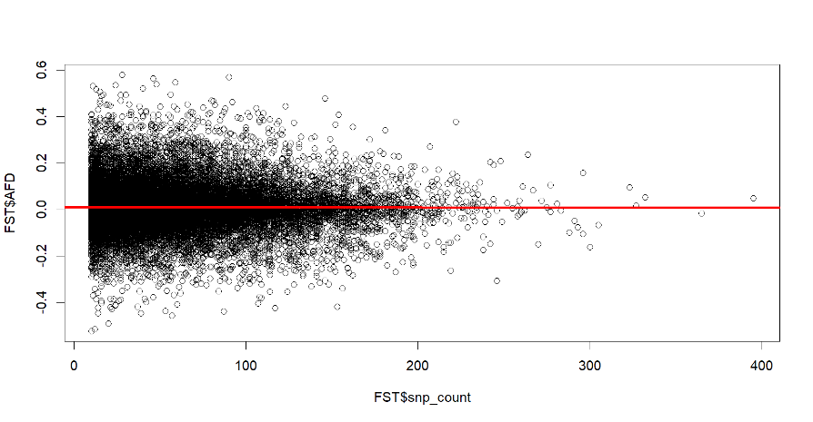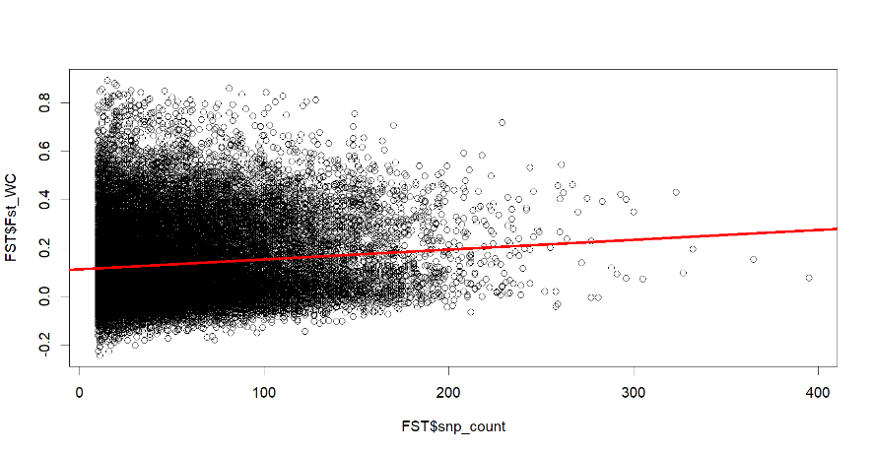

**B**

**A**

AFD

FST

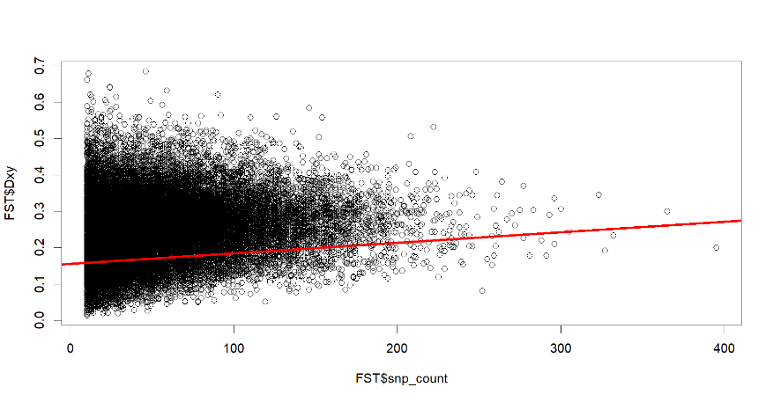

SNP Count

SNP Count

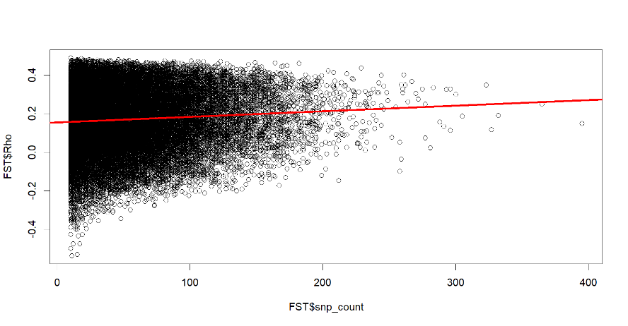

**D**

**C**

DXY

Rho

SNP Count

SNP Count

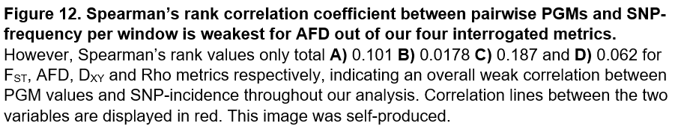

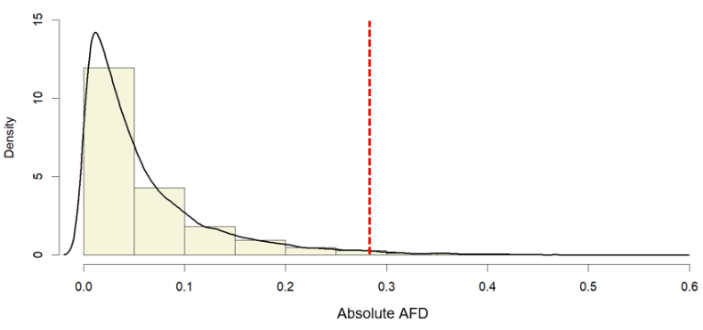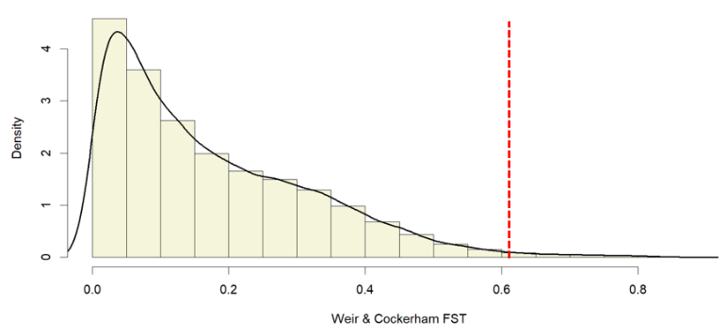Upper 99th-percentile candidate gene lists total 249 for each PGM. Identified candidates require cautious interpretation; lists assume directional-selection dictates loci with greatest differentiation, particularly uncertain considering projected strong linkage and high potential for genetic drift and local adaptation. However, PGM distributions shown in Figures 13a-d demonstrate most alleles are not under significant variation between cytotypes, indicating historical genetic drift is unlikely to prevent selectively advantageous genes from appearing in candidate lists.

**B**

**A**

Weir & Cockerham FST

Density

Absolute AFD

Density

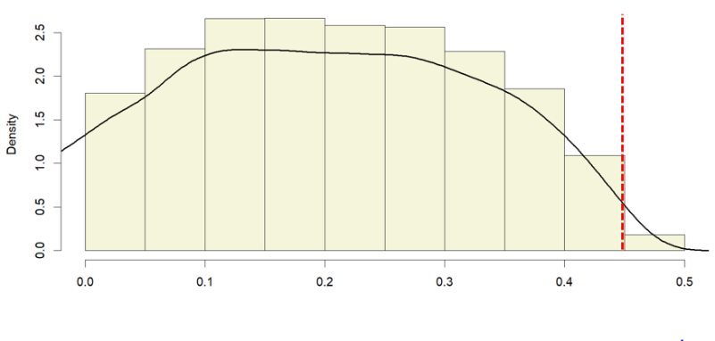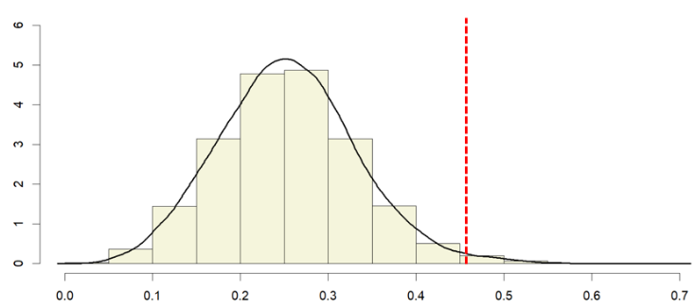

**C**

**D**

Density

Density

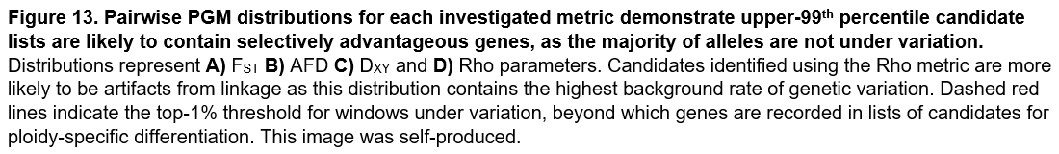

Rho

DXY

The locations of upper 99th-percentile outliers from each investigated metric are shown in Figures 14a-d, with all candidates from every parameter displayed in 14g. Chromosome 10 constitutes a disproportionate fraction of outliers from both FST and Rho metrics. The majority of these proposed candidates likely represent linkage from a smaller number of beneficial alleles, as advantageous variants are yet to be separated by recombination due to the recency of WGD. We therefore also provide FST and Rho distributions excluding scaffold-10 in Figures 14e-f, as chromosome 10-exclusive outliers will form the basis of our analysis for these two metrics. We here note each scaffold corresponds to its eponymous chromosome – i.e., scaffold 1 = chromosome 1

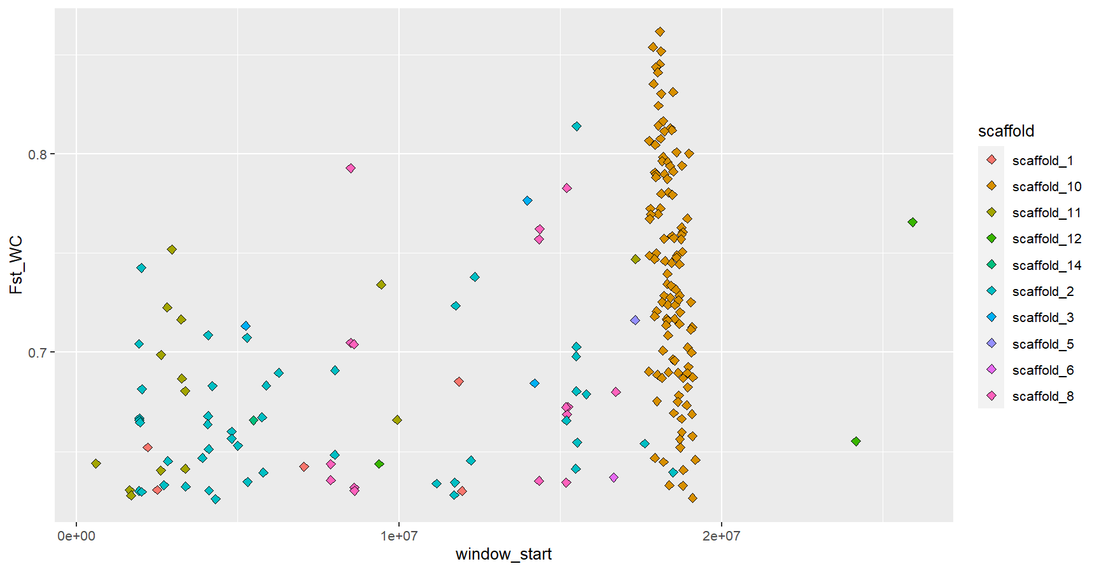

**A**

FST

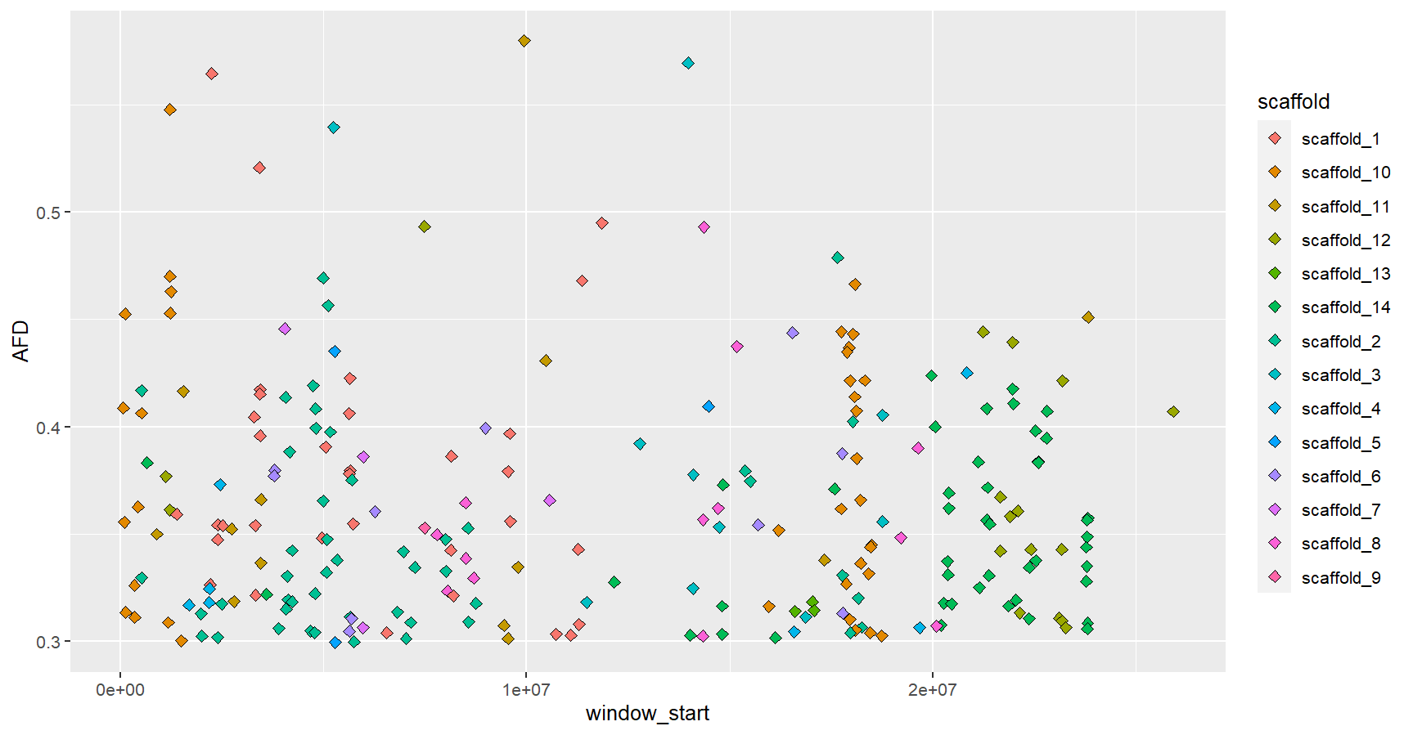

**B**

Start of Candidate Window

AFD

Start of Candidate Window

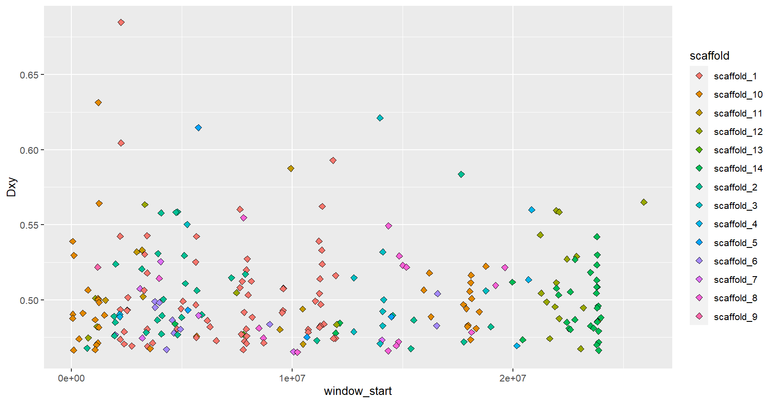

**C**

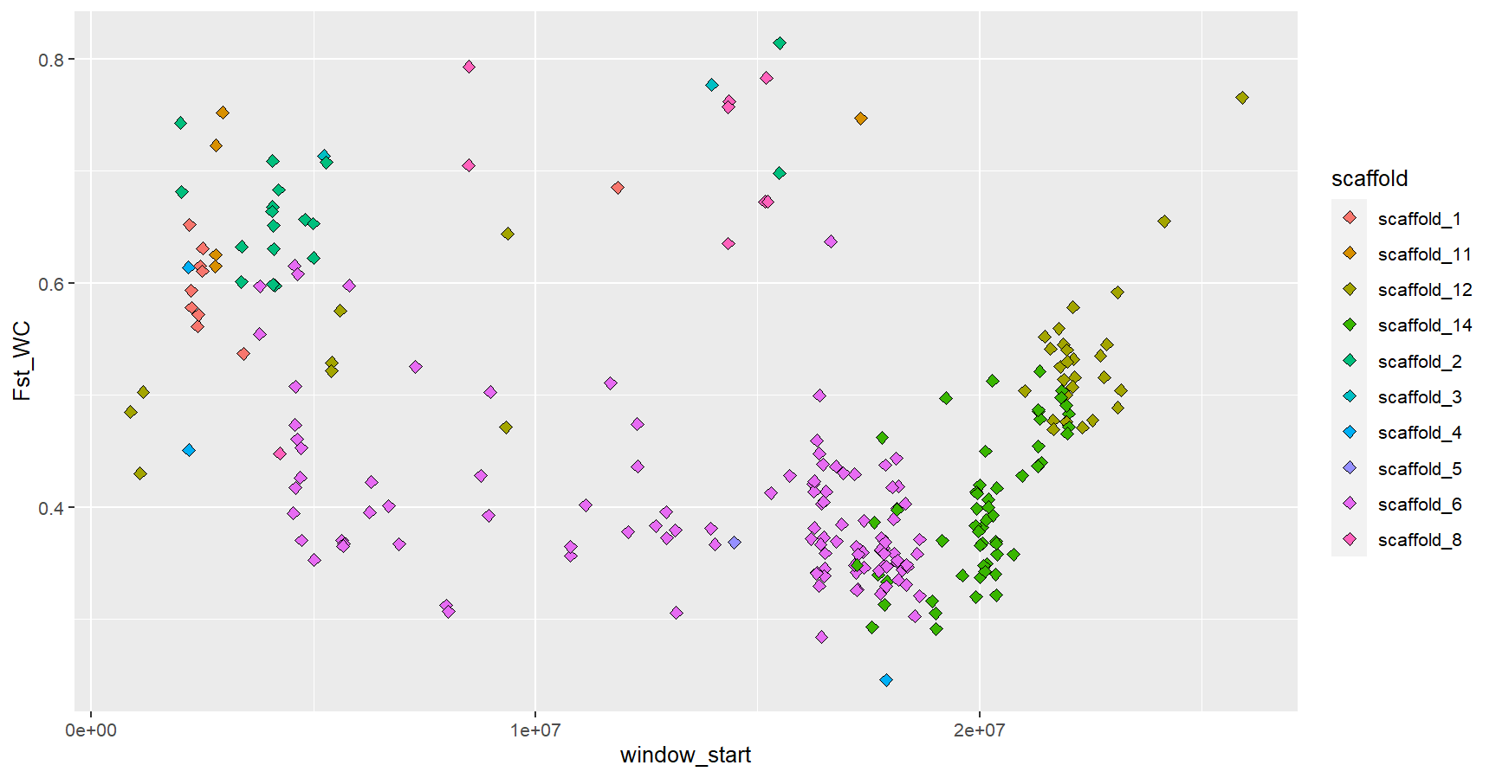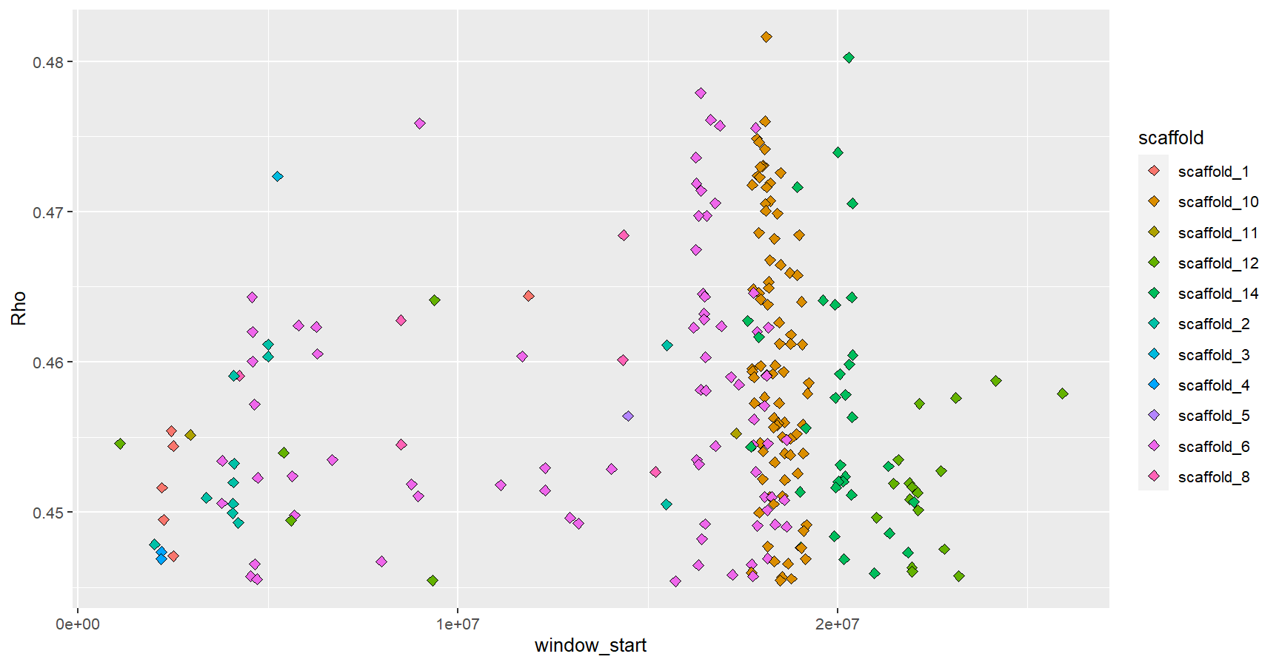

**E**

**D**

**Excluding Scaffold 10**

Start of Candidate Window

FST

Rho

Start of Candidate Window

Start of Candidate Window

DXY

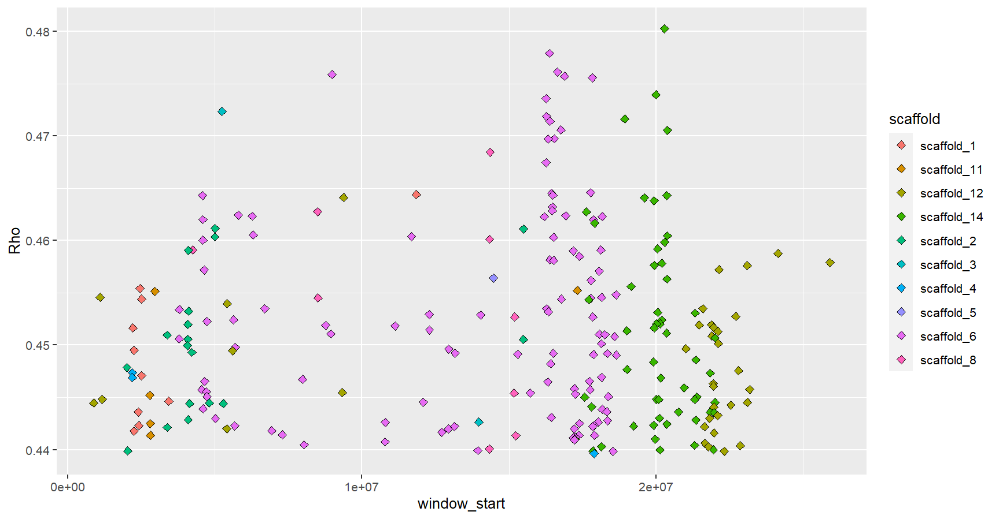

**Excluding Scaffold 10**

**F**

Rho

Start of Candidate Window

**Every outlier from all metrics**

**G**

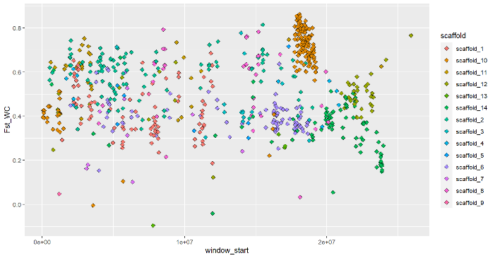

Start of Candidate Window

FST

All outliers

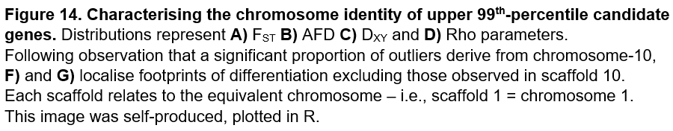

Figure 15 demonstrates several scaffolds contain outlier proportions inconsistent with their respective fractions of the genome - for example, chromosomes 6 and 14 possess more candidates than the neutral expectation, whilst chromosomes 9 and 13 contain a lower percentage of outliers. Adaptive-trait complexes are preserved by tight-linkage between co-adapted loci - correspondingly, chromosomes 6, 10 and 14, which contain excess candidates for ploidy-specific differentiation, present second, third and fourth highest LD respectively across 50-kilobase distance in Figure 11a. Scaffold 1, which also contains a greater proportion of outliers than expected, shows in Figure 11b to present strong LD across megabase genetic distances, further bestowing biological importance to this chromosome. Alleles under selection are also likely to exhibit closer linkage through intraspecies gene-flow, hence the presence of excess outliers suggests selective pressure within these chromosomes[56]. This indicates 5,000-base windows are insufficient to completely mitigate influence of genetic-hitchhiking within candidate-gene lists - linkage-disequilibrium decay-rates are slower in contigs facilitating polyploid adaptation than the neutral expectation, and retrospective studies should significantly increase window-size.

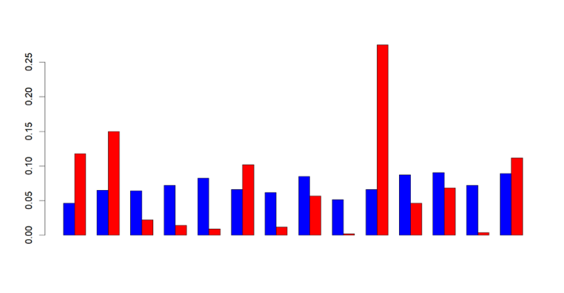

**Relative Fraction of Outliers**

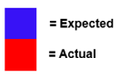

**Chr1**

**Chr2**

**Chr3**

**Chr4**

**Chr5**

**Chr6**

**Chr7**

**Chr8**

**Chr9**

**Chr10**

**Chr11**

**Chr12**

**Chr13**

**Chr14**

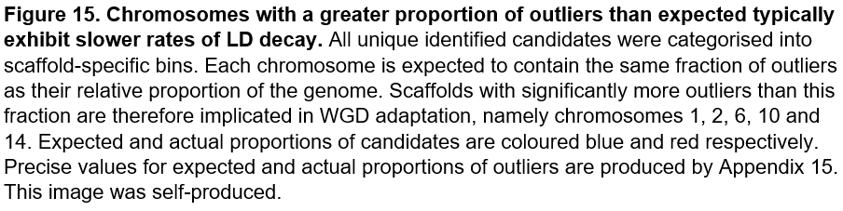

As strong linkage within chromosome-10 distorts the identity of our FST and Rho candidates, we first conduct GO analysis of the top-20 FST outliers from this scaffold (listed in Table 5), as shown in Figures 16a-b, and then remove this chromosome from subsequent analysis. Whilst it is impossible to definitively identify which candidates confer evolutionary advantages post-WGD, and which genes simply reflect linkage, these upper 20 outliers are most likely to be under selection. 6/20 uppermost FST and Rho outliers are identical, therefore we deem exclusive analysis of FST candidates sufficient to capture variation within chromosome-10. To obtain results from GO analysis, we lowered minimum fold-enrichment and outlier-number thresholds to 1.5 and 2 respectively, whilst a more permissive p-value threshold of 0.1 was implemented to allow identification of biological divergence. One minor limitation throughout our analysis is that by relating candidate genes in *M.guttatus* to TAIR IDs from *A.thaliana*, we fail to account for gene function divergence across species. However, disparities in gene character are likely uncommon as both plants possess comparable ancestry[57].

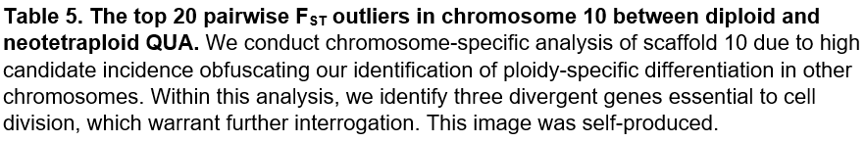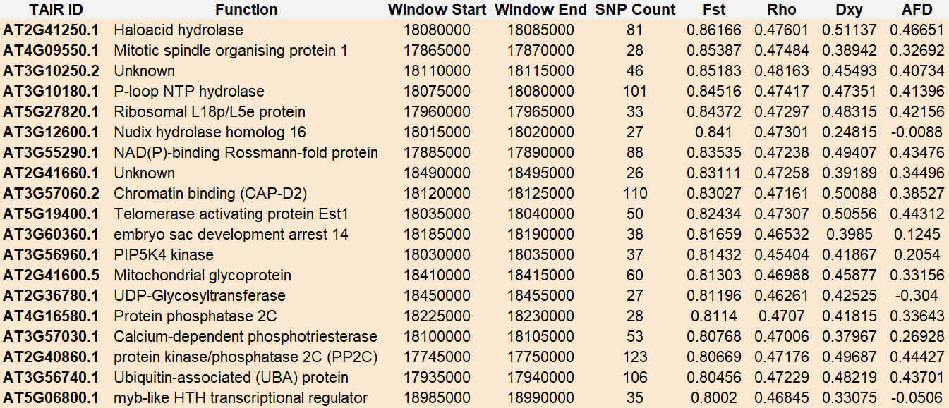

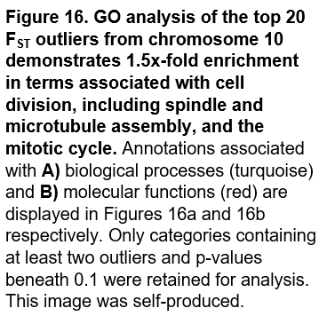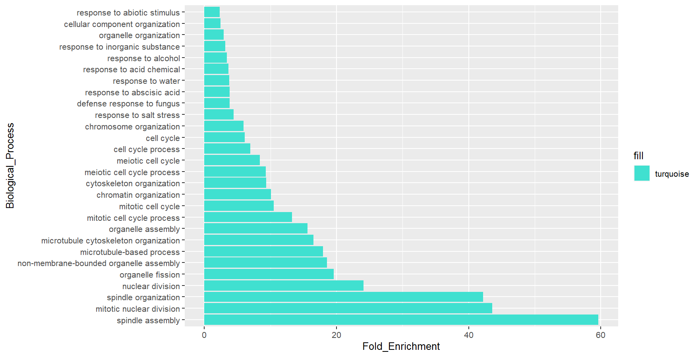

**B**

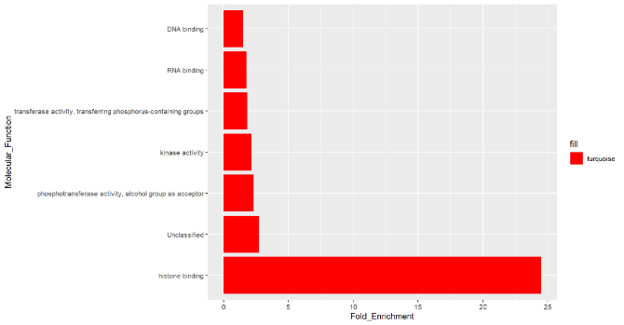

Fold Enrichment

**A**

Fold Enrichment

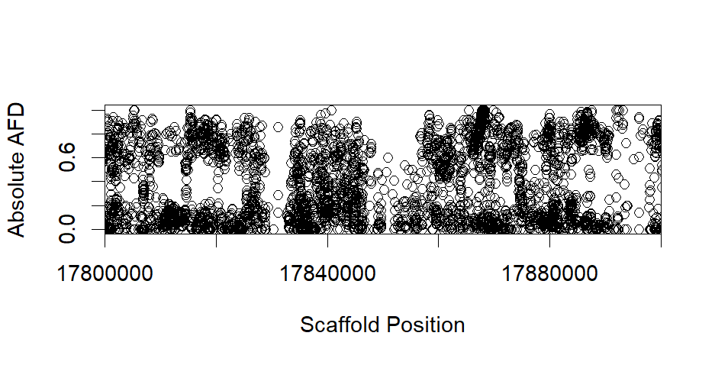From the 28 biological processes under variation, spindle assembly and organization contain most significant ploidy-specific divergence, followed by related nuclear-division and organelle assembly functions. Increased instability during chromosomal segregation represents one of the most salient immediate costs of WGD, thus it is unsurprising to identify variation in processes that can mitigate complications associated with genome doubling[58]. Neither meiotic nor mitotic cell division escapes disruption from polyploidization, which is reflected in the identity of our top three FST candidates - mitotic spindle-organising interacting protein-1 (AT4G09550.1), the condensin complex subunit-1 (AT3G57060.2) and telomerase-activating protein Est1 (AT5G19400.1) [58]. All three genes are implicated in spindle assembly, thus their variation illuminates the mechanism underlying tetraploid attempts to reduce WGD-elevated spindle attachment abnormalities that provoke chaotic chromosome segregation. Microtubule constituents of spindles also display ploidy-specific differentiation, thus immediate changes in polyploid processes capable of facilitating improved meiotic transmission are evident[59]. AFD plots for each of our selected three outliers are shown in Figures 17a-c, alongside an additional candidate implicated in microtubule organization (AT3G10180.1).All four outliers fail to show discrete, single-gene AFD peaks due to strong background chromosome-10 variation, potentially deriving from extensive linkage with our identified alleles.

**B**

**A**

Mitotic Spindle-Organising Interacting Protein 1 (AT4G09550.1). FST = 0.85.

Chromosome Position (Mb)

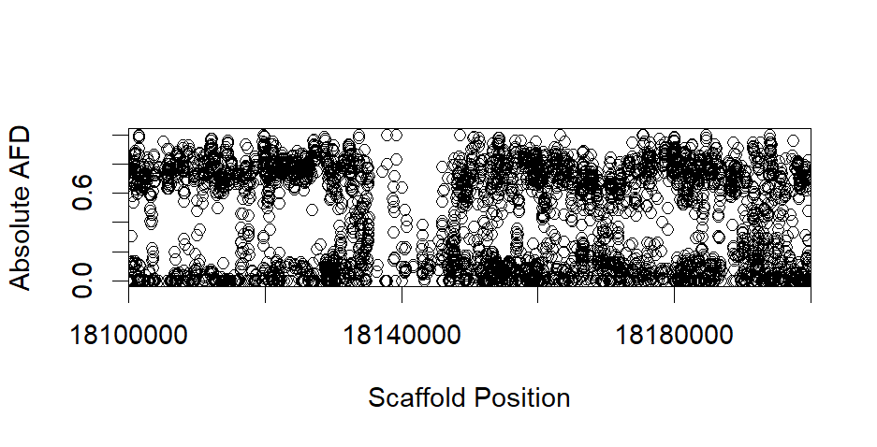

Chromosome Position (Mb)

Condensin complex subunit-1 (AT3G57060.2). FST = 0.83.

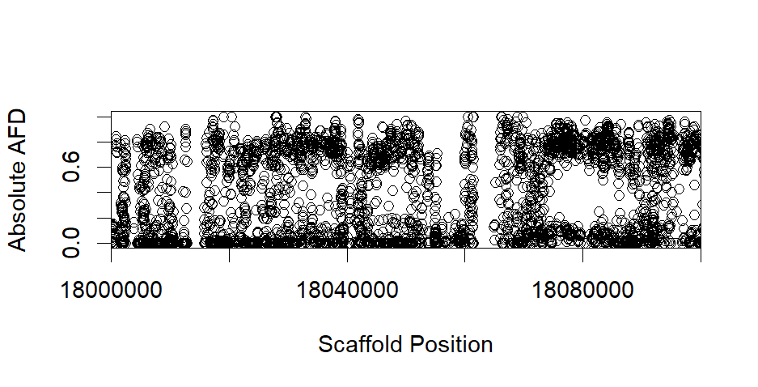

**C**

**1**

**2**

1. Telomerase-activating protein Est1 (AT5G19400.1). FST = 0.82. 2. P-loop containing NTP hydrolase (AT3G10180.1). FST = 0.85.

Chromosome Position (Mb)

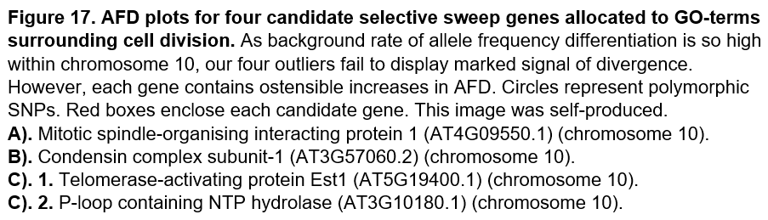

As displayed in Figure 16b, histone binding represents the most significantly altered molecular function in chromosome-10 of tetraploid QUA. This category contains two previously-described spindle-related candidates (AT4G09550.1 and AT3G57060.2), consistent with the role of nucleosomes in mediating chromosomal regulation of spindle assembly and post-mitotic nuclear envelope formation - well-evidenced methods of adaptation post-WGD[59]. STRING network analysis of our 20 outliers, shown in Figure 18, also identifies three proteins involved in a kinase-phosphatase pathway with essential function in stress tolerance, especially abscisic acid response[47,60]. In polyploid *A.thaliana*, modification of this network enhances stomatal closure relative to diploids[61]. This observation correlates with identified reductions in polyploid transpiration rates, together with increased drought and salt tolerance mediated by enhanced abscisic acid sensitivity[1,61]. Correspondingly, abscisic acid response represents an enriched process in GO analysis, therefore variation within this signalling pathway constitutes another potential mechanism of immediate adaptation to polyploidy.

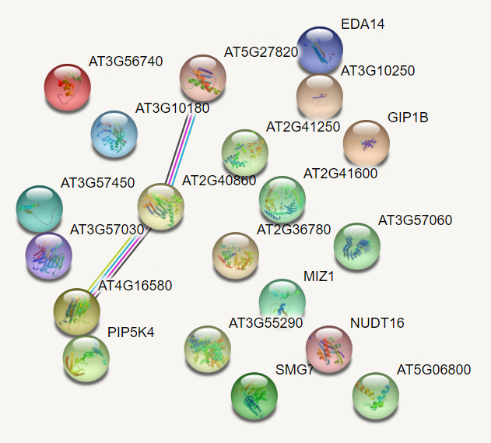

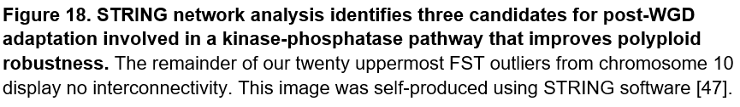

To test whether the strong, selective pressure of WGD imparted convergent directional selection at the ortholog level, we tested the number of overlaps between our candidate genes with those previously identified in *A.arenosa* and *C.amara* [29,30]. Only one orthologous locus was shared between our 20 FST outliers and the 452 candidates in *A.arenosa*, deemed statistically insignificant (p=0.33) using Fisher’s exact-test, whilst no overlaps were identified with the 229 genes from *C.amara* [48]. This conserved *arenosa* candidate is the aforementioned condensin complex subunit, supporting that variation in chromosome assembly is essential to WGD adaptation. Given the predicted similarity in attendant genomic challenges post-polyploidization, an absence of ortholog convergence is somewhat unexpected. However, we identify more significant functional convergence with *arenosa* amongst biological processes under variation; 11/28 candidate GO terms from our study are equivalent to *arenosa* (although none conserved with *amara*). Mutual processes are listed in Table 6 and broadly surround cell division, including chromosome organisation and the cell-cycle. This develops the theme that adapting reproductive processes such as meiosis is essential to ameliorating consequences from genome doubling.

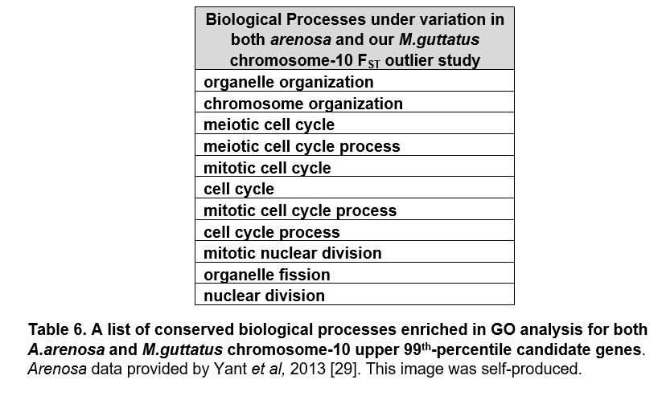

Figures 19a-b display GO analysis of enriched biological processes and molecular functions for upper-99th percentile FST outliers, with chromosome-10 removed due to extreme linkage. Candidates broadly reflect variation in metal-ion homeostasis and cellular metabolism, processes often associated with altered stress signalling post-polyploidization[29,30]. For example, multiple studies demonstrate ploidy-differentiated ion-homeostasis regulatory channels improve polyploid halotolerance[30,62]. Moreover, glycolytic metabolic changes associated with polyploidy allow increased cell size, consistent with our tetraploid QUA samples[63]. Stark molecular function divergence surrounds transporter activity, particularly iron-cation transport – previous studies have identified selective-sweep signatures at ion-homeostasis loci, consistent with adaptation to the significant transformation in ionic concentrations following WGD caused by altered incidence of particular transporter genes[29,30].

**A**

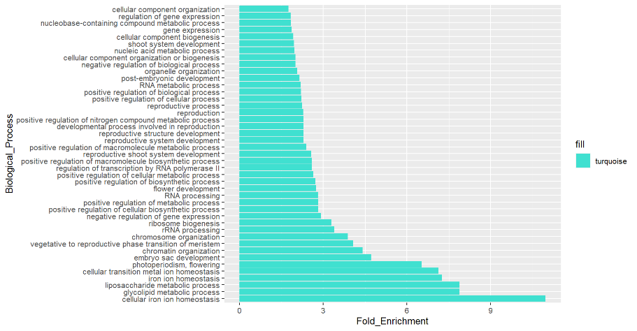

Fold Enrichment

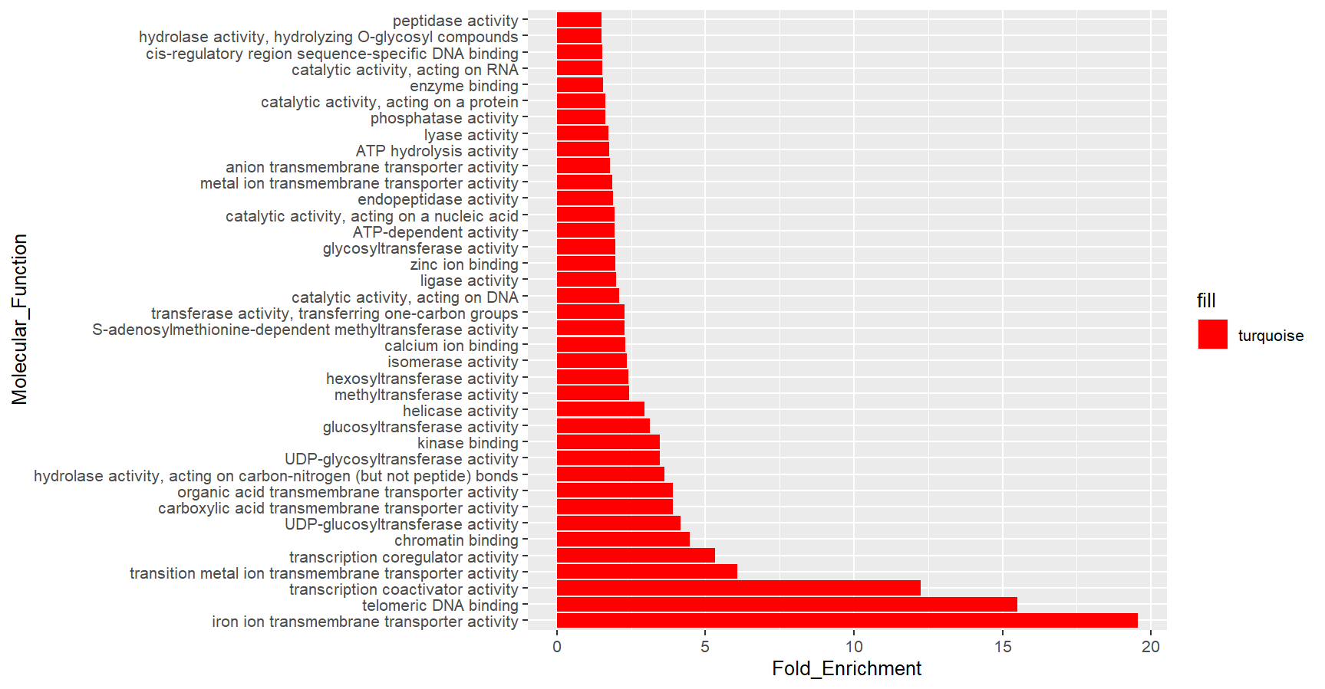

Fold Enrichment

**B**

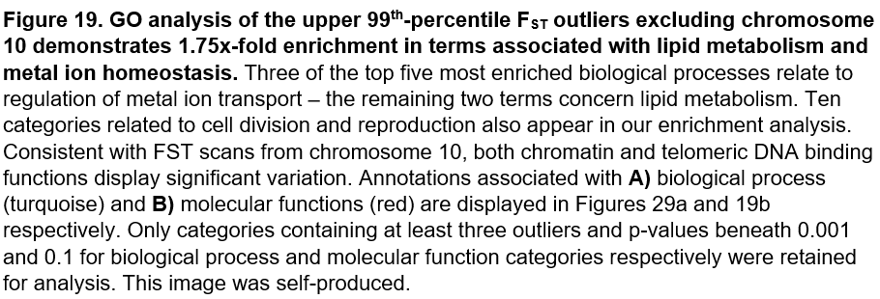

Reproduction-related processes present the most reliable fold-enrichment of any observed GO term, with a p-value for variation of 5.93x10-7. This category includes candidates related to cytoskeletal and spindle organisation, alongside histone modification proteins, further implicating these processes in adaptation following tetraploidization. Molecular function categories also display 15x and 4x fold-enrichment in telomeric and chromatin binding terms respectively, consistent with GO analysis and functional convergence observations from our chromosome-10 outliers. Several transferase-related functions also exhibit significant variation, likely mediating changes in nucleosome structure in lieu of the transformed genomic landscape post-WGD[64].

The largest outlier from each of these three identified enriched networks - metal ion-homeostasis, glycolipid metabolism and reproduction – constitute a chloroplast solute-carrier protein (AT5G26820), transcription-factor MYB36 (AT5G57620) and glutamyl-tRNA amidotransferase subunit-A (AT3G19540) respectively. This solute carrier facilitates metal-ion tolerance through regulation of iron-cation homeostasis, another enriched biological process[65]. MYB36 promotes strengthening of the Casparian strip, important for halotolerance and drought resistance, whilst the latter amidotransferase mediates chromosomal segregation during meiosis, consistent with the biological consequences of polyploidy[66,67]. As shown in Figure 20, AFD plots for each of these three outliers display higher ploidy-divergence relative to natural background variation. However, significant noise prevents clear identification of single-gene AFD peaks, likely because recombination is yet to separate neighbouring neutral alleles linked to those under recent selective advantage.

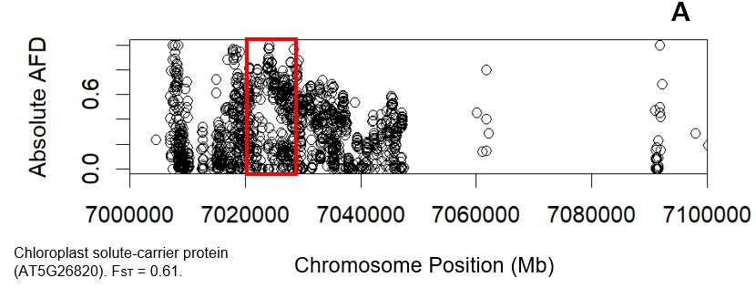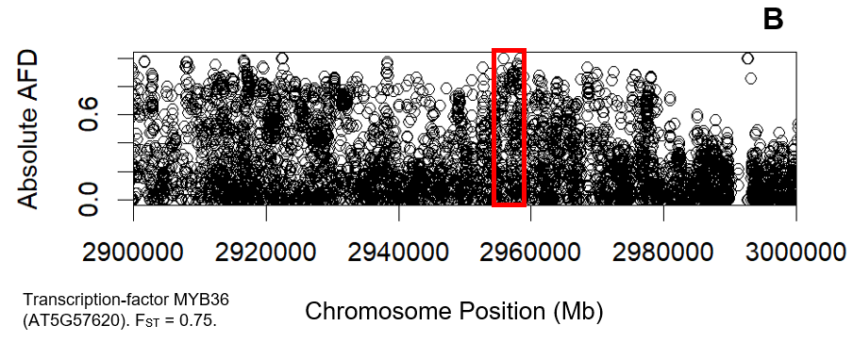

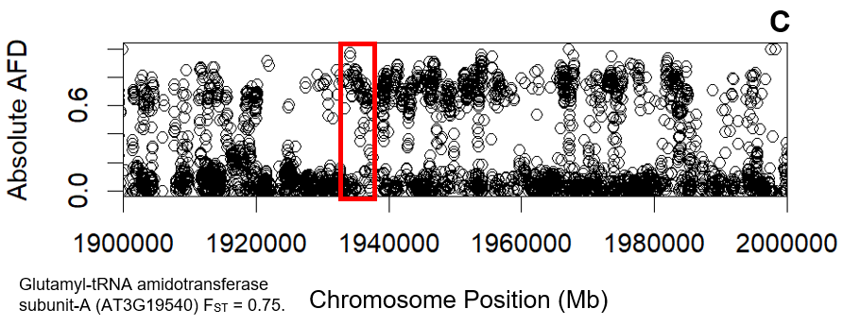

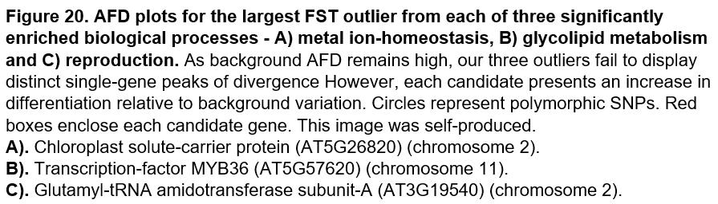

Each ScanTools metric evaluates between-population divergence using alternative mathematical equations, which provide different strengths and limitations. For example, FST is unbiased by sample size, yet values cannot be compared across studies as variable heterozygosity will always exist within polyploid individuals[68]. We therefore employ several metrics to identify ploidy-specific differentiation, including AFD, which possesses weakest correlation with SNP-frequency of all investigated parameters, and as displayed in Figure 14b provides notably unique distributions for outlier locations. Figures 21a-b display GO analysis of enriched terms from identified AFD candidates – variation in floral organ morphogenesis is consistent with observed phenotypic differences between diploid and tetraploid QUA, whilst altered protein dephosphorylation may represent modify stress-signalling post-WGD[69]. The transcription-factor MYB33 (AT5G06100) represents the most divergent outlier in floral organ morphogenesis. This protein is closely associated with the MYB36 candidate identified in our FST scan, thus increased Casparian strip strength is heavily implicated in immediate polyploidy tolerance[70].

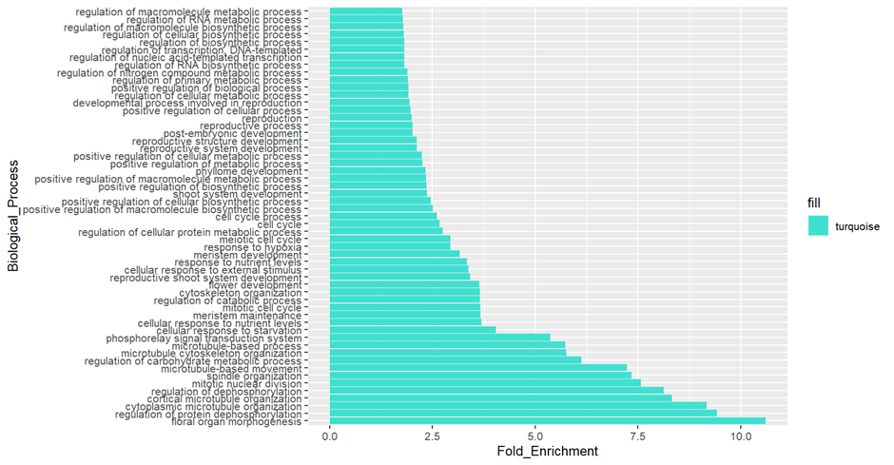

**A**

Fold Enrichment

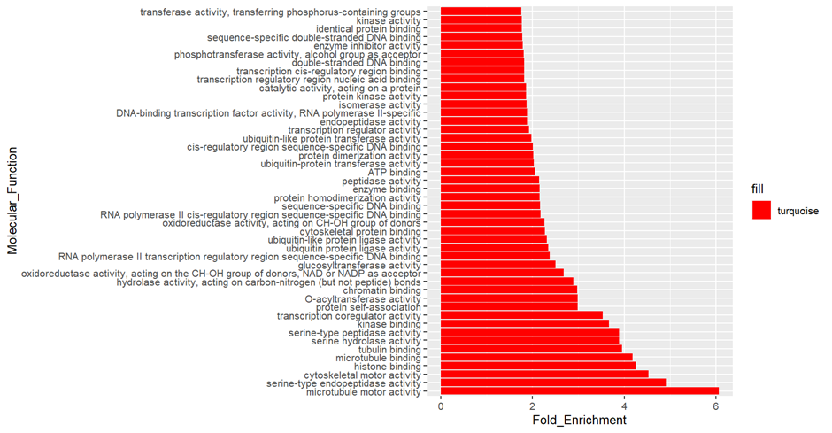

**B**

Fold Enrichment

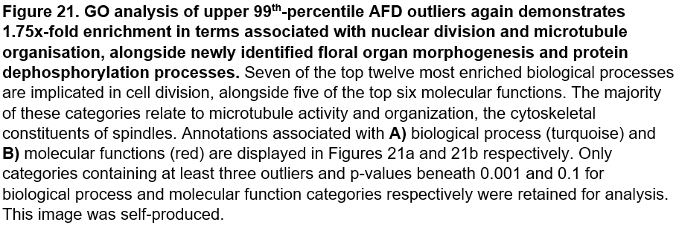

We again observe significant ploidy-differentiation within microtubule organisation, spindle development and nuclear division categories – consistent with previous evidence indicating meiosis and chromosomal segregation are under strong selective pressure post-WGD[29]. Related microtubule and cytoskeletal-binding molecular functions also display significant fold-variation, and possess smallest observed p-values, alongside the associated process of reproduction. A subtilisin-like protease (AT5G67360) and a gamma-tubulin complex component (AT5G17410) represent the two largest outliers from reproduction-related categories. The gamma-tubulin complex plays an essential role in meiotic microtubule nucleation and maintaining centromere architecture, the latter of which is noteworthy in context of our subsequent CNV analysis, which implicates centromeric regions in post-WGD adaptation[71].

Absolute AFD plots for all three aforementioned outliers are shown in Figure 22, once again failing to display discrete single-gene peaks amidst a backdrop of high general variation. We also generate plots for the twenty largest AFD outliers, located in Appendix 15, however background variation is often too high to clearly identify distinct loci under potential selection. Figure 23 displays two candidate outliers, shikimate kinase (AT2G35500) and a SPIRAL1-like protein (AT1G26355), that exhibit elevated AFD signal against pervasive noise. Polyploids present improved resistance to glyphosate fertilisers, which target this shikimate amino-acid biosynthetic pathway; we speculate targeted genetic modification of this first kinase candidate could improve crop resistance to weed control[72]. The second outlier encodes microtubule-localized SPIRAL1 protein, which maintains growth anisotropy in expanding cells[73]. Ploidy-specific divergence at this locus suggests an alternative mechanism to post-WGD adaptation, rectifying aberrant cell expansion rather than division.

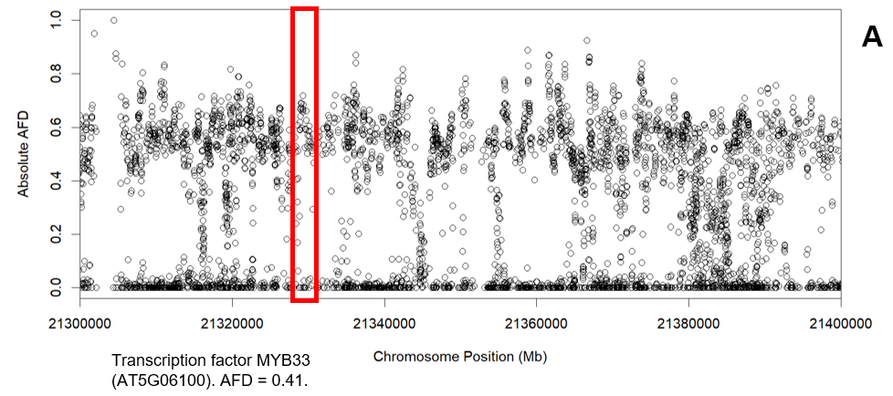

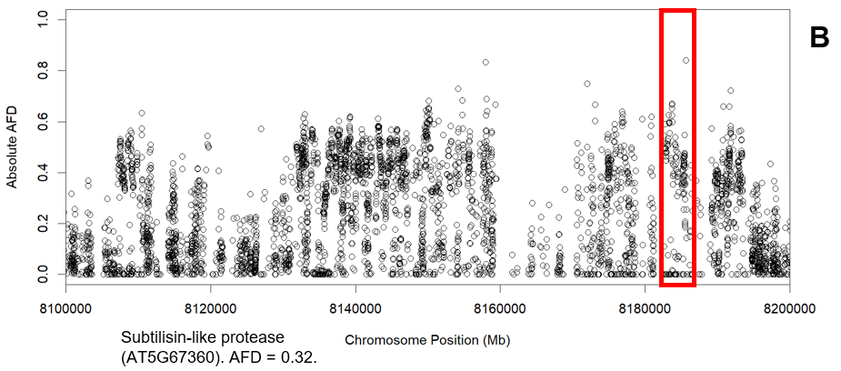

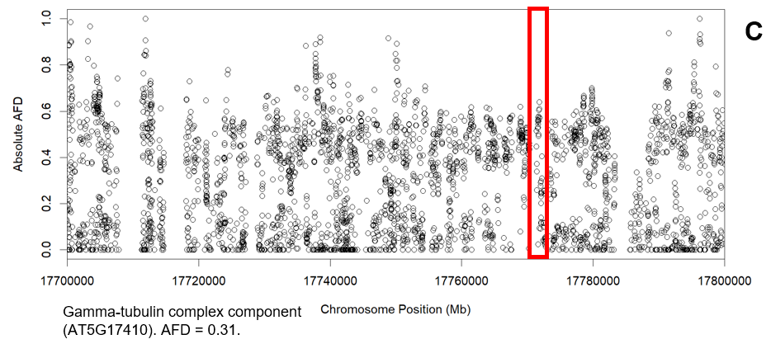

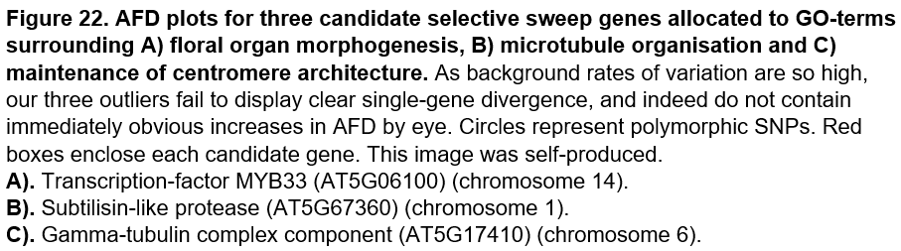



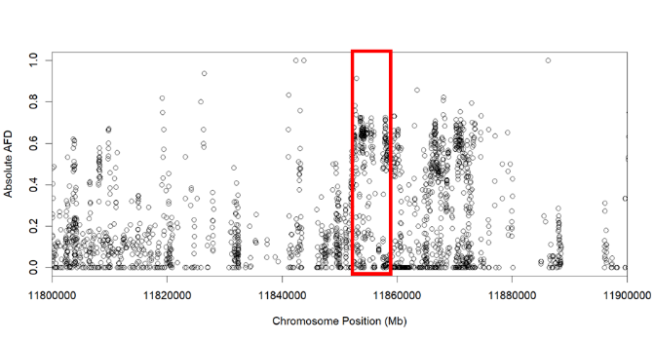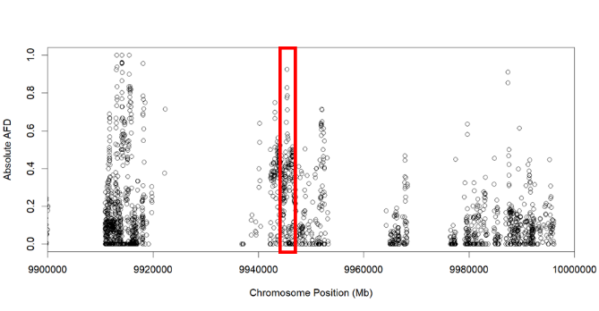

SPIRAL1-LIKE1 Protein (AT1G26355.1). AFD = 0.58.

Shikimate kinase-like 2. (AT2G35500.1). AFD = 0.50

**B**

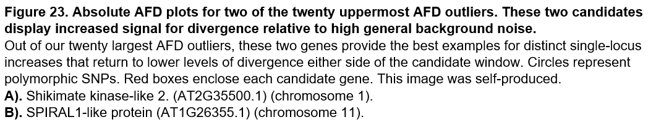

Correspondingly, GO analysis of DXY candidates indicates 7x and 4x-fold enrichment in chromatin assembly and organization respectively, consistent with observed molecular function variation in ubiquitin ligases, catalysts of histone modification[74]. Unlike other metrics, no nuclear-division genes appear in our analysis – DXY assumes substitution-rate is equal amongst all loci and populations, unlikely given highly variable outlier proportions deriving from each chromosome, therefore observations from this metric are assigned less weight than other parameters[75].

As shown in Figure 24, this GO analysis also demonstrates variation within genes mediating epigenetic modification, particularly DNA methylation, which is evidenced to alter gene expression that allows polyploid adaptation post-WGD[76]. Indeed, one study establishes differential autopolyploid methylation facilitates enhanced secondary metabolite accumulation essential to polyploid flexibility, consistent with observed AFD and DXY variation in metabolism[77]. This paper also indicates altered epigenetic modification increases the ability of polyploid plants to tolerate salt, another well-observed biological process under variation in this analysis[77].

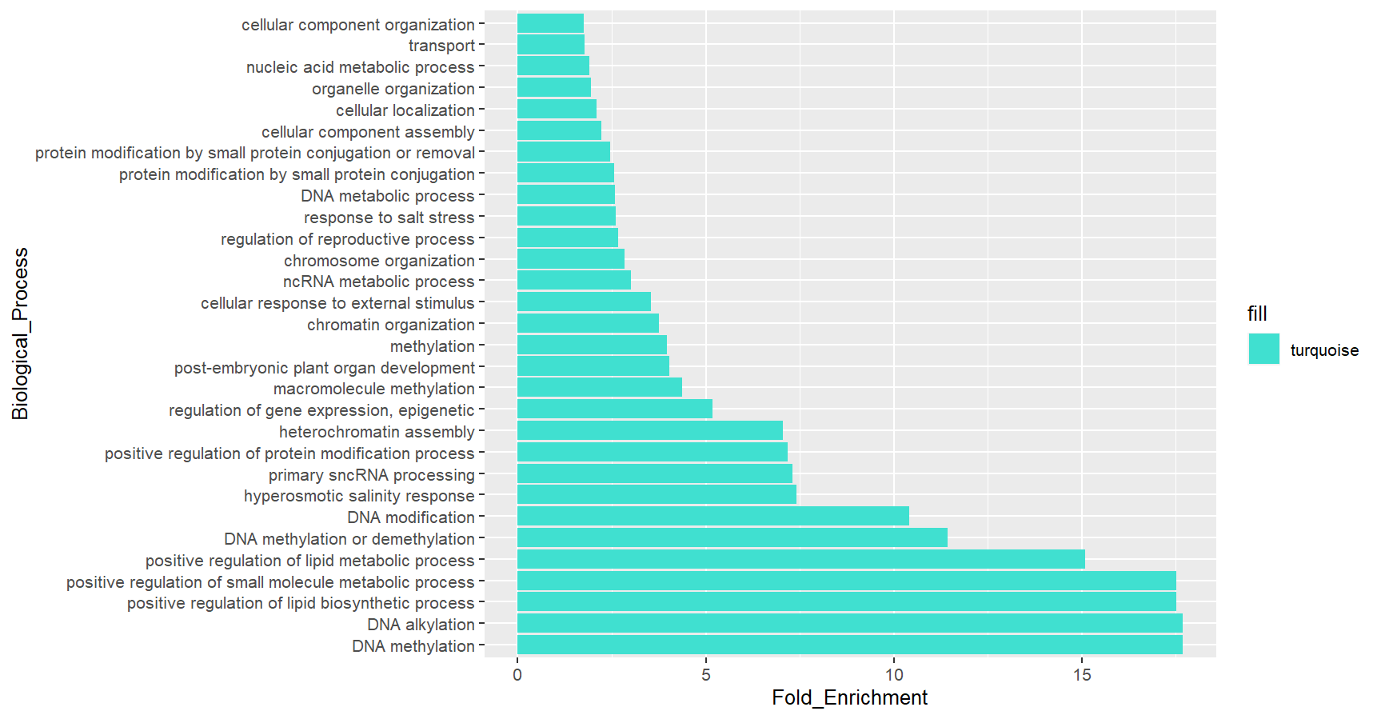

**A**

Fold Enrichment

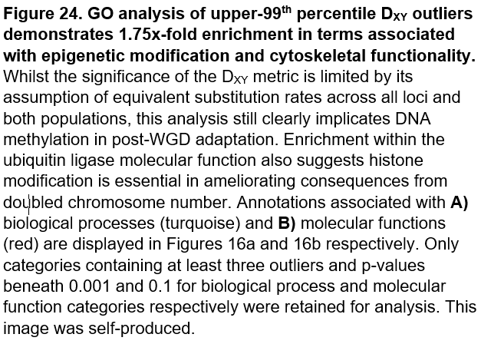

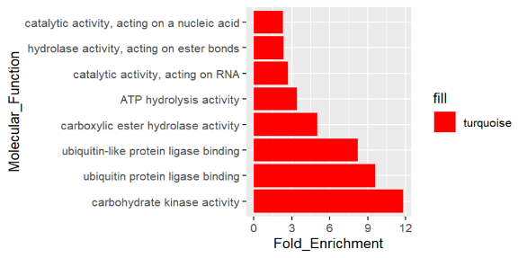

Fold Enrichment

**B**

24a and 24b respectively. Only

GO analysis of upper 99th-percentile Rho outliers displayed in Figure 25 distinguishes hormonal transport as the most significantly modified biological process, excluding photomorphogenesis. Coupled with observed variation in abscisic acid signalling and transporter activity, especially copper-ion localization, this finding suggests onset of novel polyploid stress response mechanisms post-WGD[61]. This observation also provides a potential explanation for increased growth in tetraploid QUA, through modified auxin transport[78].

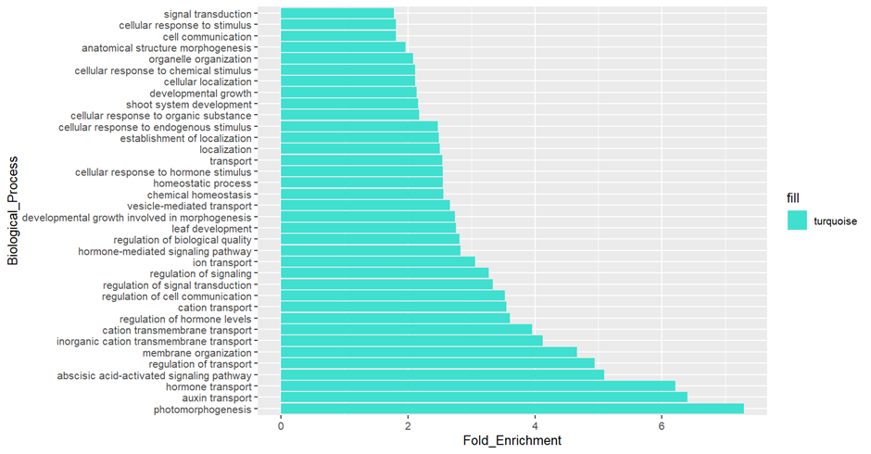

**A**

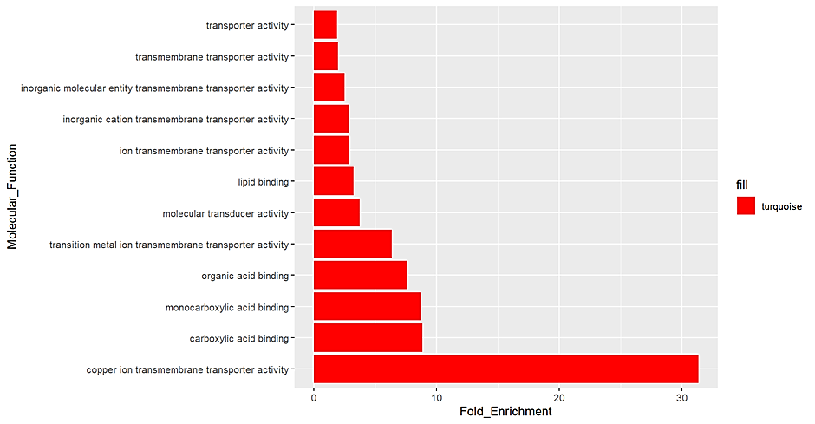

Fold Enrichment

**B**

Fold Enrichment

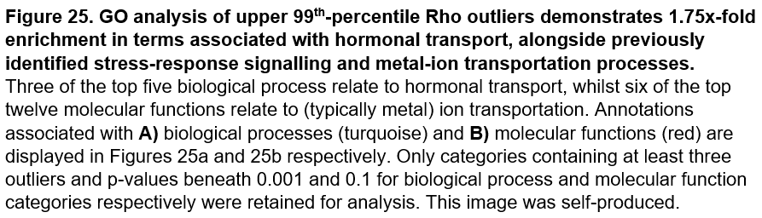

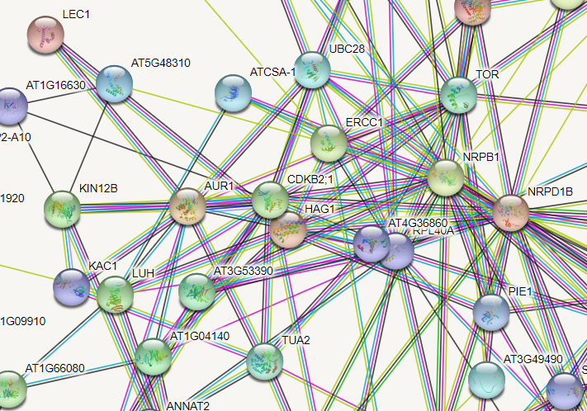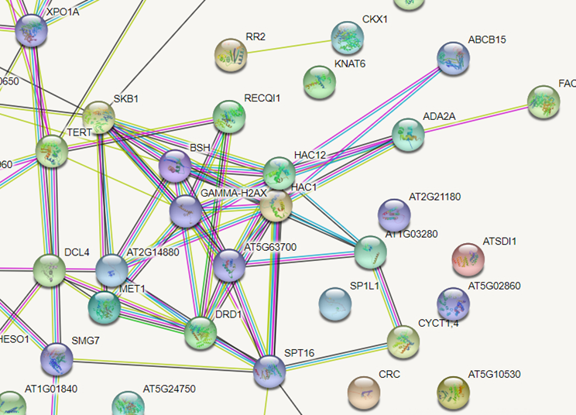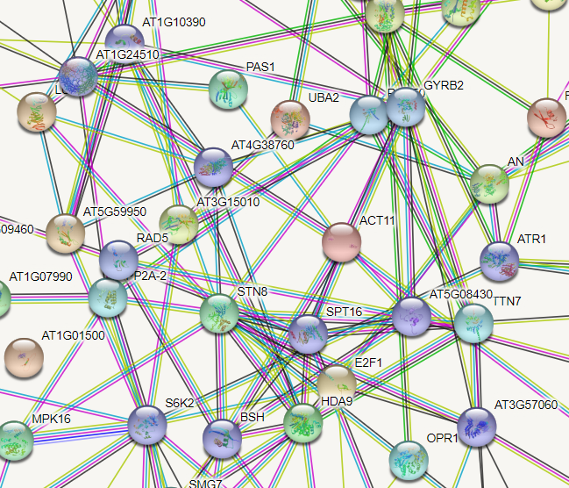Unlike previous metrics, nuclear division and chromatin-related processes are absent from Rho enrichment analysis. However, whilst STRING networks displayed in Figure 26 show reduced interaction between Rho outliers than other metrics, the largest cluster surrounds CDC2 and Aurora-1. These proteins constitute two key components of the cell-cycle that together mediate nuclear division through control of serine-10 phosphorylation on core histone H3 – coherent with previous results associating histone modification with post-polyploidy adaptation[79]. STRING analysis from our other three metrics is broadly consistent with identified biological processes under potential selection. For example, the largest cluster observed from our FST candidates contains multiple histone acetyltransferases and deacetylases, consistent with the suggestion that altered nucleosome structure through histone modification is fundamental to polyploid meiosis. Major STRING clusters from both AFD and DXY also contain genes implicated in histone modification. Multiple DNA-binding proteins and gyrases are identified from AFD candidates, alongside additional transcription factors that act to reorganize nucleosomes[80]. The highly interconnected DXY cluster distinguishes networks regulating post-translational histone modification and chromatin organisation, which are subsequently linked to additional genes involved in cell-cycle coordination, another frequently enriched biological process[79].

**C**

**B**

**A**

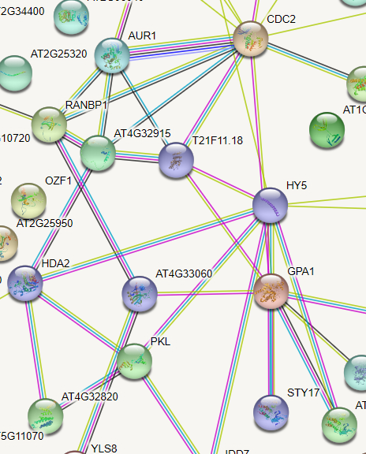

**D**

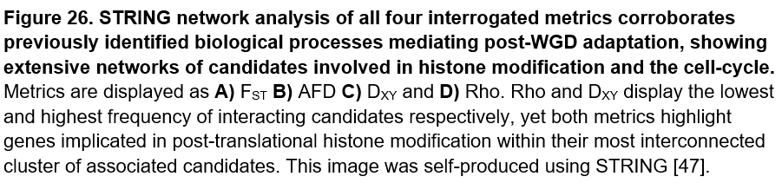

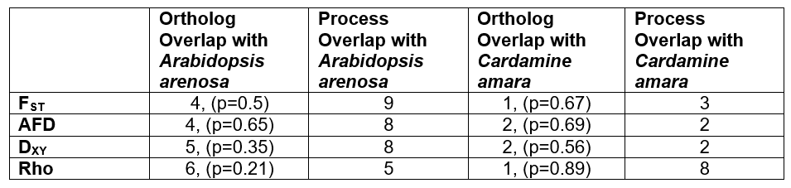Table 7 demonstrates no statistically significant orthologous overlap was identified between our 765 unique PGM-outliers and the 452 and 229 external candidates from *A.arenosa* and *C.amara* respectively[29,30]. Any observed mutualism broadly concerns nuclear division, chromosome condensation and stress-response genes – coherent with our previous results and the genomic consequences of polyploidization. Interspecies convergence between outlier candidates is therefore more frequently observed at the biological process level, although no statistical software exists to accurately evaluate this significance. Conserved terms under variation between plant species again surround chromosome organization, RNA processing and reproduction-related categories, especially the cell-cycle, suggesting adaptation within these processes is selectively advantageous in the immediate aftermath of WGD.

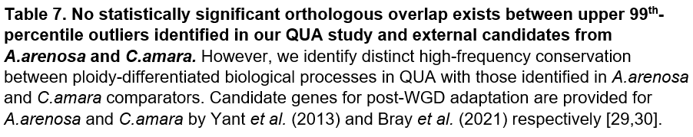

Overlap between *M.guttatus* and *A.arenosa* candidate loci is commonly more significant than with *C.amara*, except in the Rho metric. The highly-impaired ability of this parameter to discriminate strongly-differentiated candidate genes (due to inflated rates of background variation) reduces the importance of Rho compared to other metrics. However, a significant proportion of *C.amara* candidates concern ion transport, consistent with biological processes under manifest variation using the Rho parameter. Contrastingly, nuclear division and chromosome organisation represent the most significantly enriched terms for *A.arenosa* – coherent with the other three metrics. This indicates candidate genes distinguished by Rho are realistic and likely under selection, however the nature of post-WGD adaptation varies slightly between *A.arenosa* and *C.amara.* Nevertheless, our candidates in general demonstrate post-polyploidy adaptation of similar biological processes across species, such as cell division, metabolism and ion-homeostasis, but suggest great flexibility surrounding the specific genes mediating adaptation to genome doubling. Our results therefore indicate a minimally constrained mechanism for remodelling core biological processes post-WGD, and provide robust testimony to the plasticity of plant evolution.

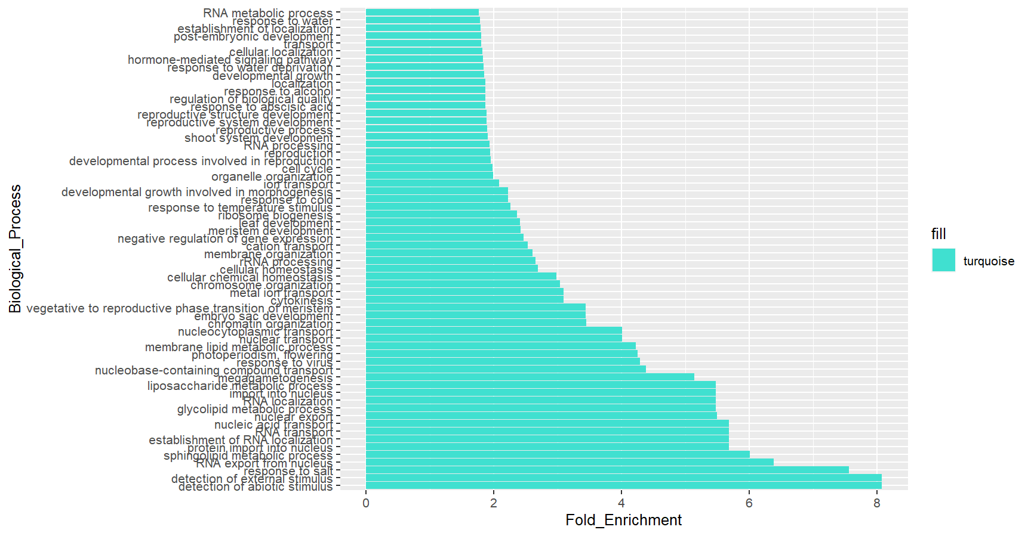To corroborate patterns of functional variation observed using individual parameters, Figure 27 displays GO analysis for upper-99th percentile outliers from all four metrics combined. Consistent with previous results, biological process categories displaying most significant fold-enrichment surround response to abiotic stimuli, chromosome organization and reproductive-related processes. Molecular function enrichment also coheres with previously identified adaptation in metal-ion transporters and chromatin-binding proteins. The largest STRING cluster from candidates combined from all metrics, shown in Figure 28, accordingly highlights a network of histone-modifying proteins, alongside several genes involved in post-transcriptional processing. Our 62 enriched biological processes also display strong process-level convergence with *A.arenosa* and *C.amara*, sharing 11 and 6 categories respectively. These overlaps once more relate to GO terms surrounding chromatin organisation, metal-ion transport, and in the case of *arenosa*, the cell-cycle. Ultimately, this evidence provides further support to the polygenic mechanism of immediate WGD adaptation, involving variation within a number of well-characterised processes, notably reproduction and ion-homeostasis.

**A**

Fold Enrichment

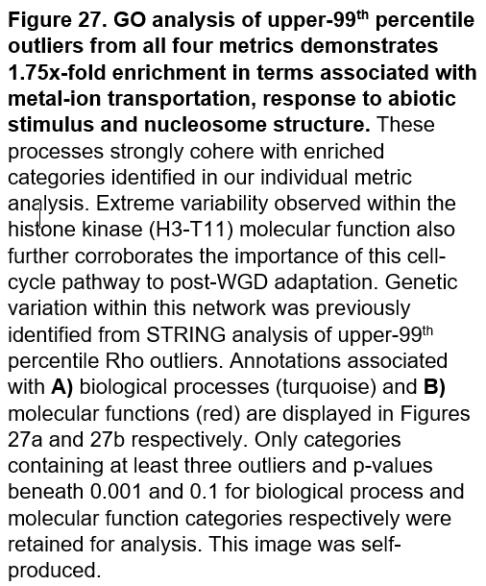

**B**

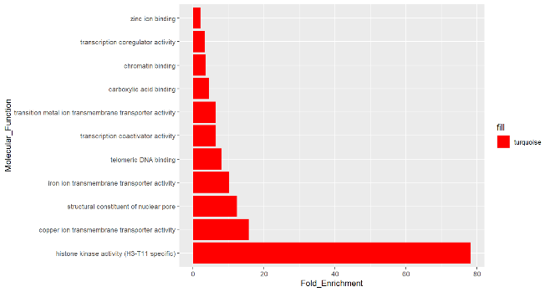

Fold Enrichment

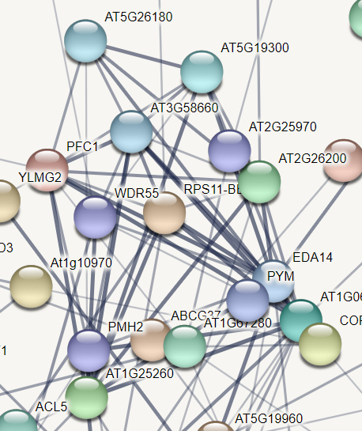

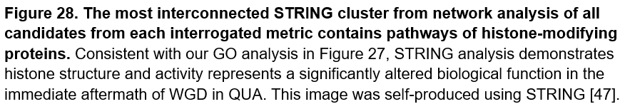

We finally compare upper 99th-percentile outliers from all four metrics to identify genes present in at least three candidate lists, as displayed in the Venn diagram of Figure 29. Table 8 displays the four genes identified within at least three metrics – unsurprisingly no DXY outliers are present here, as selective-sweeps tend to decrease genetic diversity in the ancestral population, reducing values of DXY and prompting omission of potential selection candidates[81]. Three of these genes (AT5G27820, AT3G55290 and AT2G41660) mediate response to environmental stimuli, further indicating stress tolerance represents an important adaptive process post-WGD[82,83,84]. The remaining outlier constitutes the previously-described condensin complex subunit (AT3G57060). This gene is also present within *A.arenosa* candidate lists, suggesting modifications within chromatin assembly pathways are essential to tolerating the genomic consequences of WGD[29]. Stress response and chromatin organization therefore represent our major identified sources of immediate variation post-polyploidization, with repeated orthologous adaptation observed across multiple metrics for candidates involved in these processes.

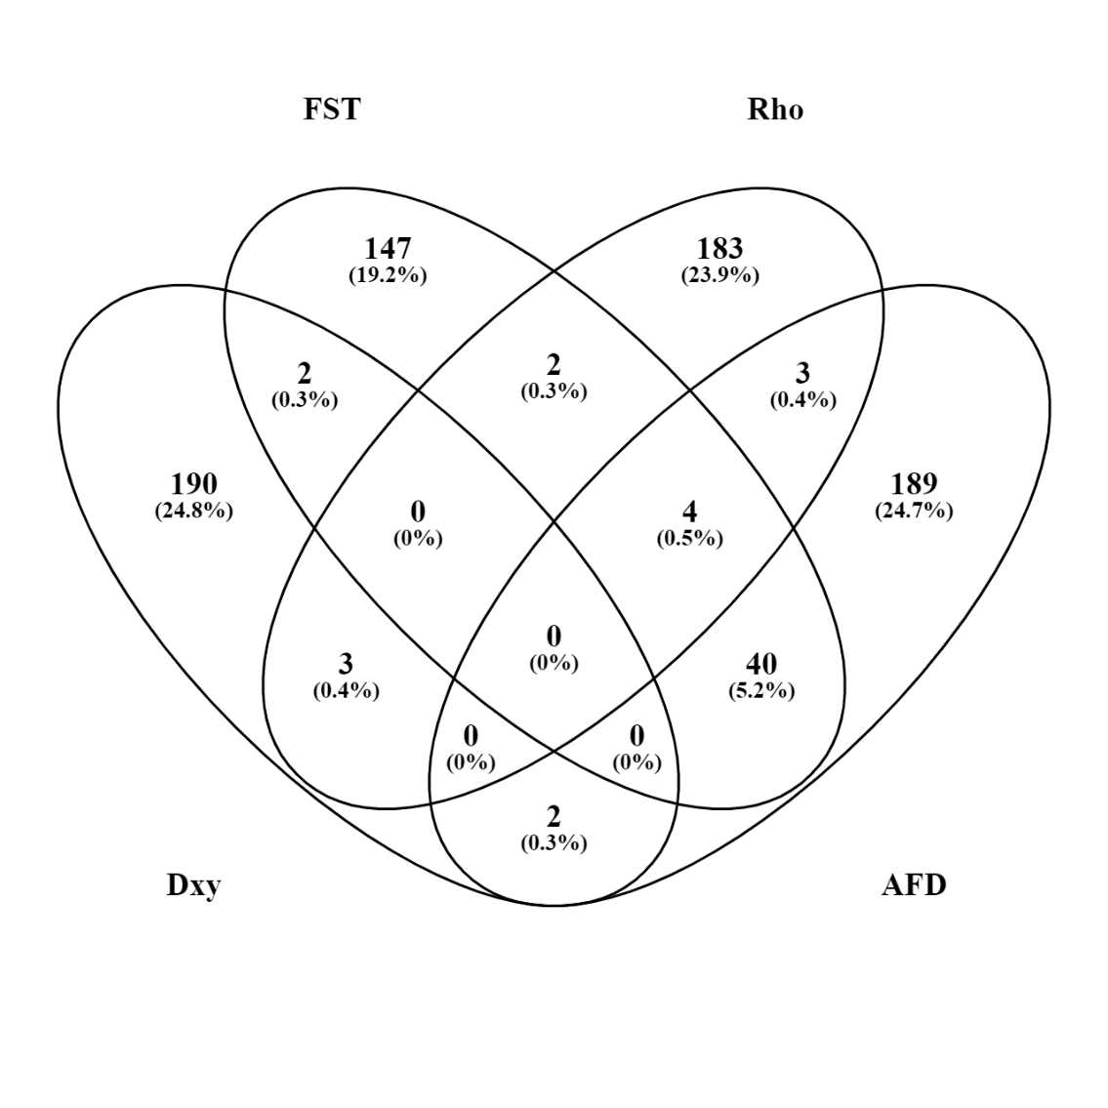

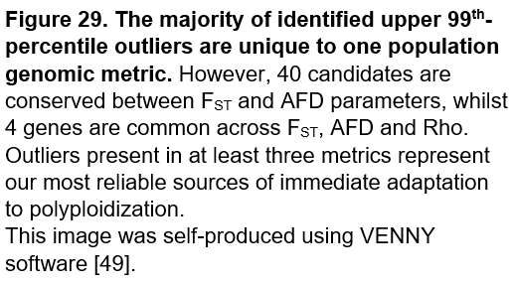

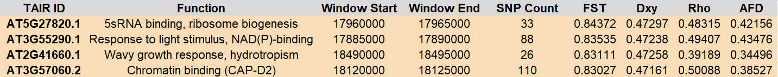

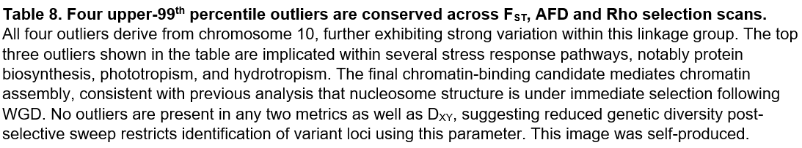

We employ qualimap to assess sequencing quality of every individual and each chromosome - obtaining an overall perspective on our data allows detection of sequencing or mapping biases in particular samples or chromosomes which may otherwise lead to overinterpretation of false-positives from subsequent study[27]. Tables 9 and 10 provide qualimap-generated results for each sample and each chromosome under investigation, with best and worst values for each metric emboldened green and red respectively. Tetraploids display slight increases in coverage compared to their diploid progenitors, which is reflected in proportionally more sequencing errors. We here speculate increased deletions in tetraploids may be linked to patterns of aneuploidy arising from inappropriate chromosomal segregation post-WGD. Ultimately, with mean read-depths exceeding 9x and general error-rates beneath 0.05, all samples possess sufficient coverage and sequencing quality for accurate CNV detection.

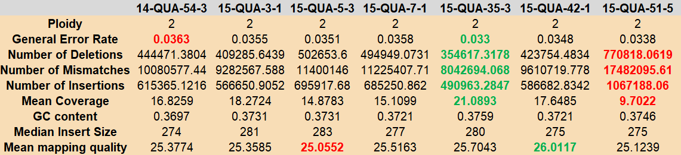

**A**

**B**

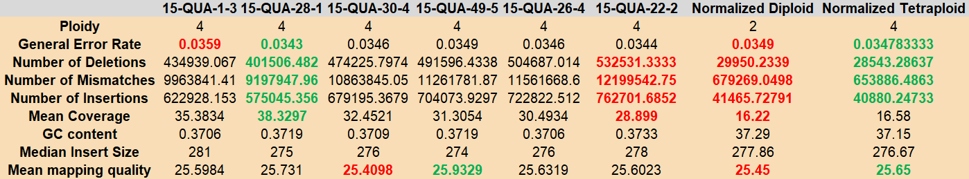

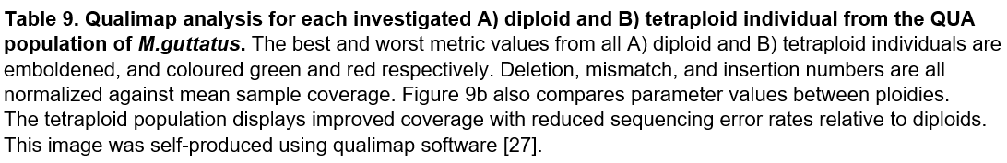

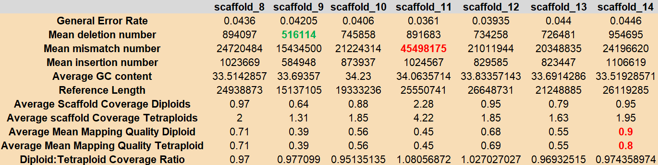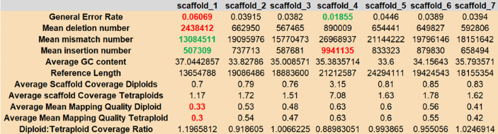

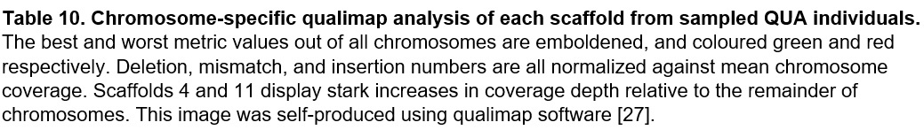

Table 10 demonstrates coverage depth is mainly uniform across chromosomes, excluding striking increases in chromosomes 4 and 11. Scaffold 4 contains an increased number of insertions relative to other chromosomes; high-coverage regions are often flanked by multiple inserted transposon elements, which accumulate more quickly in tetraploids due to relaxed purifying selection[85]. Consistent with this observation, elevated scaffold 4 read-depth is even more evident for tetraploid QUA than diploid. We therefore speculate an increase in transposon element frequency represents a potential explanation for heightened coverage in chromosome 4. Correspondingly, as displayed in Table 11, STAR mapping of scaffold 4 against the *M.guttatus* reference demonstrates doubled per-base insertion rates within this chromosome.

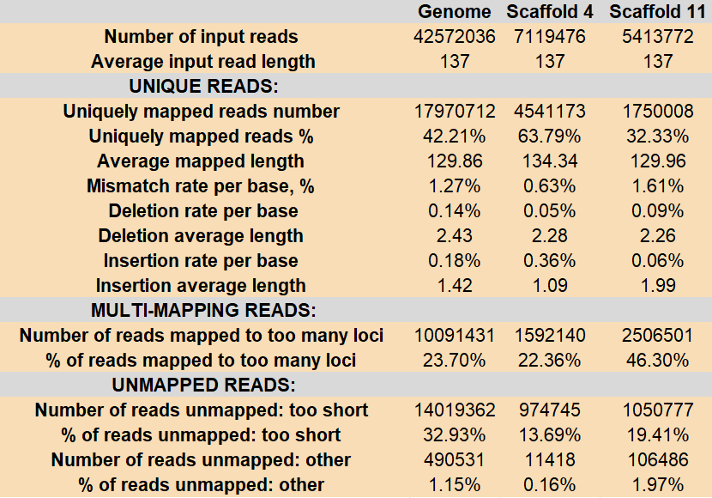

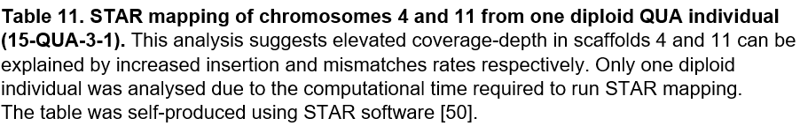

Contrastingly, STAR mapping suggests increased scaffold 11 coverage is explained by elevated mismatch frequency, with 27% higher incidence in this chromosome relative to the entire genome. We speculate mismatches may result from misassembly due to an increased proportion of homopolymeric regions in chromosome 11, as this scaffold exhibits a 22% decrease in unique-read percentage compared to genome-wide analysis, and the second lowest mean mapping-quality of any chromosome. Accounting for these potential biases, the importance of scaffolds 4 and 11 is down-weighted in subsequent CNV analysis, alongside chromosome 1, which exhibits lowest mean mapping quality with the highest general error-rate. However, STAR mapping possesses two limitations; firstly, our reference genome is assembled from the IM62 line within the Northern clade of *M.guttatus*, thus natural local adaptation generates frequent mismatches against British samples[44]. Secondly, this reference assembly is poor-quality, and contains many more scaffolds than the true fourteen chromosomes, likely through insufficient mapping information[44]. We therefore retain scaffolds 4 and 11 for CNV analysis, as STAR mapping is insufficient to definitively approbate sequencing biases in these chromosomes.

To achieve our aims of identifying patterns of aneuploidy that could facilitate adaptation following WGD, we identify ploidy-specific copy number variants within each chromosome using cn.mops software [35]. Regrettably, this program is written to handle diploid data, however use of cn.mops is necessitated by an absence of polyploid-specific alternatives. Recent evidence also confirms the ability of cn.mops to successfully identity tetraploid CNVs in *Solanum peruvianum* [86]. Moreover, this software possesses lower false-discovery rates than alternative diploid CNV callers, particularly in repeat units - especially important in context of our results[35,87]. As coverage depth scales linearly with ploidy, we employ short-read NGS data in our study to provide more accurate estimation of integer copy number and higher resolution for predicting breakpoints than provided by long-reads[88].

Short-read data also improves sensitivity for identifying shorter copy number variants - this benefit was initially less important to our specific aims, as prior to our analysis we expected to observe megabase-wide meiotic entanglements at terminal chromosome ends[89]. However, such enhanced sensitivity became secondarily advantageous as the vast majority of our detected CNV windows span much narrower genetic distances than initially predicted. Nevertheless, improvements in assembly contiguity provided by long-read sequencing will ultimately be required to conclusively elucidate the mechanism of adaptation post-WGD, particularly in context of marked variation within repeat-rich centromeres in this study, which Illumina technologies resolve less accurately than Oxford Nanopore alternatives[90].

Only CNVs with more negative mean expected log2-fold changes than -0.2 and -0.5 are retained for tetraploids and diploids respectively, as these values represent the minimum thresholds relating to biologically feasible copy number decreases, consistent with Table 3. However, the necessitated use of a lower tetraploid CNV-detection threshold introduces potential for observed ploidy-specific variation to solely reflect a reduction in CNV-calling stringency relative to diploids. Moreover, use of a negative threshold limits our analysis to decreases in copy number associated with aneuploidy; however, the biological consequences of an immediate additional increase in genetic material post-WGD are less likely to provide an evolutionary advantage to polyploid crops[23]. We initially implemented a minimum window-size of 500-bases to conduct our analysis, however using this threshold, observed CNV widths ubiquitously exceeded 1,500 base-pairs, as displayed in Figure 30, thus we increased minimum window-size accordingly.

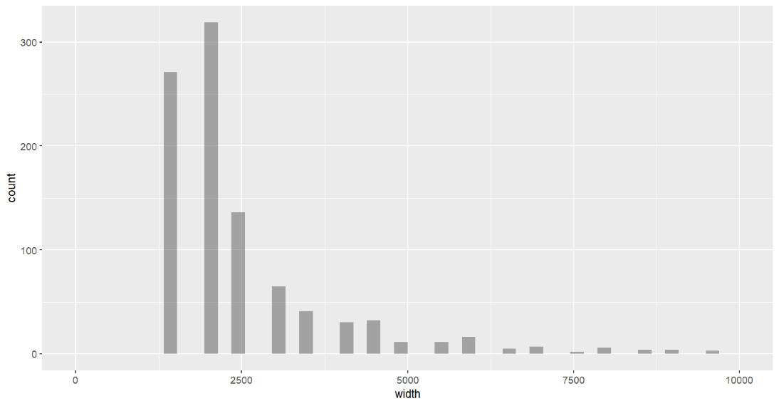

**A**

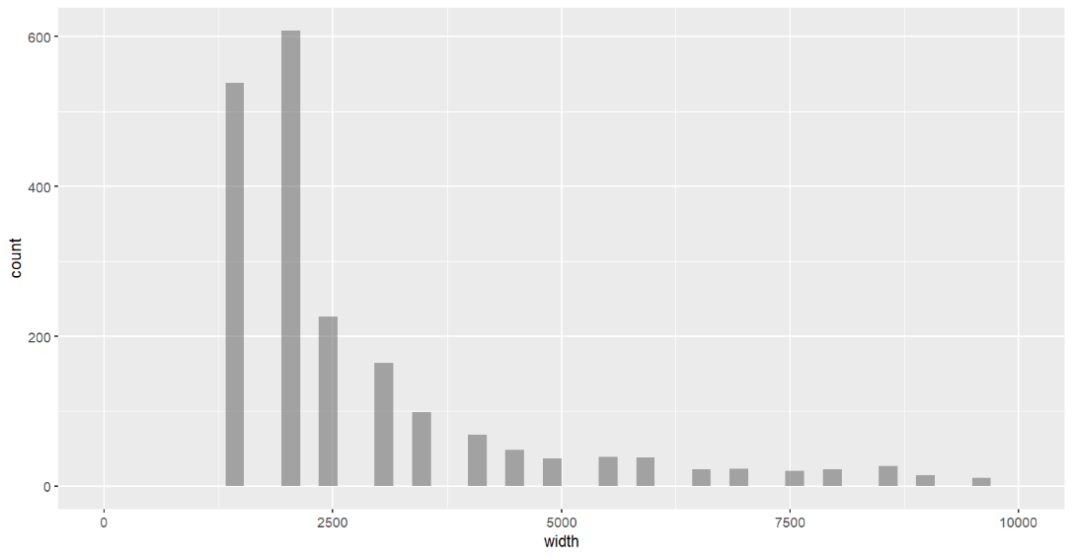

**B**

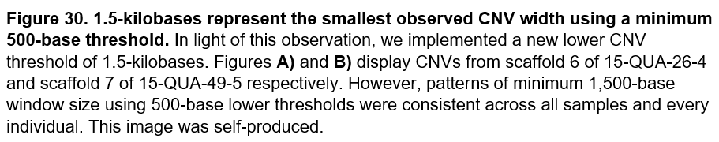

We analyse each tetraploid independently against all diploids at once, and concatenate outliers identified from each sample into one larger list of candidate tetraploid regions under copy number variation. This sample-specific approach is required because simultaneous analysis of all tetraploid individuals homogenises average coverage depth and obscures ploidy-specific read-count ratio changes. We also identify CNVs observed within the diploid population, as variants observed in tetraploid samples may simply reflect copy number decreases predating polyploidization, or indeed artifacts from misassembly.

When generating frequency histograms, diploid CNV count was multiplied by 1.71 to account for the increased number of sampled chromosomes in tetraploids (24) relative to diploids (14). Following normalization, integrative analysis of frequency histograms and dot-plots of CNV locations indicates increased variation within tetraploid centromeres relative to their diploid progenitors. Centromere locations are characterised according to those reported by Fishman *et al.* in 2010, previously displayed in Figure 5[39,51]. This paper provided foundational evidence of centromere-associated meiotic drive, and has since been subject to extensive peer-review across multiple journals, supporting the applicative reliability of corresponding data.

As displayed in Figures 31 and 32, both ploidies display high rates of copy number variation within centromeres, however the relative proportion of CNVs in centromeric regions is most significant for tetraploid QUA. Normalised read-count ratio plots generated by cn.mops, also shown in Figure 32, further corroborate ploidy-specific decreased coverage within tetraploid centromeres. However, in 2 of the 14 *M.guttatus* chromosomes, diploid centromeric CNV frequency outcompetes that observed in tetraploids. Rare observation of elevated relative CNV incidence in diploid centromeres, shown in Figure 33, reduces the validity of our initial hypothesis, as this finding suggests centromeric CNVs simply reflect difficulties resolving repeat-rich sequence using Illumina technology. Moreover, as displayed in Figure 34, colchiploids also exhibit occasional ploidy-specific increases in CNV frequency within centromeres. This observation further supports a negative result from our cn.mops analysis, as colchiploids are infertile and selection is unable to act before one round of reproduction[91]. Nevertheless, both the extent and frequency of ploidy-specific centromeric CNV increase is lower for colchiploids than in neotetraploid QUA. In addition, conversion to polyploidy may have sparked immediate centromeric modification even in infertile colchiploids, therefore the observation of increased copy number variation within colchiploid centromeres may instead support suggestions of elevated tetraploid centromeric divergence post-WGD.

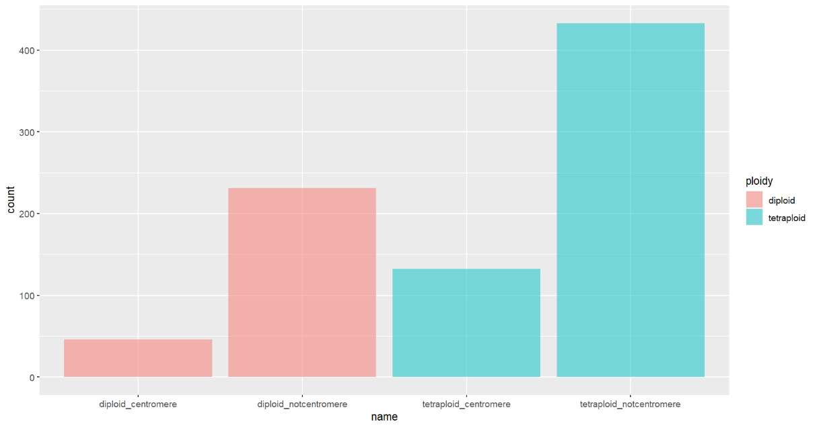

Diploid Centromere

Diploid Not Centromere

Tetraploid Centromere

Tetraploid Not Centromere

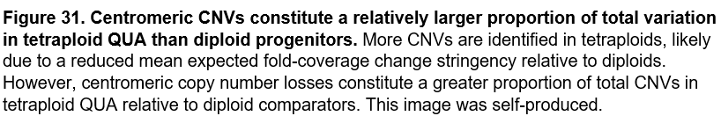

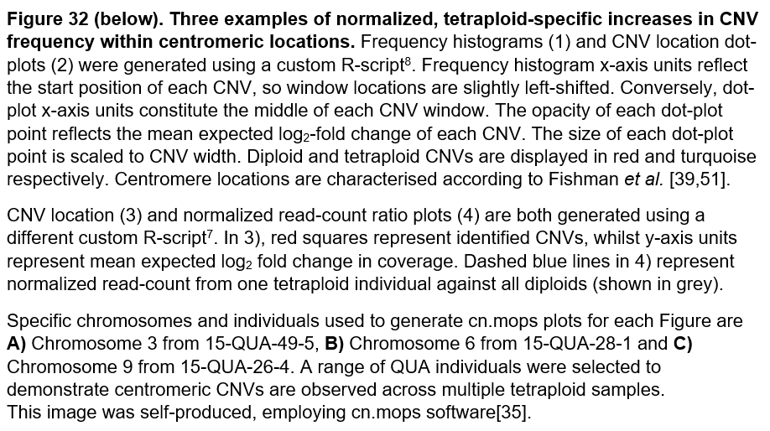

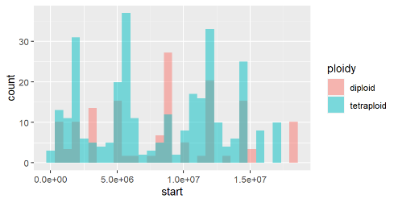

**A**

**1.**

Start Position (Mb)



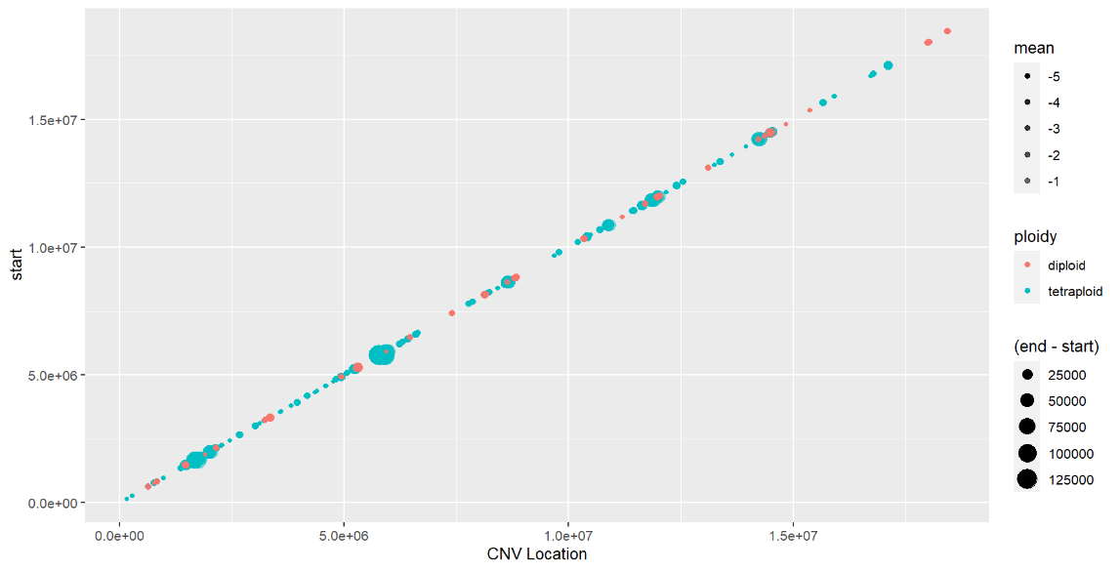

**2.**



**3.**

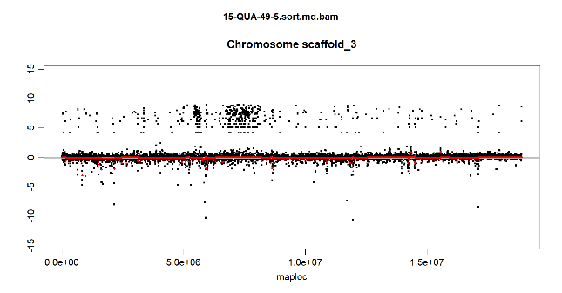

Nucleotide Position



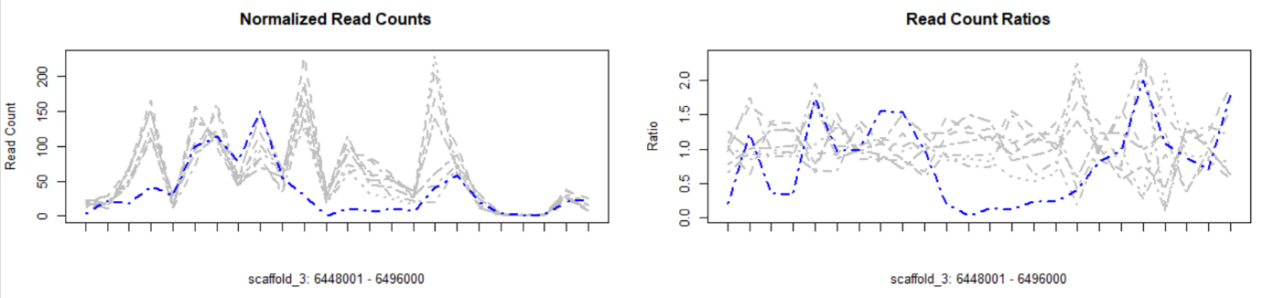

**4.**

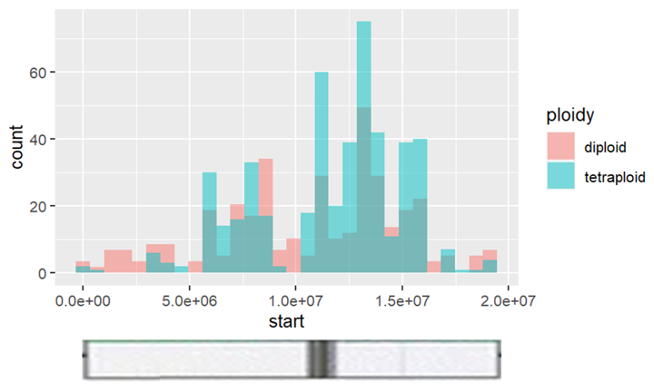

**1.**

**B**

Start Position (Mb)

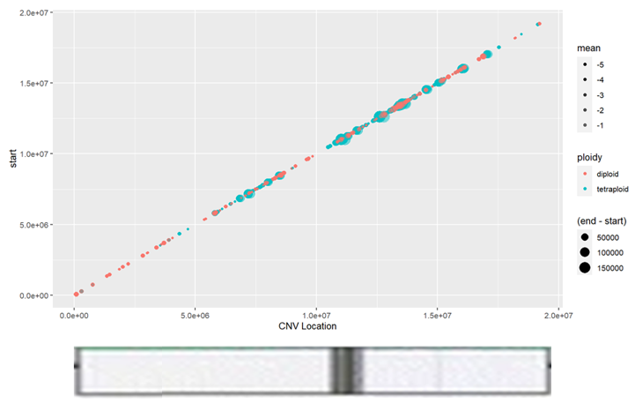

**2.**

**3.**

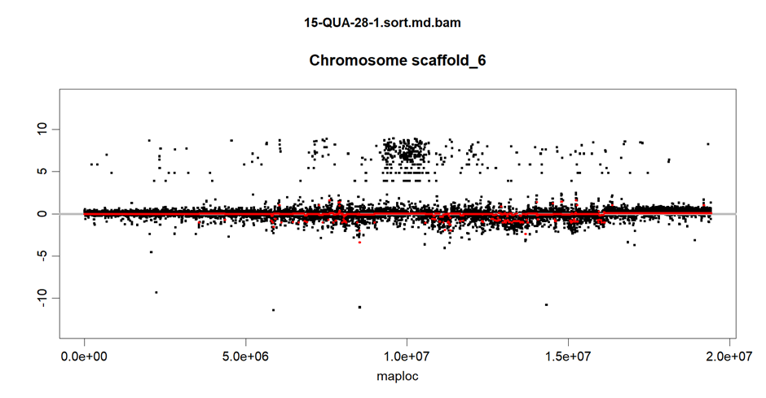



Nucleotide Position

**4.**

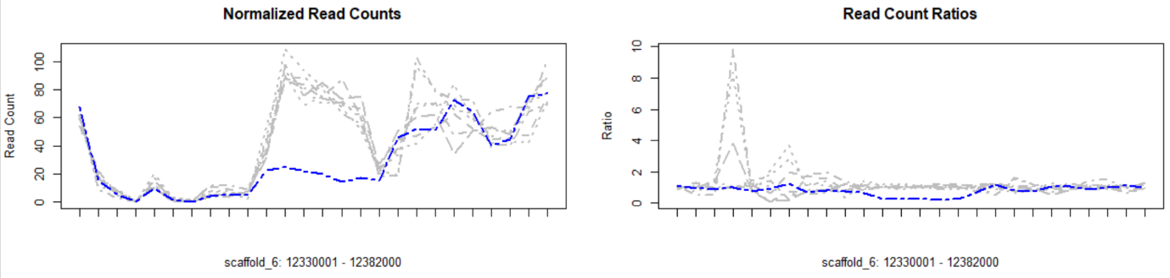

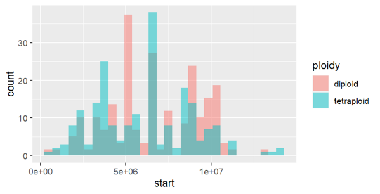

**C**

**1.**



Start Position (Mb)

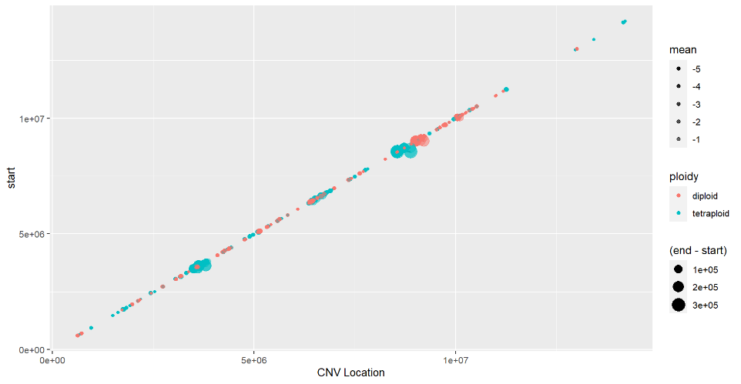

**2.**

**3.**

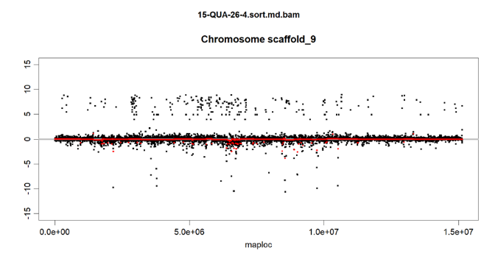

Nucleotide Position



**4.**

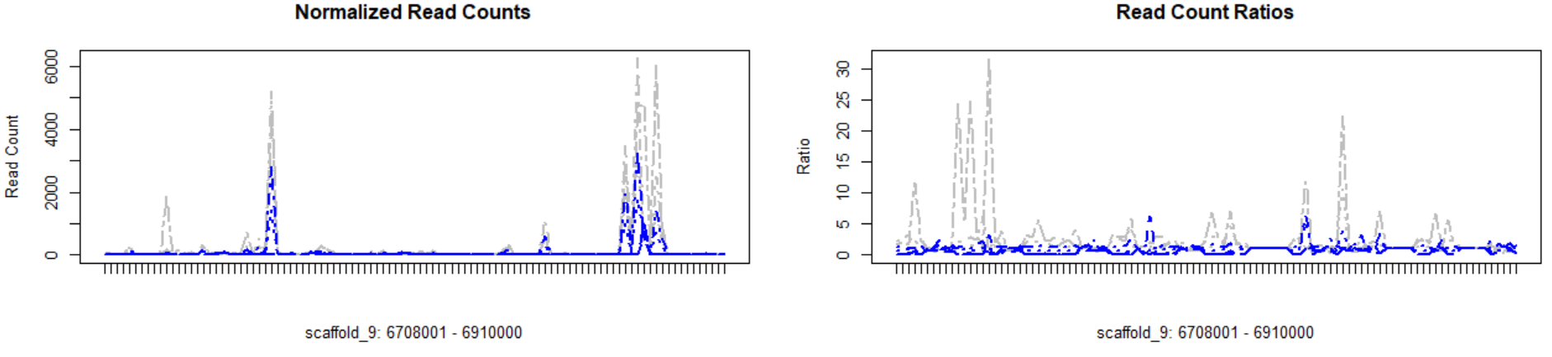

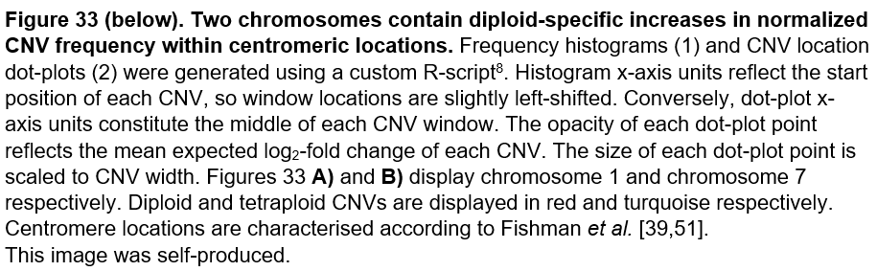

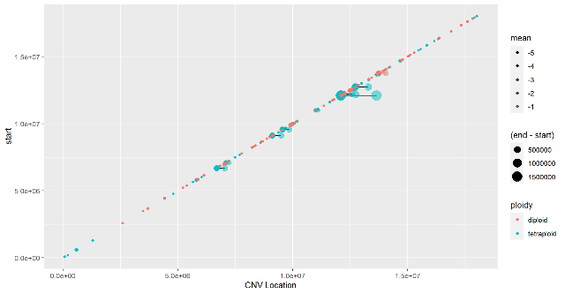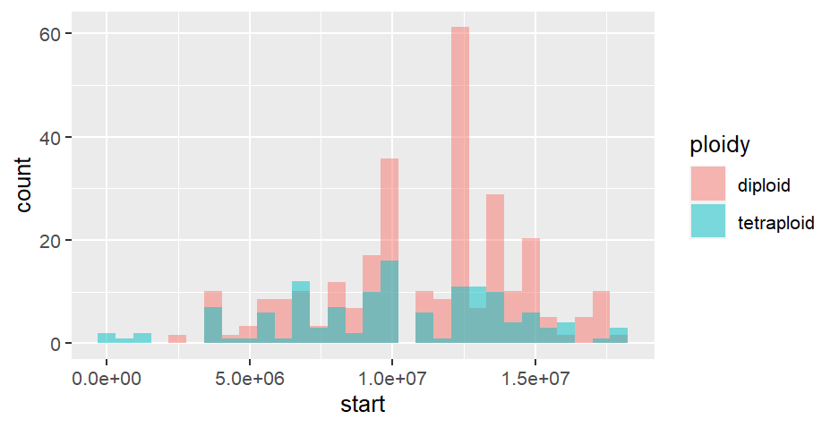

Start Position (Mb)

**A**

**1.**



**2.**



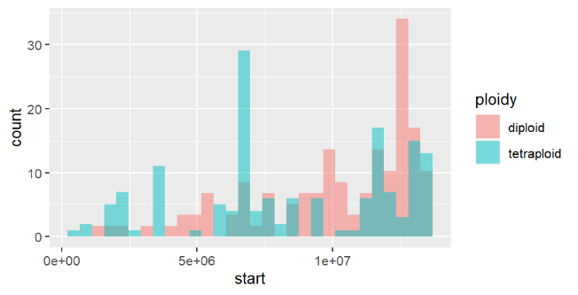

**B**

**1.**

Start Position (Mb)



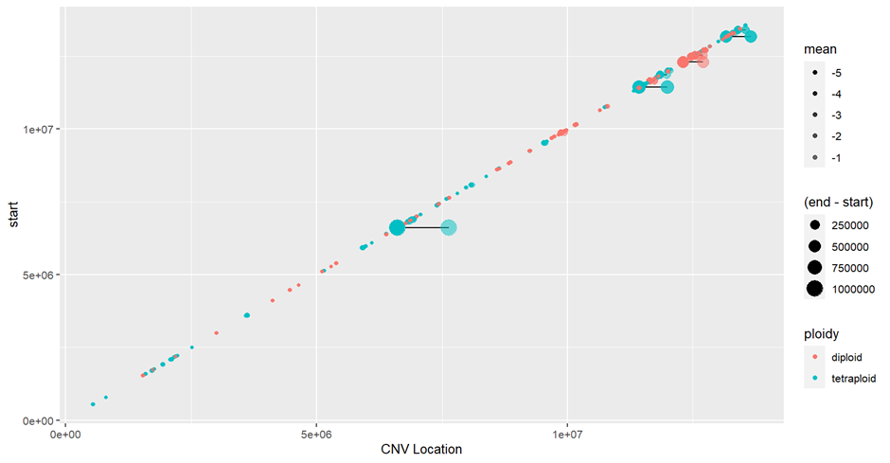

**2.**



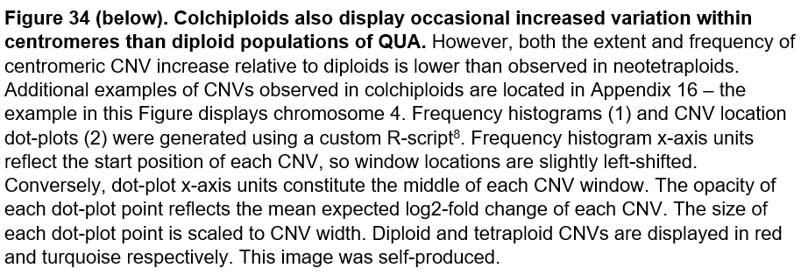

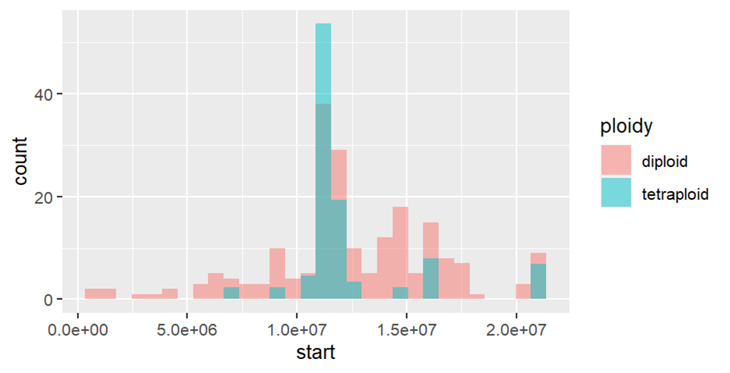

colchiploid

**1.**



Start Position (Mb)

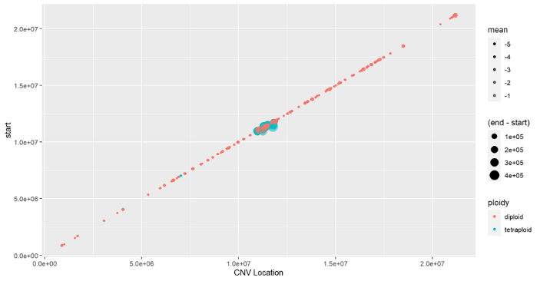

**2.**

colchiploid



However, frequency histograms fail to appropriately account for the size of each CNV window, and may accordingly obscure identification of genomic regions under variation. For example, the chromosome-7 dot-plot shown in Figure 33b indicates tetraploid CNV windows are larger than diploids, but this width difference is not considered in subsequent frequency-histograms, which correspondingly exhibit an unrealistically diminished proportion of centromeric CNVs in tetraploids. When we restrict CNVs retained for analysis to windows greater than 50,000-kilobases, we observe a much more prominent increase in tetraploid centromeric variants. As exemplified in Figure 35, large centromeric CNVs are consistently more common in tetraploids than diploids; indeed, only 1/14 chromosomes provide evidence for equivalent or increased diploid centromere CNV frequency. Candidate centromeric regions under selection also display IGV support for decreased tetraploid coverage, as shown for chromosomes 3 and 6 in Figure 36, further corroborating the potential for copy number decreases within centromeres to mediate adaptation following polyploidization[92].

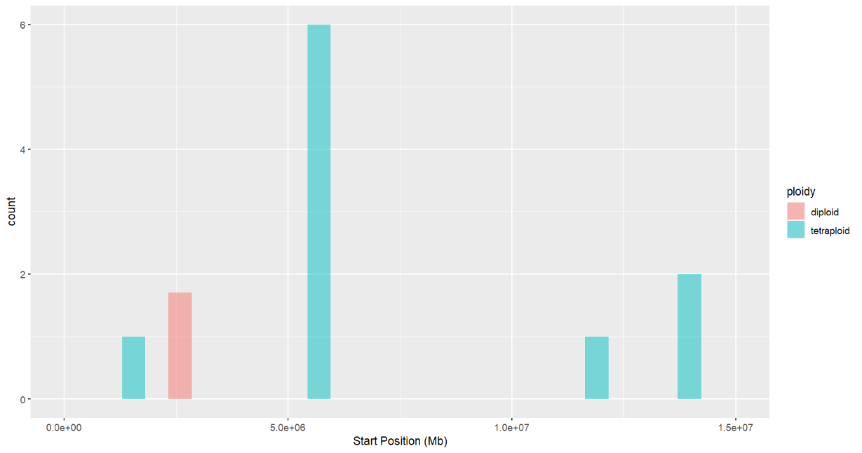

**1.**

**A**



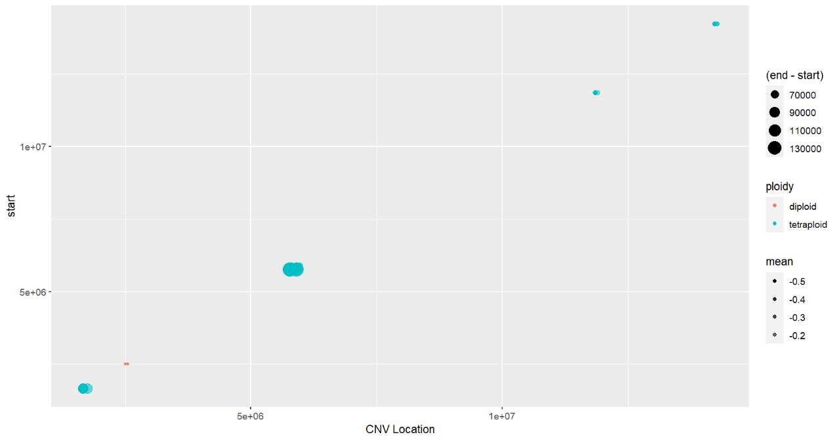

**2.**



**B**

**1.**

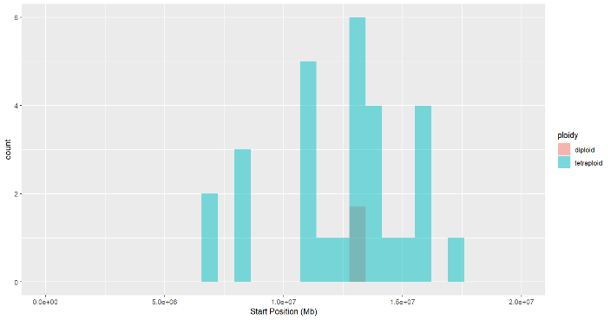

**2.**

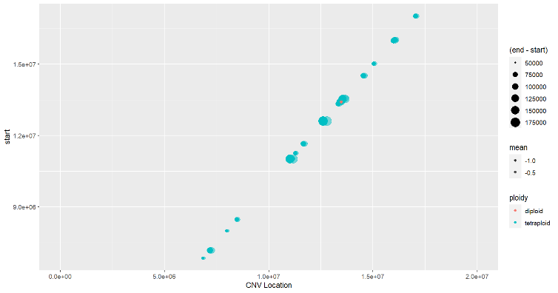

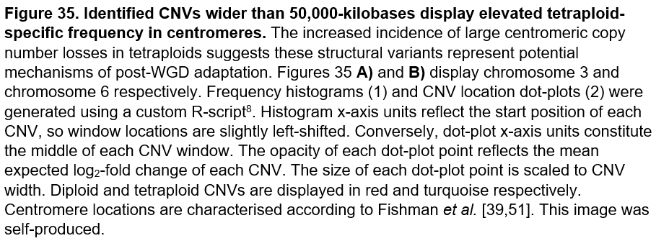

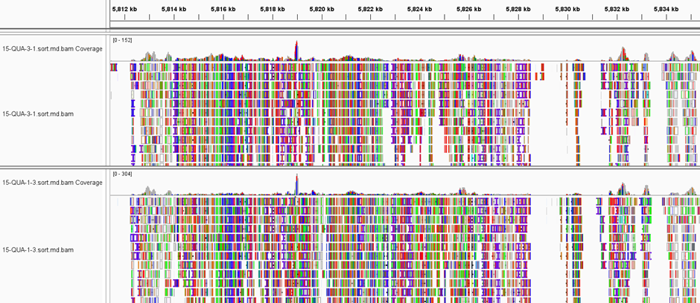

**A**

`

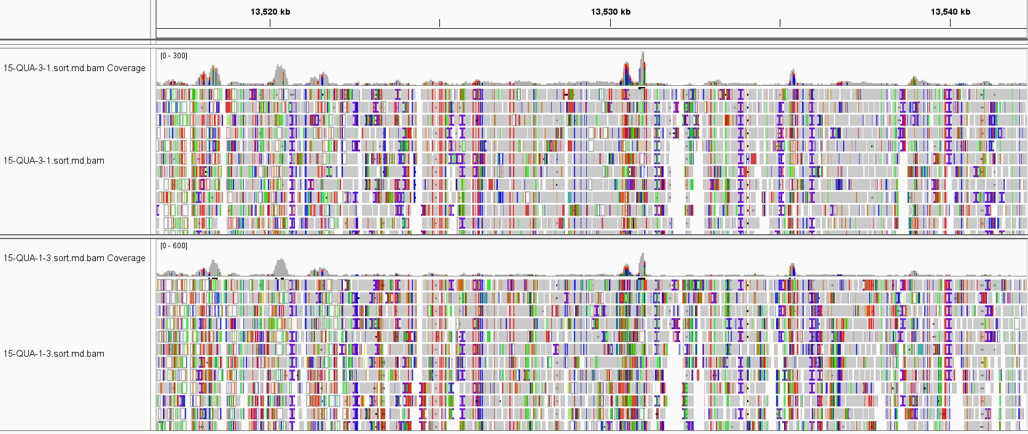

**B**

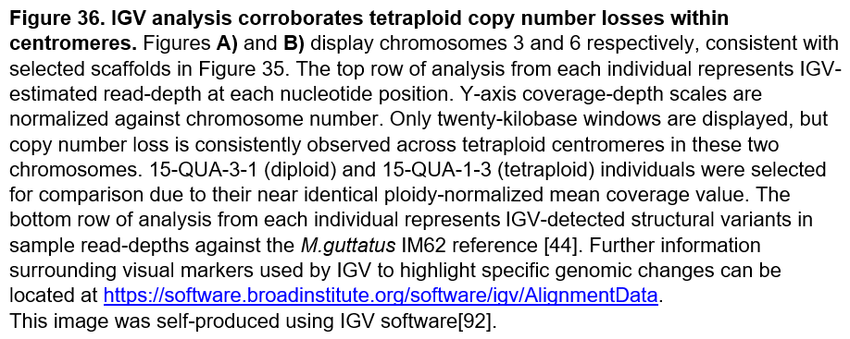

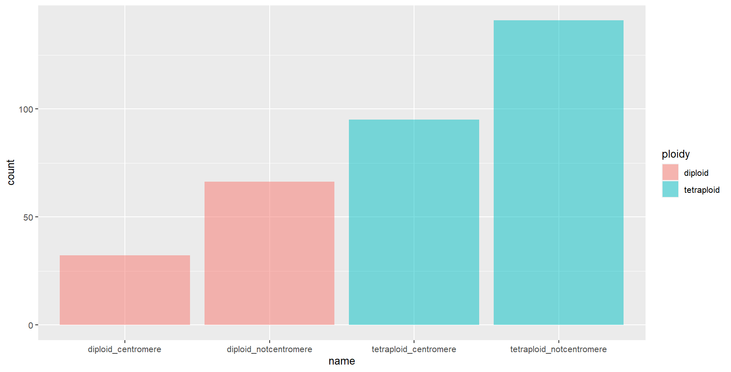Figure 37 confirms an increased proportion of observed tetraploid CNVs wider than 50-kilobases reside within centromeres compared to diploid QUA. However, a significant fraction of >50-kilobase diploid CNV windows are also in centromeres (although at much lower frequency). Moreover, Figure 37 demonstrates more >50-kilobase windows are observed in tetraploids than diploids. Although these windows may genuinely reflect wider CNVs, this increased number of >50-kilobase windows is likely to bias observation of larger centromeric variants in tetraploid QUA. Long-read sequencing analysis is ultimately required to determine whether the elevated frequency of large centromeric CNVs in tetraploids simply constitutes noise, either from additional chromosome sampling or implementation of a lower threshold for CNV detection, or whether observed centromeric copy number decreases possess biological significance.

Diploid Centromere

Diploid Not Centromere

Tetraploid Centromere

Tetraploid Not Centromere

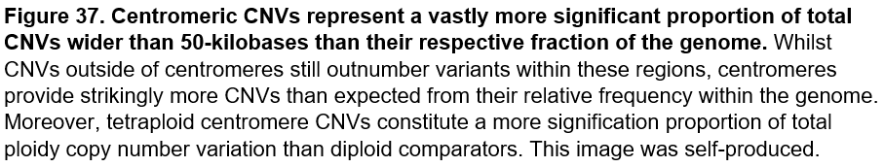



Characterising potential variation within tetraploid centromeres is particularly noteworthy in context of previous *M.guttatus* research. During cell division, centromeres are the assembly-site of kinetochore proteins, which direct chromosome segregation by mediating attachment of sister chromatids to spindle microtubules[93]. Centromeric variation therefore possesses great potential for improving the fidelity of meiotic transmission, particularly important post-WGD in lieu of doubled homolog number, which represents a significant and immediate challenge to chromosome segregation. Consistent with the high-frequency of recent WGD within the species, in 2008 Fishman *et al.* identified *M.guttatus* possesses an unusual, putatively centromeric-associated meiotic drive system, where centromeres are under strong evolutionary pressure to provide a transmission advantage in asymmetric female meiosis[94]. In context of this selfish meiotic drive model, we speculate centromeric CNVs in tetraploid QUA may provide immediate improvements to the fidelity of chromosome transmission that enables polyploid survival post-WGD.

However, whilst centromeric changes can provide meiotic transmission advantages, these variants also entail costs that favour evolution of drive-suppressing mutations in kinetochore proteins[39]. This DNA-protein arms race provides one explanation for rapid centromeric variation, and suggests ploidy-specific differentiation within kinetochore proteins is expected if centromeric CNVs are truly present in the immediate aftermath of polyploidization, given the expected antagonistic co-evolution between centromeres and kinetochores[39]. Correspondingly, unpublished selection scans of older polyploidization events in the Pacific North-Western population of *M.guttatus* implicate kinetochore proteins in WGD adaptation, whilst recent analysis of an autotetraploid *Cochlearia* population provides additional examples of cytotype-specific divergence in kinetochore candidates post-WGD[31]. These observations are further supported by PGM scans of the mixed-ploidy QUA population in our study, which frequently identify upper 99th-percentile outliers implicated in spindle organization and nuclear division, notably one highly differentiated AFD candidate from the gamma-tubulin complex. We therefore speculate altered co-evolution of kinetochore and centromere functionality may play a key role in QUA adaptation post-polyploidization. However, long-read sequencing analysis is ultimately required to definitively characterise tetraploid-specific copy number variation within centromeres.

Figure 38 demonstrates the majority of detected >50-kilobase CNVs in tetraploid centromeres display mean log2 fold-coverage decreases consistent with simplex aneuploidy. Duplex variation is observed with diminishing incidence, whilst diploid CNVs broadly concern heterozygous mutations. Most centromeric tetraploid variants possess less negative fold-coverage decreases than the threshold for detecting diploid CNVs. From this observation, we predict increased relative tetraploid false-discovery rates, through more frequent detection of non-adaptive noise or sequencing errors in repeat-rich regions caused by a lowered stringency for tetraploid CNV detection. However, outside of centromeres, simplex mutations remain the most frequent aneuploidy state, indicating difficulties resolving repetitive regions in centromeres yield little contribution to observed copy number variation. Moreover, the extreme high-frequency of tetraploid simplex mutation may genuinely reflect copy number loss, however this hypothesis requires corroborative evidence from long-read analysis.

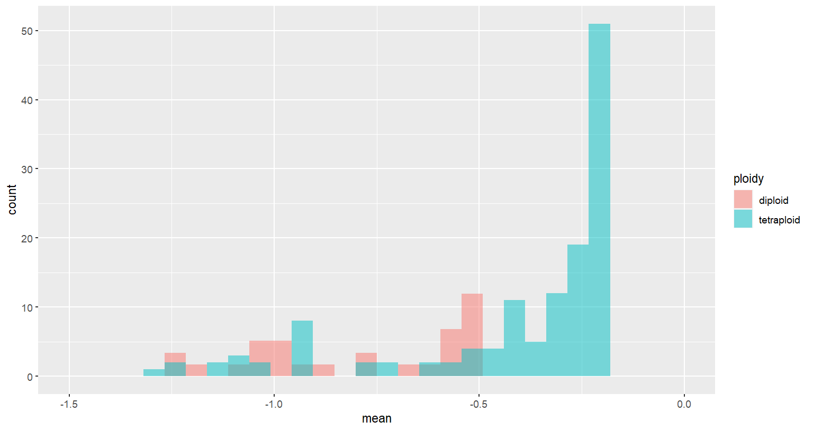

**A**

Diploid Centromere

Tetraploid Centromere

Mean Log2 Fold-Coverage Change

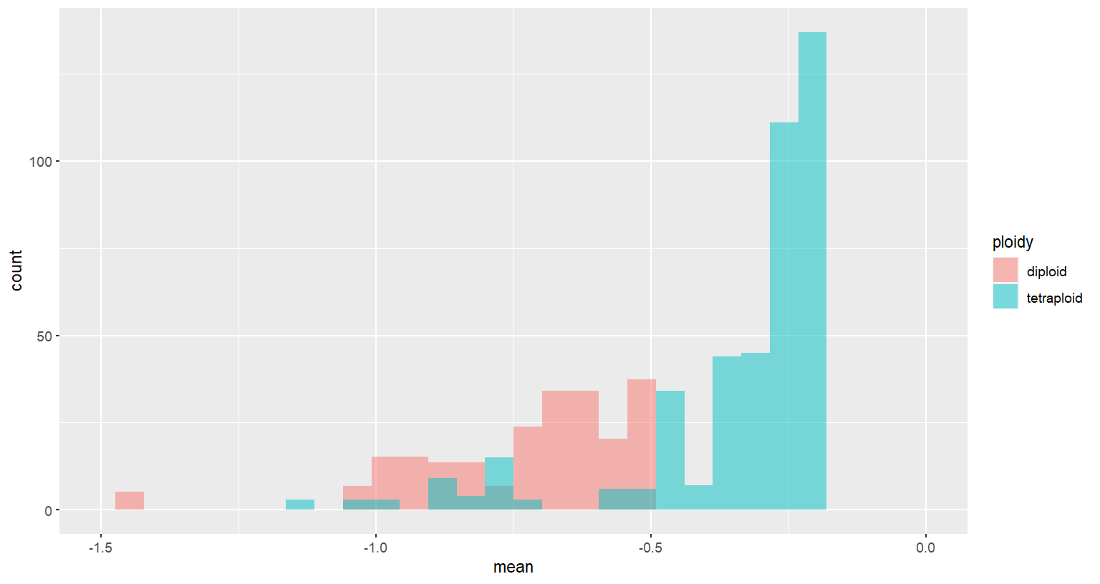

Diploid Outside Centromere

Tetraploid Outside Centromere

Mean Log2 Fold-Coverage Change

**B**

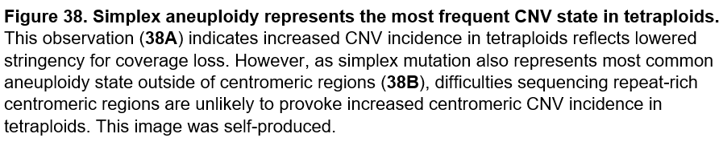

We finally characterise the identity of QUA individuals containing centromeric CNVs larger than 50-kilobases, displayed in Figure 39. All six tetraploid samples contribute significant amounts of windows, demonstrating patterns of centromeric copy number loss are consistent across these individuals. Contrastingly, our seven diploid samples display widespread range of centromeric CNV frequency. Two individuals providing significant proportions of windows constitute 15-QUA-51-5 (DIP7) and 14-QUA-54-3 (DIP1). These two diploids possess greatest phylogenetic similarity to our tetraploid QUA population, as displayed in the neighbour-joining tree of Figure 7, suggesting a genetic origin for observed centromeric variation instead of sequencing noise. This conclusion is corroborated by the complete absence of centromeric CNV windows in 15-QUA-42-1 (DIP6), together with low incidence in 15-QUA-35-3 (DIP5). These two samples represent the only diploids more than one internal node apart from a tetraploid individual. It could therefore be suggested centromeric CNVs are genetically conserved between closely-related individuals of any cytotype, and thus identified variation is ploidy-independent. However, it is possible to speculate that CNVs in close diploid relatives of tetraploid populations provide perfect genetic conditions within centromeres to facilitate transition to tetraploidy.

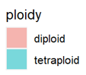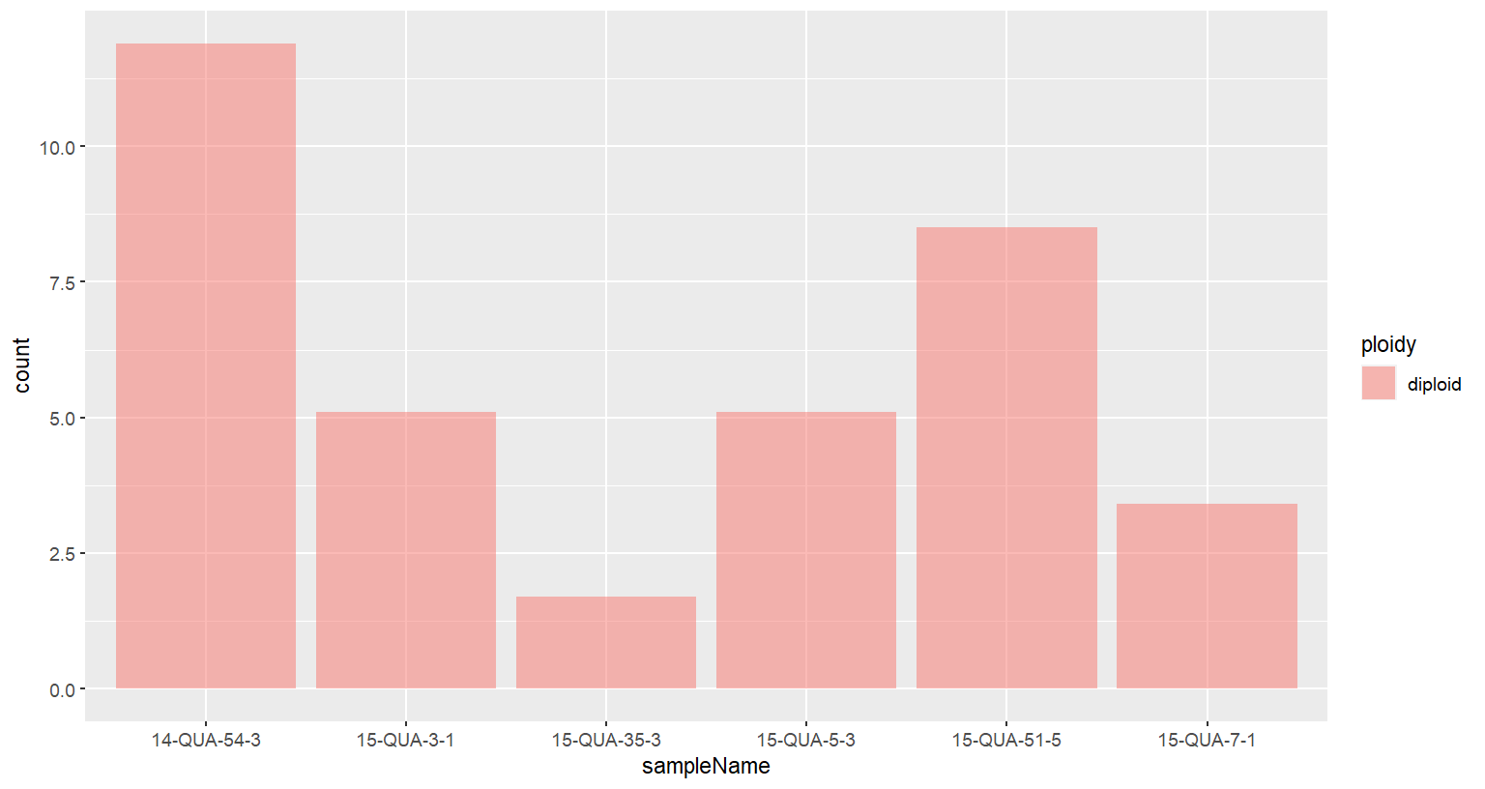

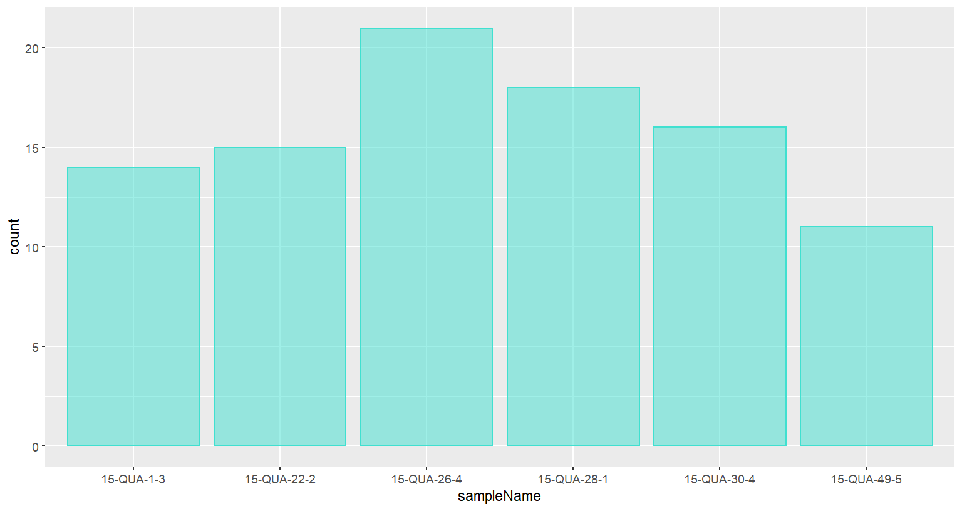

**B**

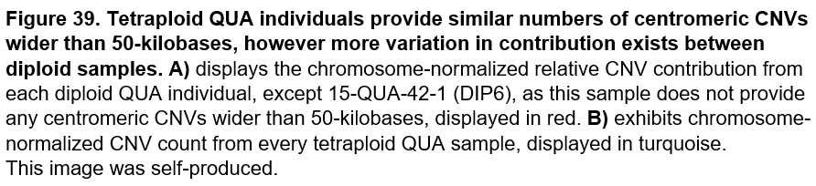

A second form of read-depth analysis – mean normalized-coverage plots - provide some evidence of copy number loss in tetraploid centromeres, as displayed in Figure 40. However, the majority of scaffolds display no coverage decrease within centromeric regions (see Appendix 13). As shown in Figure 41, this form of analysis also corroborates an absence of polyploid telomeric aneuploidy, with comparable normalized coverage observed across both cytotypes at chromosome termini. This contradicts our initial expectation that inappropriate chromosomal segregation following whole genome duplication events produces large meiotic entanglements at terminal ends.

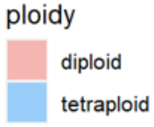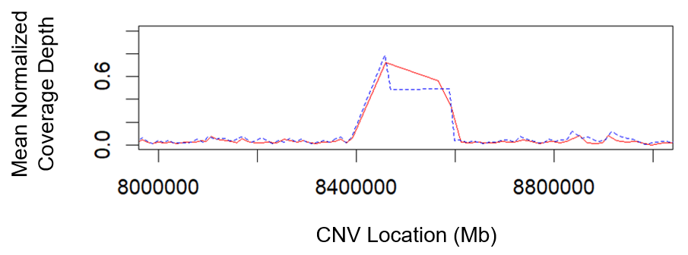

**A**

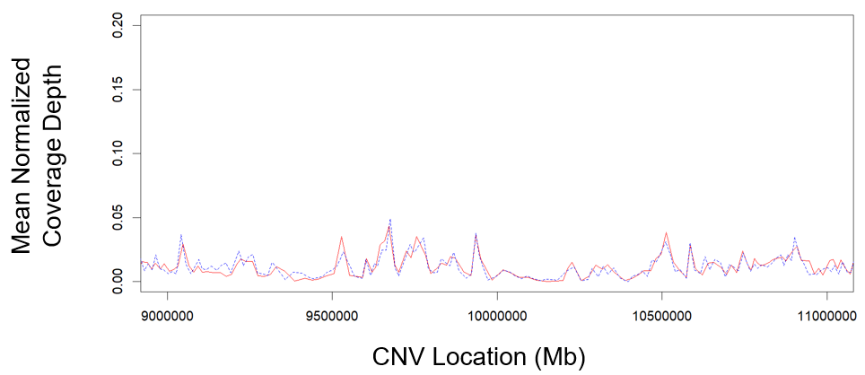

Nucleotide Position (base-pairs)

**B**



Nucleotide Position (base-pairs)

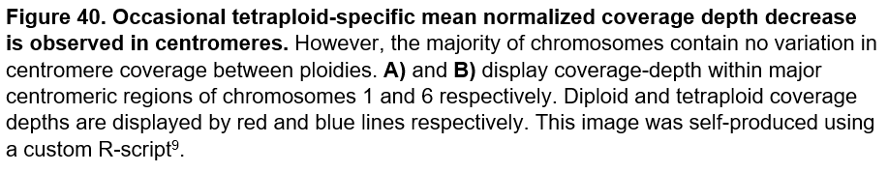

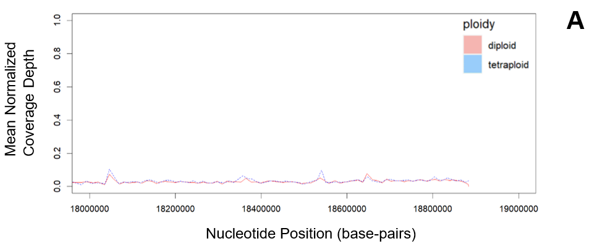

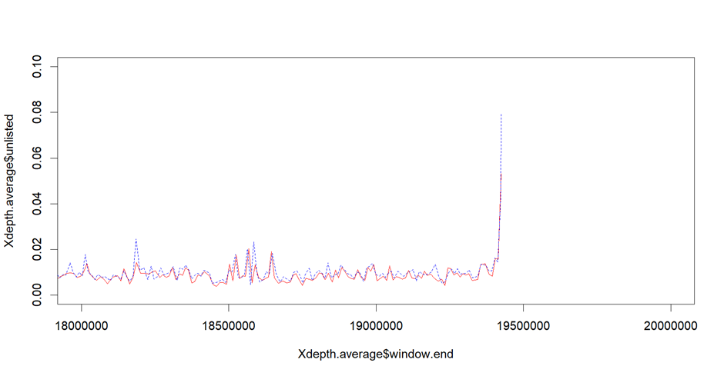

Mean Normalized Coverage Depth

**B**

Nucleotide Position (base-pairs)

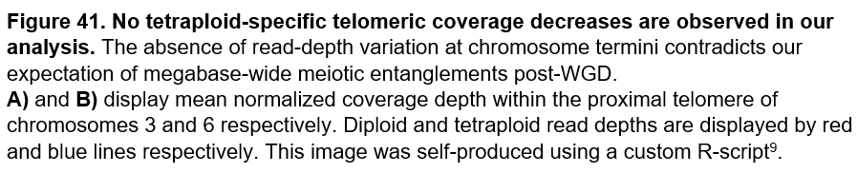

Across our two techniques aimed at characterising tetraploid-specific copy number variation, we identify potential patterns of aneuploidy that could underly increased adaptive ability of polyploid plants - copy number loss within tetraploid centromeres may expedite centromere-associated meiotic drive. However, telomeric aneuploidy events predicted to result from aberrant chromosome segregation post-WGD were not observed in our analysis. Moreover, by identifying consistent ploidy-specific differentiation within multiple biological processes, namely ion-homeostasis, chromatin organization and nuclear division, we identify several multifactorial mechanisms by which *M.guttatus*, and flowering plants more broadly, handle the immediate aftermath of polyploidization. Whilst our CNV investigation requires corroborate evidence from long-read analysis, our results together provide a preliminary perspective on processes under instant variation following whole genome duplication. Further research in this manner will rationalise design of more robust polyploid crops, with increased tolerance to drought and salt, whilst preventing unfavourable decline in the fidelity of meiotic chromosomal transmission.

**References:**

1. Li, M., Zhang, C., Hou, L., Yang, W., Liu, S., Pang, X., & Li, Y. (2021). Multiple responses contribute to the enhanced drought tolerance of the autotetraploid *Ziziphus jujuba Mill. var. spinosa*. *Cell & Bioscience,* **11(1).**
2. Sugiyama S. (2005). Polyploidy and cellular mechanisms changing leaf size: comparison of diploid and autotetraploid populations in two species of Lolium. *Annals of botany,* **96(5):** 931–938.
3. Risso-Pascotto C., Pagliarini M., & do Valle C.B. (2005). Multiple spindles and cellularization during microsporogenesis in an artificially induced tetraploid accession of *Brachiaria ruziziensis (Gramineae).* *Plant Cell Reports,* **23:** 522–527.
4. Wright, K. M., Pires, J. C., & Madlung, A. (2009). Mitotic instability in resynthesized and natural polyploids of the genus *Arabidopsis(Brassicaceae). American Journal of Botany,* **96(9):** 1656–1664.
5. Monnahan, P. *et al.* (2019). Pervasive population genomic consequences of genome duplication in *Arabidopsis arenosa*. *Nat. Ecol. Evol,* **3:** 457.
6. Hahn, M., van Kleunen, M., & Müller-Schärer, H. (2012). Increased Phenotypic Plasticity to Climate May Have Boosted the Invasion Success of Polyploid *Centaurea stoebe*. *Plos ONE,* **7(11):** e50284.
7. Renny-Byfield, S. & Wendel, J. F. (2014). Doubling down on genomes: Polyploidy and crop plants. *American Journal of Botany,* **101(10):** 1711–1725.
8. Parisod, C., Holderegger, R., & Brochmann, C. (2010). Evolutionary consequences of autopolyploidy. *New Phytologist,* **186(1):** 5-17.
9. Baduel, P., Bray, S., Vallejo-Marin, M., Kolář, F., & Yant, L. (2018). The “Polyploid Hop”: Shifting Challenges and Opportunities Over the Evolutionary Lifespan of Genome Duplications. *Frontiers In Ecology And Evolution,* **6.**
10. Morgan, C., White, M., Franklin, F., Zickler, D., Kleckner, N., & Bomblies, K. (2021). Evolution of crossover interference enables stable autopolyploidy by ensuring pairwise partner connections in *Arabidopsis arenosa.* *Current Biology,* **31(21):** 4713-4726.
11. Cheng, J., Li, J., Zhang, Z., Lu, H., Chen, G., & Yao, B. *et al.* (2021). Autopolyploidy‐driven range expansion of a temperate‐originated plant to pan‐tropic under global change. *Ecological Monographs,* **91(2).**
12. Parisod, C. (2008). Postglacial recolonisation of plants in the western Alps of Switzerland. *Botanica Helvetica,* **118(1):** 1-12.
13. Rosche, C., Hensen, I., Mraz, P., Durka, W., Hartmann, M., & Lachmuth, S. (2017). Invasion success in polyploids: the role of inbreeding in the contrasting colonization abilities of diploid versus tetraploid populations of *Centaurea stoebe. Journal of Ecology,* **105(2):** 425-435.
14. Corneillie, S. , De Storme, N. , Van Acker, R. , Fangel, J. U. , De Bruyne, M. , De Rycke, R. , … Boerjan, W. (2019). Polyploidy affects plant growth and alters cell wall composition. *Plant Physiology,* **179:** 74–87.
15. Pacey, E. K., Maherali, H., & Husband, B. C. (2020). The influence of experimentally induced polyploidy on the relationships between endopolyploidy and plant function in *Arabidopsis thaliana. Ecology and Evolution,* **10(1):** 198-216.
16. Levy A. & Feldman M. (2004). Genetic and epigenetic reprogramming of the wheat genome upon allopolyploidization. *Biological Journal of the Linnean Society,* **82:** 607–613.
17. Puzey, J. and Vallejo-Marín, M. (2014), Genomics of invasion: diversity and selection in introduced populations of monkeyflowers (*Mimulus guttatus*). *Molecular Ecology,* **23:** 4472–4485
18. Lowry, D. B., Rockwood, R. C., & Willis, J. H. (2008). Ecological reproductive isolation of coastal and inland races of *Mimulus guttatus. Evolution,* **62(9):** 2196–2214.
19. Simón-Porcar, V. I., Silva, J. L., Meeus, S., Higgins, J. D., & Vallejo-Marín, M. (2017). Recent autopolyploidization in a naturalized population of *Mimulus guttatus (Phrymaceae). Botanical Journal of the Linnean Society.***185(2):**189-207.
20. Porturas, L. (2018). The effect of genome duplication on the reproductive ecology of plants. *Doctoral dissertation, Syracuse University.*
21. Vallejo‐Marín, M., & Hiscock, S. J. (2016). Hybridization and hybrid speciation under global change. *New Phytologist,* **211(4):** 1170-1187.
22. Brownfield, L. & Köhler, C. (2011). Unreduced gamete formation in plants: mechanisms and prospects. *Journal of Experimental Botany,* **62(5):** 1659-1668.
23. Otto, S. P. (2007). The evolutionary consequences of polyploidy. *Cell,* **131(3):** 452-462.
24. Leung, Y., Hui, L. Y., & Kraus, V. B. (2015). Colchicine—update on mechanisms of action and therapeutic uses. *Seminars in arthritis and rheumatism*, **45(3):** 341-350.
25. Verma, R. C., Dass, P., Shaikh, N. & Khah, M. A. (2017). Cytogenetic investigations in colchicine-induced tetraploid of *Cosmos sulphureus (Asteraceae).* *Chromosome Botany,* **12(3):** 41-45.
26. Flagel, L., Blackman, B. K., Fishman, L., Monnahan, P. J., Sweigart, A., & Kelly, J. K. (2018). A synthesis of mapping experiments reveals extensive genomic structural diversity in the *Mimulus guttatus* species complex. *BioRxiv*, **330159.**
27. García-Alcalde, F., Okonechnikov, K., Carbonell, J., Cruz, L. M., Götz, S., Tarazona, S., ... & Conesa, A. (2012). Qualimap: evaluating next-generation sequencing alignment data. *Bioinformatics,* **28(20):** 2678-2679.
28. Korunes, K. L., & Samuk, K. (2021). pixy: Unbiased estimation of nucleotide diversity and divergence in the presence of missing data. *Molecular ecology resources,* **21(4):** 1359-1368.
29. Yant, L., Hollister, J. D., Wright, K. M., Arnold, B. J., Higgins, J. D., Franklin, F. C. H., & Bomblies, K. (2013). Meiotic adaptation to genome duplication in *Arabidopsis arenosa.* *Current biology,* **23(21):** 2151-2156.
30. Bohutínská, M., Alston, M., Monnahan, P., Mandáková, T., Bray, S., Paajanen, P., ... & Yant, L. (2021). Novelty and convergence in adaptation to whole genome duplication. *Molecular biology and evolution,* **38(9):** 3910-3924.
31. Bray, S. M., Wolf, E. M., Zhou, M., Busoms, S., Bohutínská, M., Paajanen, P., ... & Yant, L. (2020). Convergence and novelty in adaptation to whole genome duplication in three independent polyploids. *BioRXiv.*
32. Barton, N. H. (2022). The “New Synthesis”. *Proceedings of the National Academy of Sciences,* **119(30):** e2122147119.
33. Vergara, F., Rymen, B., Kuwahara, A., Sawada, Y., Sato, M., & Hirai, M. Y. (2017). Autopolyploidization, geographic origin, and metabolome evolution in *Arabidopsis thaliana. American Journal of Botany,* **104(6):** 905-914.
34. Kendall, J., & Krasnitz, A. (2014). Computational methods for DNA copy-number analysis of tumors. *Cancer Genomics and Proteomics,* **1176:** 243-259.
35. Klambauer, G., Schwarzbauer, K., Mayr, A., Clevert, D. A., Mitterecker, A., Bodenhofer, U., & Hochreiter, S. (2012). cn.MOPS: mixture of Poissons for discovering copy number variations in next-generation sequencing data with a low false discovery rate. *Nucleic acids research,* **40(9):** e69-e69.
36. Danecek, P., Bonfield, J. K., Liddle, J., Marshall, J., Ohan, V., Pollard, M. O., ... & Li, H. (2021). Twelve years of SAMtools and BCFtools. *Gigascience,* **10(2):** 8.
37. Quinton, R. J., DiDomizio, A., Vittoria, M. A., Kotýnková, K., Ticas, C. J., Patel, S., ... & Ganem, N. J. (2021). Whole-genome doubling confers unique genetic vulnerabilities on tumour cells. *Nature,* **590(7846):** 492-497.
38. Treangen, T. J., & Salzberg, S. L. (2012). Repetitive DNA and next-generation sequencing: computational challenges and solutions. *Nature Reviews Genetics,* **13(1):** 36-46.
39. Fishman, L., & Kelly, J. K. (2015). Centromere‐associated meiotic drive and female fitness variation in *Mimulus. Evolution*, **69(5):** 1208-1218.
40. Jombart, T (2008). Adegenet: an R package for the multivariate analysis of genetic markers. *Bioinformatics,* **24:** 1403-1405.
41. Huson, D. H. (1998). SplitsTree: analyzing and visualizing evolutionary data. *Bioinformatics,* **14(1):** 68-73.
42. Danecek, P., Auton, A., Abecasis, G., Albers, C. A., Banks, E., DePristo, M. A., ... & 1000 Genomes Project Analysis Group. (2011). The variant call format and VCFtools. *Bioinformatics,* **27(15):** 2156-2158.
43. Wickham, H., François, R., Henry, L., & Müller, K. (2015). dplyr: A grammar of data manipulation. *R package version 0.4,* **3:**156.
44. Hellsten, U., Wright, K. M., Jenkins, J., Shu, S., Yuan, Y., Wessler, S. R., … Rokhsar, D. S. (2013). Fine-scale variation in meiotic recombination in *Mimulus* inferred from population shotgun sequencing. *Proceedings of the National Academy of Sciences,* **110(48):** 19478–19482.
45. Quinlan, A. R., & Hall, I. M. (2010). BEDTools: a flexible suite of utilities for comparing genomic features. *Bioinformatics,* **26(6):** 841-842.
46. Thomas, P. D., Campbell, M. J., Kejariwal, A., Mi, H., Karlak, B., Daverman, R., ... & Narechania, A. (2003). PANTHER: a library of protein families and subfamilies indexed by function. *Genome research*, **13(9):** 2129-2141.
47. Szklarczyk, D., Gable, A. L., Lyon, D., Junge, A., Wyder, S., Huerta-Cepas, J., ... & Mering, C. V. (2019). STRING v11: protein–protein association networks with increased coverage, supporting functional discovery in genome-wide experimental datasets. *Nucleic acids research,* **47(1):** D607-D613.
48. Shen, L. J. R. P. (2014). GeneOverlap: An R package to test and visualize gene overlaps. *R Package, 3.*
49. Oliveros, J.C. (2007-). VENNY An Interactive Tool for Comparing Lists with Venn Diagrams.
50. Dobin, A., Davis, C. A., Schlesinger, F., Drenkow, J., Zaleski, C., Jha, S., ... & Gingeras, T. R. (2013). STAR: ultrafast universal RNA-seq aligner. *Bioinformatics,* **29(1):** 15-21.
51. Colicchio, J. M., Miura, F., Kelly, J. K., Ito, T., & Hileman, L. C. (2015). DNA methylation and gene expression in *Mimulus guttatus. BMC genomics,* **16(1):** 1-15.
52. Awadalla, P., & Ritland, K. (1997). Microsatellite variation and evolution in the *Mimulus guttatus* species complex with contrasting mating systems. *Molecular biology and evolution,* **14(10):** 1023-1034.
53. McKenna, A., Hanna, M., Banks, E., Sivachenko, A., Cibulskis, K., Kernytsky, A., ... & DePristo, M. A. (2010). The Genome Analysis Toolkit: a MapReduce framework for analyzing next-generation DNA sequencing data. *Genome research,* **20(9):** 1297-1303.
54. Griswold, C. K., & Williamson, M. W. (2017). A two-locus model of selection in autotetraploids: chromosomal gametic disequilibrium and selection for an adaptive epistatic gene combination. *Heredity,* **119(5):** 314-327.
55. Sharma, S. K., MacKenzie, K., McLean, K., Dale, F., Daniels, S., & Bryan, G. J. (2018). Linkage disequilibrium and evaluation of genome-wide association mapping models in tetraploid potato. *G3: Genes, Genomes, Genetics*, **8(10):** 3185-3202.
56. Rendón-Anaya, M., Wilson, J., Sveinsson, S., Fedorkov, A., Cottrell, J., Bailey, M. E., ... & Ingvarsson, P. K. (2021). Adaptive introgression facilitates adaptation to high latitudes in European aspen (*Populus tremula L*.). *Molecular biology and evolution,* **38(11):** 5034-5050.
57. Goldwasser, Y., Westwood, J. H., & Yoder, J. I. (2002). The use of *Arabidopsis* to study interactions between parasitic angiosperms and their plant hosts. *The Arabidopsis Book/American Society of Plant Biologists,* **1.**
58. Hollister, J. D., Arnold, B. J., Svedin, E., Xue, K. S., Dilkes, B. P., & Bomblies, K. (2012). Genetic adaptation associated with genome-doubling in autotetraploid *Arabidopsis arenosa. PLoS genetics,* **8(12):** 1003093.
59. Yant, L., & Bomblies, K. (2015). Genome management and mismanagement—cell-level opportunities and challenges of whole-genome duplication. *Genes & development,* **29(23):** 2405-2419.
60. Xue, T., Wang, D., Zhang, S., Ehlting, J., Ni, F., Jakab, S., ... & Zhong, Y. (2008). Genome-wide and expression analysis of protein phosphatase 2C in rice and *Arabidopsis. BMC genomics,* **9(1):** 1-21.
61. Asad, M. A. U., Zakari, S. A., Zhao, Q., Zhou, L., Ye, Y., & Cheng, F. (2019). Abiotic stresses intervene with ABA signaling to induce destructive metabolic pathways leading to death: premature leaf senescence in plants. *International Journal of Molecular Sciences,* **20(2):** 256.
62. Bomblies, K. (2020). When everything changes at once: finding a new normal after genome duplication. *Proceedings of the Royal Society B*, **287(1939):** 20202154.
63. Schoenfelder, K. P., & Fox, D. T. (2015). The expanding implications of polyploidy. *The Journal of cell biology,* **209(4):** 485.
64. Boycheva, I., Vassileva, V., & Iantcheva, A. (2014). Histone acetyltransferases in plant development and plasticity. *Current genomics,* **15(1):** 28.
65. Kim, L. J., Tsuyuki, K. M., Hu, F., Park, E. Y., Zhang, J., Iraheta, J. G., ... & Jeong, J. (2021). Ferroportin 3 is a dual‐targeted mitochondrial/chloroplast iron exporter necessary for iron homeostasis in *Arabidopsis.* *The Plant Journal,* **107(1):** 215-236.
66. Kamiya, T., Borghi, M., Wang, P., Danku, J. M., Kalmbach, L., Hosmani, P. S., ... & Salt, D. E. (2015). The MYB36 transcription factor orchestrates Casparian strip formation. *Proceedings of the National Academy of Sciences,* **112(33):** 10533-10538.
67. Dal Bosco, C., Lezhneva, L., Biehl, A., Leister, D., Strotmann, H., Wanner, G., & Meurer, J. (2004). Inactivation of the chloroplast ATP synthase γ subunit results in high non-photochemical fluorescence quenching and altered nuclear gene expression in *Arabidopsis thaliana. Journal of Biological Chemistry,* **279(2):** 1060-1069.
68. Flanagan, S. P., & Jones, A. G. (2017). Constraints on the FST-Heterozygosity Outlier Approach. *The Journal of heredity,* **108(5):** 561–573.
69. Ardito, F., Giuliani, M., Perrone, D., Troiano, G., & Lo Muzio, L. (2017). The crucial role of protein phosphorylation in cell signalling and its use as targeted therapy. *International journal of molecular medicine,* **40(2):** 271-280.
70. Oliva, M., Stuart, T., Tang, D., Pflueger, J., Poppe, D., Jabbari, J. S., ... & Lister, R. (2022). An environmentally-responsive transcriptional state modulates cell identities during root development. *bioRxiv.*
71. Chumová, J., Kourová, H., Trögelová, L., Daniel, G., & Binarová, P. (2021). γ-tubulin complexes and fibrillar arrays: Two conserved high molecular forms with many cellular functions. *Cells,* **10(4):** 776.
72. Rutland, C. A., Hall, N. D., & McElroy, J. S. (2021). The impact of polyploidization on the evolution of weed species: Historical understanding and current limitations. *Frontiers* in Agronomy, **3:** 626454.
73. Nakajima, K., Furutani, I., Tachimoto, H., Matsubara, H., & Hashimoto, T. (2004). SPIRAL1 encodes a plant-specific microtubule-localized protein required for directional control of rapidly expanding *Arabidopsis* cells. *The Plant Cell,* **16(5):** 1178-1190.
74. Wang, J., Qiu, Z., & Wu, Y. (2018). Ubiquitin Regulation: The Histone Modifying Enzyme′ s Story. *Cells,* **7(9):** 118.
75. Satta, Y., O'hUigin, C., Takahata, N., & Klein, J. (1993). The synonymous substitution rate of the major histocompatibility complex loci in primates. *Proceedings of the National Academy of Sciences,* **90(16):** 7480-7484.
76. Song, Q., & Chen, Z. J. (2015). Epigenetic and developmental regulation in plant polyploids. *Current opinion in plant biology,* **24:** 101-109.
77. Liu, H., Sun, H., Bao, L., Han, S., Hui, T., Zhang, R., ... & Jiao, F. (2021). Secondary Metabolism and Hormone Response Reveal the Molecular Mechanism of Triploid Mulberry *(Morus Alba L.) Trees Against Drought. Frontiers in Plant Science,* **2103.**
78. Quint, M., & Gray, W. M. (2006). Auxin signaling. *Current opinion in plant biology,* **9(5):** 448-453.
79. Nigg, E. A. (2001). Mitotic kinases as regulators of cell division and its checkpoints. *Nature reviews Molecular cell biology,* **2(1):** 21-32.
80. Chen, S., Wang, R., Zheng, D., Zhang, H., Chang, X., Wang, K., ... & Cheng, H. (2019). The mRNA export receptor NXF1 coordinates transcriptional dynamics, alternative polyadenylation, and mRNA export. *Molecular cell,* **74(1):** 118-131.
81. Sjöstrand, A. E., Sjödin, P., & Jakobsson, M. (2014). Private haplotypes can reveal local adaptation. *BMC genetics,* **15(1):** 1-14.
82. Liao, Q., Tang, T. J., Zhou, T., Song, H. X., Hua, Y. P., & Zhang, Z. H. (2020). Integrated transcriptional and proteomic profiling reveals potential amino acid transporters targeted by nitrogen limitation adaptation. *International journal of molecular sciences,* **21(6):** 2171.
83. Baduel, P., Arnold, B., Weisman, C. M., Hunter, B., & Bomblies, K. (2016). Habitat-associated life history and stress-tolerance variation in *Arabidopsis arenosa. Plant physiology,* **171(1):** 437-451.
84. Kobayashi, A., Takahashi, A., Kakimoto, Y., Miyazawa, Y., Fujii, N., Higashitani, A., & Takahashi, H. (2007). A gene essential for hydrotropism in roots. *Proceedings of the National Academy of Sciences,* **104(11):** 4724-4729.
85. Baduel, P., Quadrana, L., Hunter, B., Bomblies, K., & Colot, V. (2019). Relaxed purifying selection in autopolyploids drives transposable element over-accumulation which provides variants for local adaptation. *Nature communications,* **10(1):** 1-10.
86. Lin, C. S., Hsu, C. T., Yuan, Y. H., Zheng, P. X., Wu, F. H., Cheng, Q. W., ... & Lin, Y. C. (2022). DNA-free CRISPR-Cas9 gene editing of wild tetraploid tomato *Solanum peruvianum* using protoplast regeneration. *Plant physiology,* **188(4):** 1917-1930.
87. Zhao, L., Liu, H., Yuan, X., Gao, K., & Duan, J. (2020). Comparative study of whole exome sequencing-based copy number variation detection tools. *BMC bioinformatics,* **21(1):** 1-10.
88. Gabrielaite, M., Torp, M. H., Rasmussen, M. S., Andreu-Sánchez, S., Vieira, F. G., Pedersen, C. B., ... & Bagger, F. O. (2021). A comparison of tools for copy-number variation detection in germline whole exome and whole genome sequencing data. *Cancers,* **13(24):** 6283.
89. Wicker, T., Wing, R. A., & Schubert, I. (2015). Recurrent sequence exchange between homeologous grass chromosomes. *The Plant Journal,* **84(4):** 747-759.
90. Amarasinghe, S. L., Su, S., Dong, X., Zappia, L., Ritchie, M. E., & Gouil, Q. (2020). Opportunities and challenges in long-read sequencing data analysis. *Genome biology,* **21(1):** 1-16.
91. Manzoor, A., Ahmad, T., Bashir, M. A., Hafiz, I. A., & Silvestri, C. (2019). Studies on colchicine induced chromosome doubling for enhancement of quality traits in ornamental plants. *Plants,* **8(7):** 194.
92. Robinson, J. T., Thorvaldsdóttir, H., Winckler, W., Guttman, M., Lander, E. S., Getz, G., & Mesirov, J. P. (2011). Integrative genomics viewer. *Nature biotechnology,* **29(1):** 24-26.
93. Rošić, S., Köhler, F., & Erhardt, S. (2014). Repetitive centromeric satellite RNA is essential for kinetochore formation and cell division. *Journal of Cell Biology,* **207(3):** 335-349.
94. Fishman, L., & Saunders, A. (2008). Centromere-associated female meiotic drive entails male fitness costs in monkeyflowers. *Science,* **322(5907):** 1559-1562.

**Appendices:**

1 – ScanTools generated PGM metrics for all chromosomes

2a – *M.guttatus* Gene Orientation File

2b – *M.guttatus* TAIR Annotation

3-6 – TAIR IDs for upper 99th-percentile outliers from each metric (FST, AFD, DXY and Rho respectively.

7-8 – TAIR ID candidates in *C.amara* and *A.arenosa*

9 – Qualimap results

10 – STAR mapping

11 – Frequency histograms and dot-plots of CNV locations

12 – Frequency histograms and dot-plots of CNV locations >50-kilobases

13 – Mean normalized coverage plots

14 – Expected vs. actual chromosome outlier proportions

15 – Absolute AFD plots for our top twenty AFD outliers

16 – Frequency histograms and dot-plots of CNV locations >50-kilobases in colchiploids